Microsoft Cloud Workshops

Enterprise-class Networking in Azure Hackathon

Lab Guide

February 2017

© 2017 Microsoft Corporation. All rights reserved. This document is confidential and proprietary to Microsoft. Internal use only. This document is for informational purposes only. MICROSOFT MAKES NO WARRANTIES, EXPRESS OR IMPLIED, IN THIS SUMMARY.

This document is provided "as-is." Information and views expressed in this document, including URL and other Internet Website references, may change without notice. You bear the risk of using it.

Some examples are for illustration only and are fictitious. No real association is intended or inferred.

Contents

Enterprise-class Networking in Azure Hackathon 1

Overview 1

Requirements 1

Lab structure 1

Prerequisites 2

Preparation: Provision a Lab VM with Azure PowerShell 2

Exercise 1: Proof of concept deployment 13

Help references 14

Task 1: Create a virtual network and provision subnets 14

Tasks to complete 14

Exit criteria 15

Task 2: Create route tables with required routes 15

Tasks to complete 15

Exit criteria 15

Task 3: Create n-tier application servers 15

Tasks to complete 15

Exit criteria 18

Tack 4: Build the management station 19

Tasks to complete 19

Exit criteria 19

Task 5: Provision and configure partner firewall solution 19

Tasks to complete 19

Exit criteria 20

Task 6: Site-to-site connectivity 21

Configure another Azure virtual network 21

Exit criteria 21

Enterprise-class Networking in Azure Hackathon answers 22

Overview 22

Task 1: Create a virtual network and provision subnets 22

Task 2: Create route tables 29

Task 3: Add routes to each route table 33

Task 4: Create n-tier application and validate functionality 38

Task 5: Provision and configure partner firewall solution 43

Removing a spending cap and associating a credit card with your subscription 43

Provision the firewall appliance 45

Enable IP forwarding on the firewall network interface 55

Task 6: Build the management station 58

Task 7 Complete the n-tier application configuration 67

Use PowerShell DSC to customize the webservers and the SQL Server 67

Create a Load Balancer to distribute load between the web servers 69

Configure the load balancer 72

Task 8 Configure the firewall to control traffic flow 78

Logon to pfSense and Add Aliases 78

Add NAT rules 83

Configure Firewall Rules 87

Associate route tables to subnets 95

Validate connectivity 100

Task 9 – Configuring site-to-site connectivity 104

Create another virtual network 104

Configure Gateway Subnets for both virtual networks 105

Create the First Gateway 110

Create the Second Gateway 113

Connect the Gateways 116

Task 10 - Validate connectivity from ‘on-premises’ to Azure 120

Create a virtual machine to validate connectivity 120

Configure routing for simulated ‘on-premises’ to Azure traffic 122

Add a firewall rule on pfSense 127

Validate connectivity from ‘on-prem’ to ‘Azure’ side 128

Conclusion 132

# Enterprise-class Networking in Azure Hackathon

## Overview

The Enterprise-class Networking in Azure Hackathon is a hands-on exercise that will challenge you to implement an end-to-end scenario using hybrid and core virtual networking technologies available in Azure. The Hackathon can be implemented on your own, but it is highly recommended to pair up with other members at the Hackathon to model a real world experience much closer and to allow each member to share their expertise for the overall solution.

## Requirements

* Microsoft Azure subscription

## Lab structure

This lab has two sets of instructions. The first is a high-level set of instructions that is designed for attendees that have previous experience with building virtual machines and networks in Azure. The second is a traditional hands-on lab guide that is designed for attendees that do not have this experience.

## Prerequisites

You must have a working Azure subscription to carry out this Hackathon. Additionally, you will need to use Azure PowerShell. If working on a Windows machine with Azure PowerShell installed (version 1.5.1 or later) then you are ready to proceed to Exercise 1: Proof of concept deployment. If you need to install or update Azure PowerShell, proceed to Preparation Exercise 1. If you are working on a Mac or Linux machine, proceed to Preparation Exercise 2 to create a Windows VM in Azure that has Azure PowerShell installed.

**Note you only need to carry out Exercise 1 OR Exercise 2, not both of them.**

### Preparation: Provision a Lab VM with Azure PowerShell

If you are working on a machine that cannot run PowerShell, carry out this task. Only do this if you are not running the commands on your local machine, but are provisioning a VM to perform the steps.

#### Provision a lab VM

1. Launch a browser and navigate to <https://portal.azure.com>. When prompted, log in with your Microsoft Azure credentials. If prompted, choose whether your account is an organization account or just a Microsoft Account.

**Note:** You may need to launch an "in-private" session in your browser if you have multiple Microsoft Accounts. The version of Visual Studio 2015 may differ in the portal compared to what is in the lab guide as newer versions of Visual Studio are released or updates to Visual Studio 2015 are released. Please check the version used that closely matches the lab guide.

1. Click **+NEW**, and in the search box type in **Visual Studio Community 2015** and press enter.

In the returned search results click the image name looking for update 3.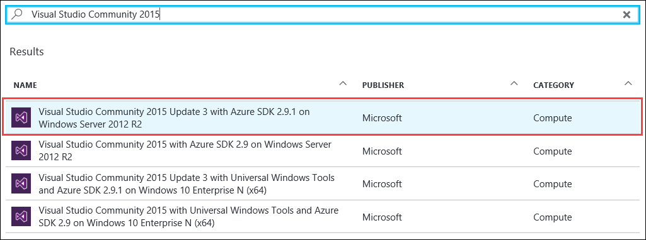

1. In the blade that comes up, at the bottom of the page keep the deployment model set to **Resource Manager** and click **Create**.

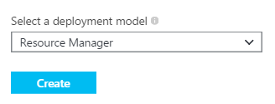

1. Set the following configuration on the Basics tab and click **OK**. See the following screenshot for more details.
   * Name: **LABVM**
   * User name: **demouser**
   * Password: **demo@pass123**
   * Subscription: **If you have multiple subscriptions choose the subscription to execute your labs in.**
   * Resource Group: Select **Create new** and enter the name **OPSLABRG**
   * Location: **Choose the closest Azure region to you.**

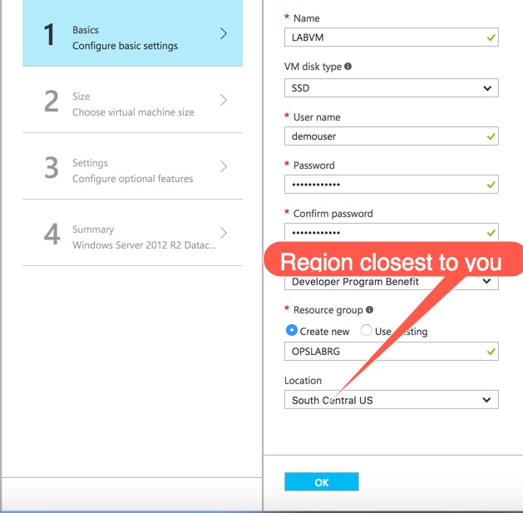

Choose the **D1_V2 Standard** instance size on the Size blade, then click **Select** at the bottom of the blade.

VM disk type is also required now in the VM selection – defaults to SSD

**Note:** You may have to click the **View All** link to see the instance sizes.

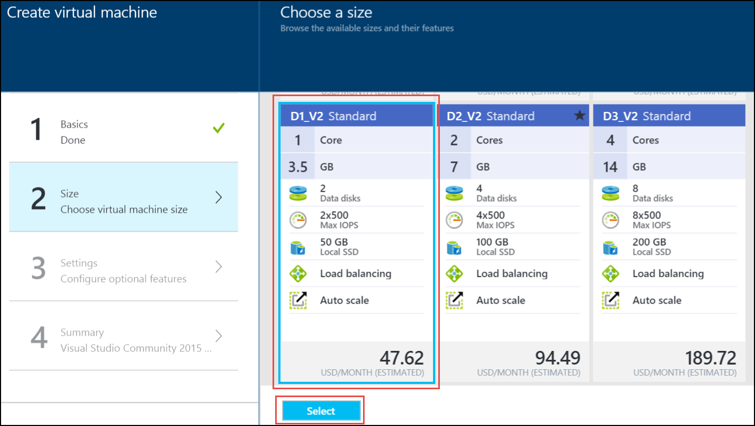

**Note:** One of the recommended configurations may be selected, but if you are using a trial Azure subscription there is a restriction of 10 cores per region. Choosing VM sizes with lower core counts enables the provisioning of all required lab VMs and consumes less of the trial subscription credit.

1. Accept the default values on the **Settings** blade and click **OK**. On the Summary page click **OK**. The deployment should begin provisioning. It may take 10+ minutes for the virtual machine to complete provisioning.
2. Notice that at the summary page, there is an option next to the OK, Download template and parameters is shown from here we can get the JSON template from our selection, this can be used to download and check how the template is created also.

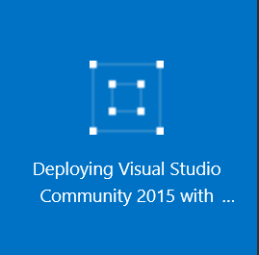

1. Move back to the Portal page on your local machine and wait for **LABVM** to show the Status of **Running**. Click **Connect** to establish a new Remote Desktop Session.

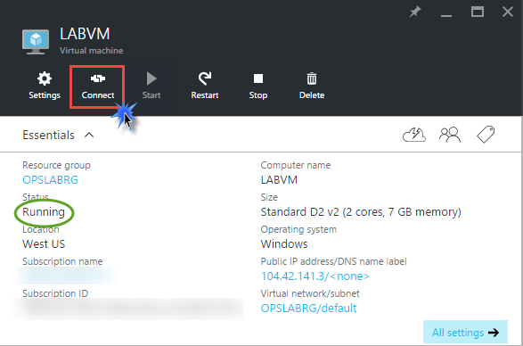

1. Depending on your remote desktop protocol client and browser configuration you will either be prompted to open an RDP file, or you will need to download it and then open it separately to connect.
2. Log in with the credentials specified during creation:
   1. User: **demouser**
   2. Password: **demo@pass123**
3. You will be presented with a Remote Desktop Connection warning because of a certificate trust issue. Click **Yes** to continue with the connection.

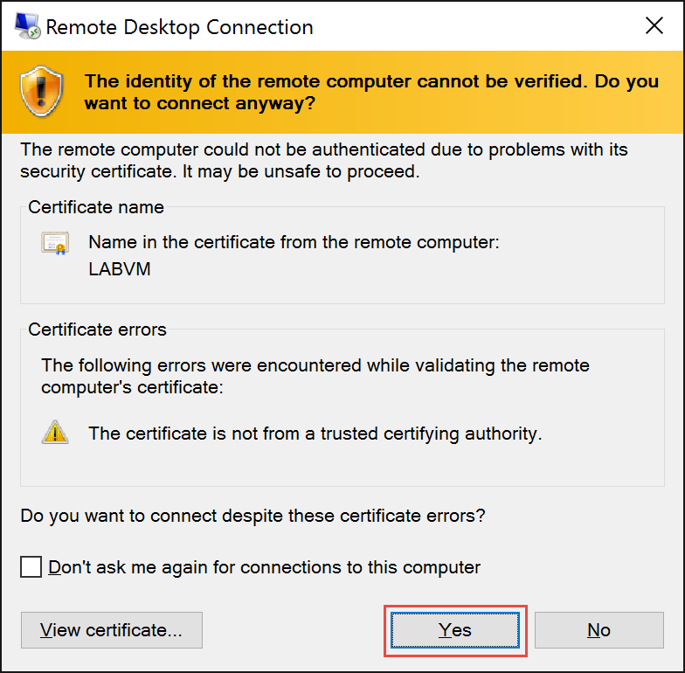

1. When logging on for the first time you will see a prompt on the right asking about network discovery. Click **No**.

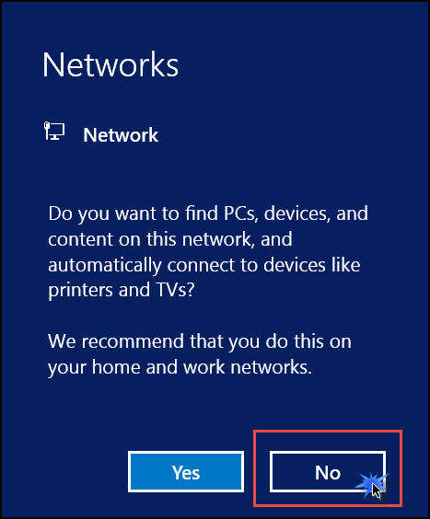

1. Notice that Server Manager opens by default. On the left, click **Local Server**.

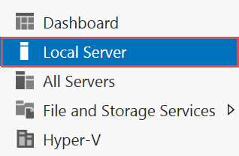

1. On the right side of the pane, click **On** by **IE Enhanced Security Configuration**.

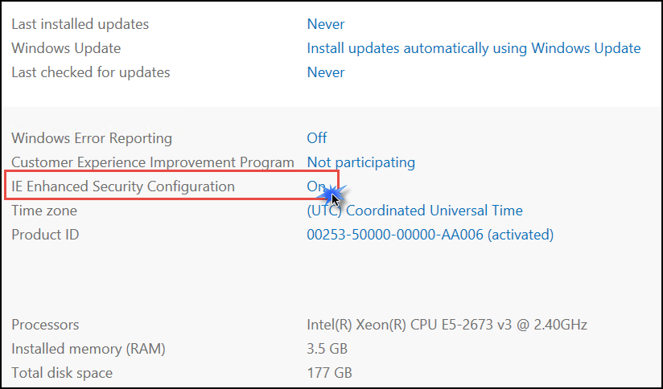

1. Change to **Off** for Administrators and click **OK**.

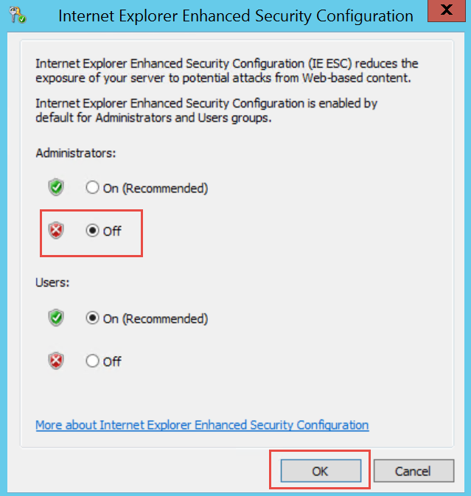

#### Update Azure PowerShell version

1. While logged into LabVM via RDP, open Internet Explorer and navigate to <http://aka.ms/webpi-azps>. This will download an executable. After the download is finished, click **Run** toexecute it.

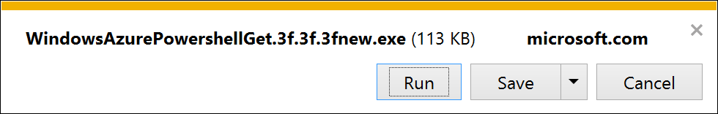

1. A Web Platform Installer dialog box will open. Click **Install** to install the latest version of the Azure PowerShell module (your version may differ from the screenshot).

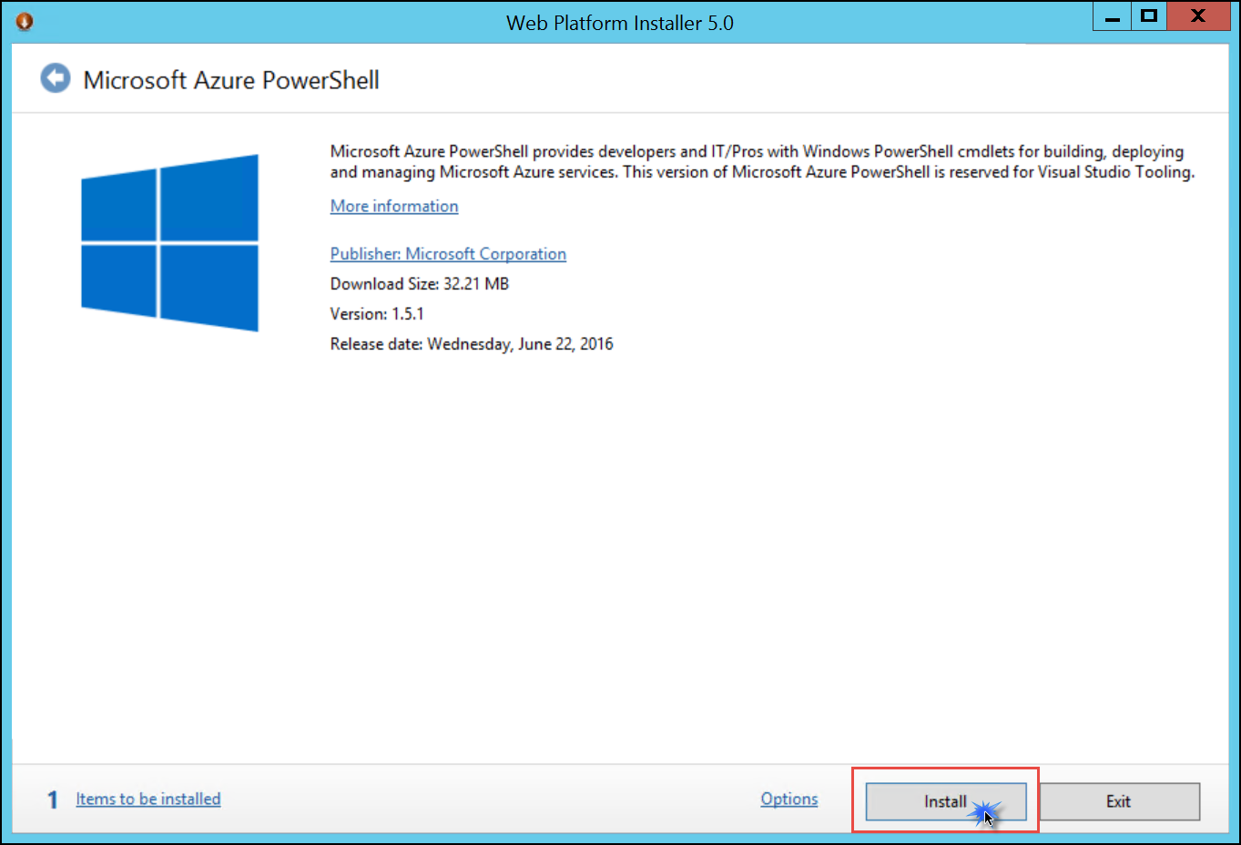

1. Accept the license terms by clicking **I Accept**.

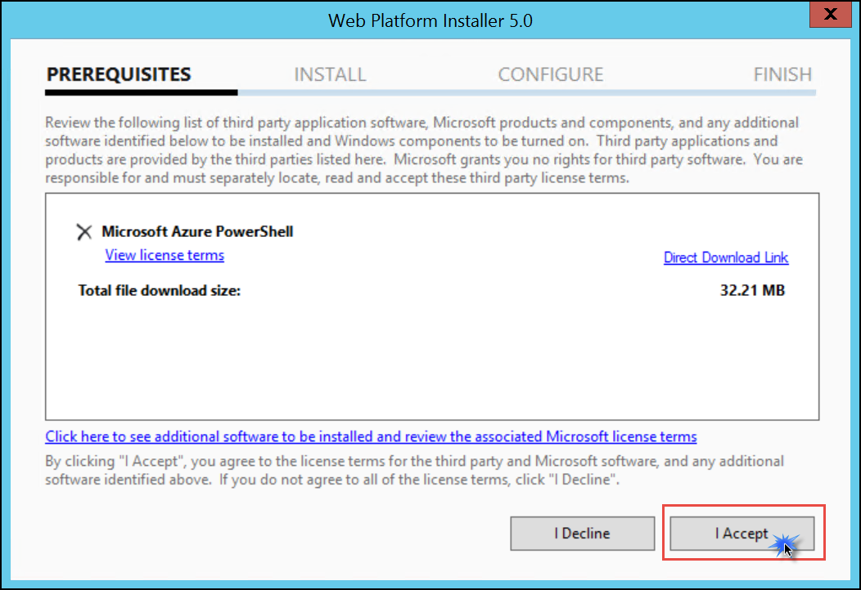

1. Click **Finish** to complete the installation.

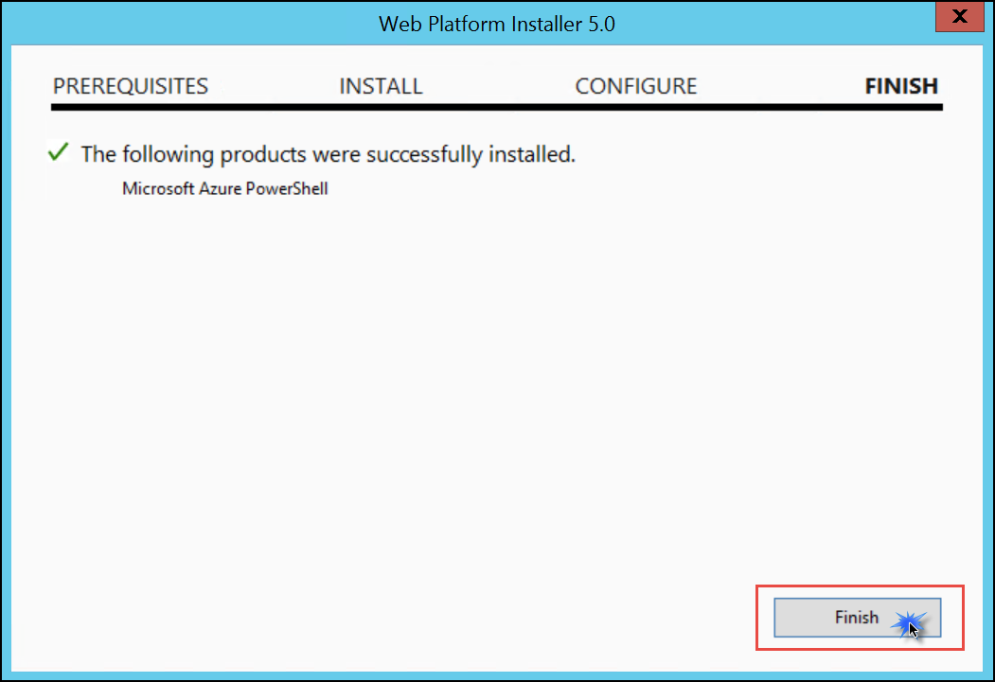

1. After the installation is complete, **reboot** the machine you installed Azure PowerShell on.

#### Download Hackathon support files

1. After the reboot has completed, download the zipped Hackathon student files by clicking on this link: <https://opsgilityweb.blob.core.windows.net/cebootcamp-feb-2017/Enterprise%20Class%20Networking%20in%20Azure%20Hackathon%20-%20Student%20Files.zip>
2. Extract the downloaded files into the directory C:\ECN-Hackathon.

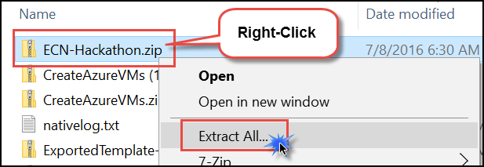

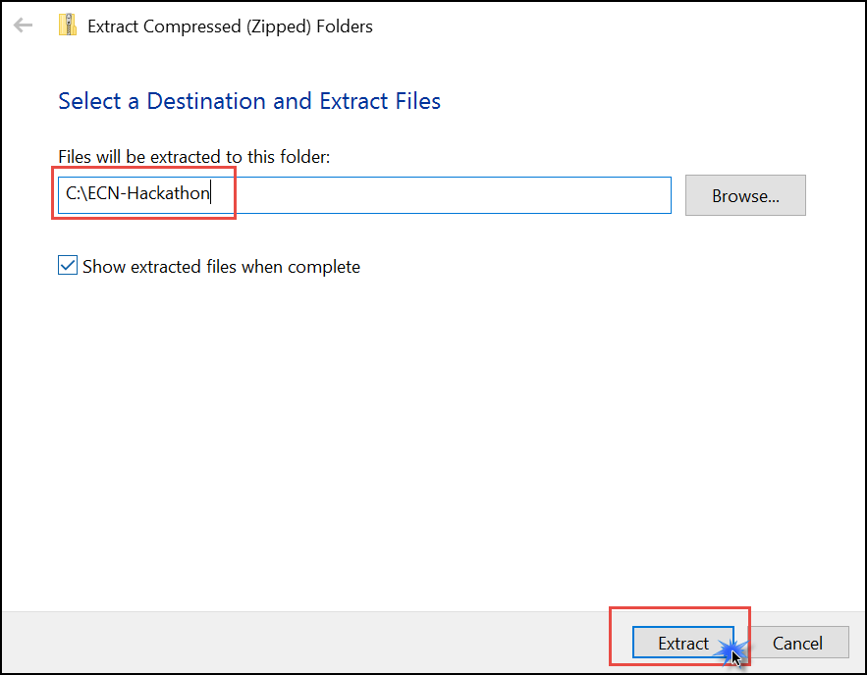

## Exercise 1: Proof of concept deployment

You have been asked by Woodgrove Financial Services to provision an environment that is similar to what was proposed for their Azure-based network scenario (assumes exposure to the workshop). This environment will be used by the Woodgrove team to gain familiarity with a complex virtual networking deployment, including all of the components that enable the solution. Specifically, the Woodgrove team will be learning about:

* How to bypass system routing to accomplish custom routing scenarios
* How to capitalize on load balancers to distribute load and ensure service availability
* How to implement a partner firewall solution to control traffic flow based on policies.

The end result of this proof of concept will be an environment resembling this diagram:

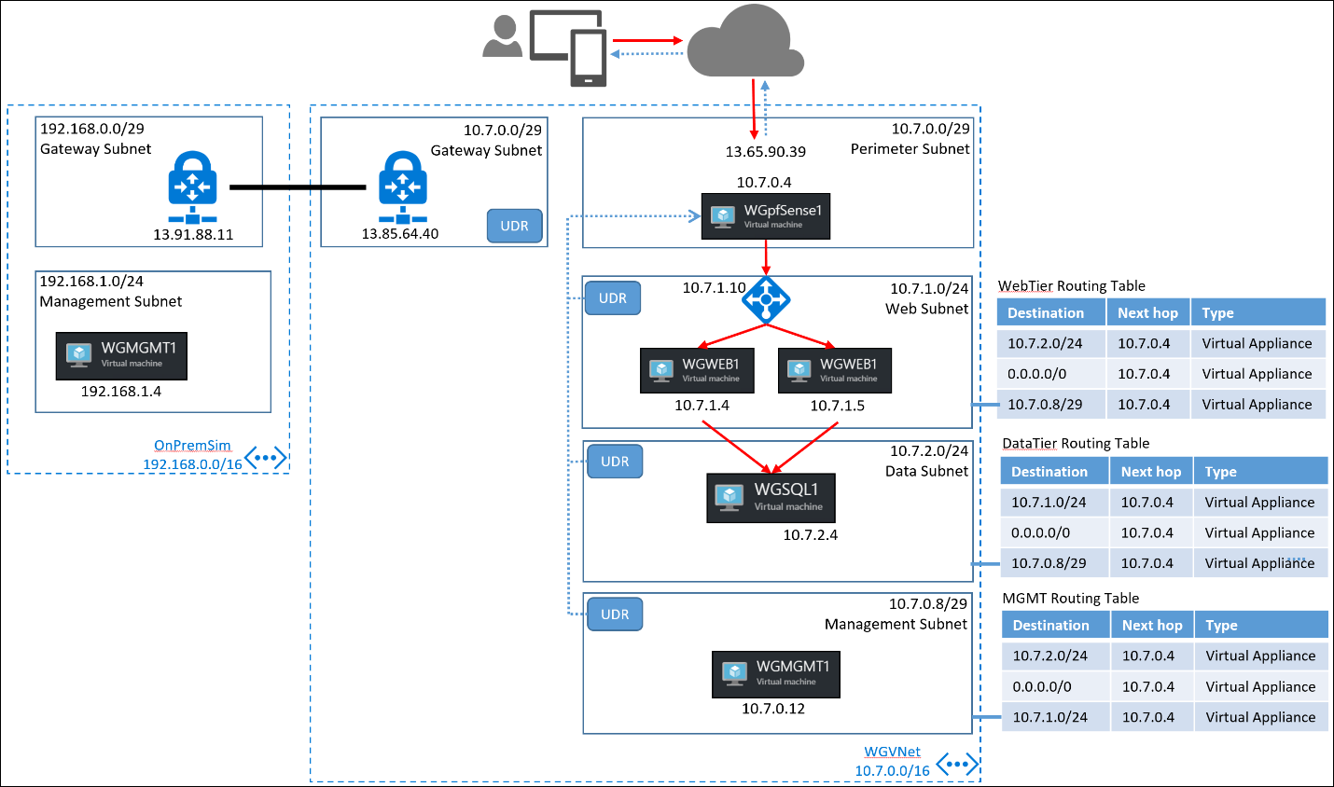

### Help references

| **Description** | **Links** |
| --- | --- |
| IP Addressing and Subnetting for New Users | http://www.cisco.com/c/en/us/support/docs/ip/routing-information-protocol-rip/13788-3.html |
| CIDR / VLSM Supernet Calculator | <http://www.subnet-calculator.com/cidr.php> |
| Virtual Network documentation | <https://azure.microsoft.com/en-us/documentation/services/virtual-network/> |
| Network Security Group documentation | <https://azure.microsoft.com/en-us/documentation/articles/virtual-networks-nsg/> |
| IP addresses in Azure | https://azure.microsoft.com/en-us/documentation/articles/virtual-network-ip-addresses-overview-arm/ |
| User-Defined Routing and IP Forwarding | <https://azure.microsoft.com/en-us/documentation/articles/virtual-networks-udr-overview/> |
| Load Balancer | <https://azure.microsoft.com/en-us/documentation/articles/load-balancer-overview/> |
| Implementing a DMZ between Azure and your on-premises datacenter | <https://azure.microsoft.com/en-us/documentation/articles/guidance-iaas-ra-secure-vnet-hybrid/> |
| pfSense firewall rule basics | <https://doc.pfsense.org/index.php/Firewall_Rule_Basics> |
| How can I forward ports with pfSense | <https://doc.pfsense.org/index.php/How_can_I_forward_ports_with_pfSense> |

## Task 1: Create a virtual network and provision subnets

### Tasks to complete

* Provision a virtual network in your Azure subscription. It should have a perimeter subnet, a web tier subnet and a data tier subnet. This will support future tasks that will enable traffic segregation commensurate with an n-tier application deployment in an enterprise.
* Provision a management subnet. This subnet will have a management server from which management traffic is allowed to the internal subnets.

### Exit criteria

* One virtual network is provisioned
* Four subnets are configured
  + Perimeter
  + Management
  + Web Tier
  + Data Tier

## Task 2: Create route tables with required routes

### Tasks to complete

* Configure route tables with appropriate routes for each subnet in the virtual network (with the exception of the perimeter subnet). The goal is to provide directed traffic flow to a network virtual appliance (NVA) that you will deploy as a later task. All traffic between subnets and to the Internet must be managed by the firewall. The only appliance that should be deployed in your perimeter subnet is the NVA. As such, it will take the first IP address available in the subnet. So, if your subnet address range is 10.7.0.0/29 then your NVA will be allocated 10.7.0.4 (the first four addresses are reserved by Azure fabric). Use route tables and appropriate routes to direct traffic to this address.
* **Do not associate the route tables with their corresponding subnet until directed to do so in a later task.**

### Exit criteria

* A route table configured for each subnet (with the exception of the perimeter subnet).
* Each route table will have routes to the other subnets and to the Internet, all with a ‘next hop’ configured as the NVA.

## Task 3: Create n-tier application servers

### Tasks to complete

* Provision 2 IIS-based web server running the example website, CloudShop. It is recommended to use the Windows Server 2012 R2 Datacenter.

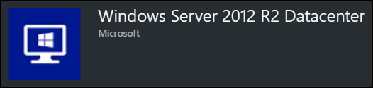

* The configuration of the website will be identical on both web servers. This website requires a SQL data tier. These servers should have public IP addresses and network security groups that allow HTTP traffic inbound. You will use the public IP addresses to gain access to the servers for initial configuration and validation. After the site is configured, you will remove the public IP addresses.
* Provision one SQL server (web edition is adequate) to host the application database. This server should exist in the Data tier subnet. For ease of deployment, it is recommended to use a SQL server image in the Azure marketplace, rather than installing SQL on an IaaS VM.

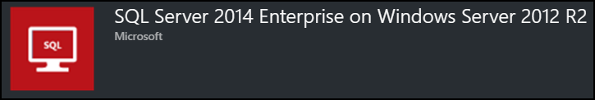

**To ensure the website functions properly, name the SQL server WGSQL1**. This server should not have a public IP address.

* Configure an Azure internal load-balancer to balance load between the two web servers. This load-balancer should have an HTTP health-check probe configured. It should have a static IP address in the Web tier subnet.

After the SQL and web servers are provisioned, you can create the website using these steps:

1. Connect to one of the web servers via RDP and download the content found at this link: <https://opsgilityweb.blob.core.windows.net/cebootcamp-feb-2017/Enterprise%20Class%20Networking%20in%20Azure%20Hackathon%20-%20Student%20Files.zip>
2. Extract the contents to C:\CloudShopSite.
3. Open the **Manual CloudShop Build** folder, and then open the **CloudShop** folder. Copy the ***contents*** of the **CloudShop** folder into C:\inetpub\wwwroot.
4. Navigate to C:\inetpub\wwwroot. Open **web.config** and do a Find/Replace as shown below:

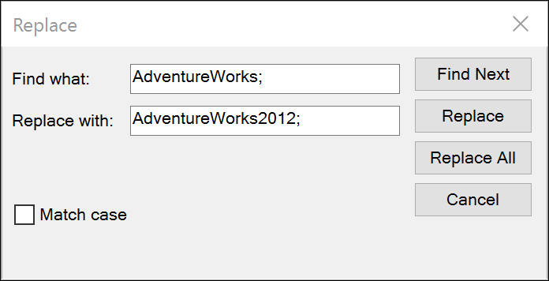

Save the file.

1. Repeat step 3 and 4 on the other IIS server.
2. Within the **Manual CloudShop Build** folder there is a backed up database file (AdventureWorks2012.bak). Copy this to the SQL server and recover the database using instructions found here: <https://msdn.microsoft.com/en-us/library/ms177429.aspx>
3. On the SQL server, change the authentication type to *mixed-mode* and enable the ***‘sa’*** account.
4. After the database is restored, you should be able to browse the website using the public IP address of either web server. Validate from the web servers IP address directly and from the load balancer IP. Because it is an internal load balancer, you need to accomplish this while connected to a web server over RDP. You should see the following screenshot:

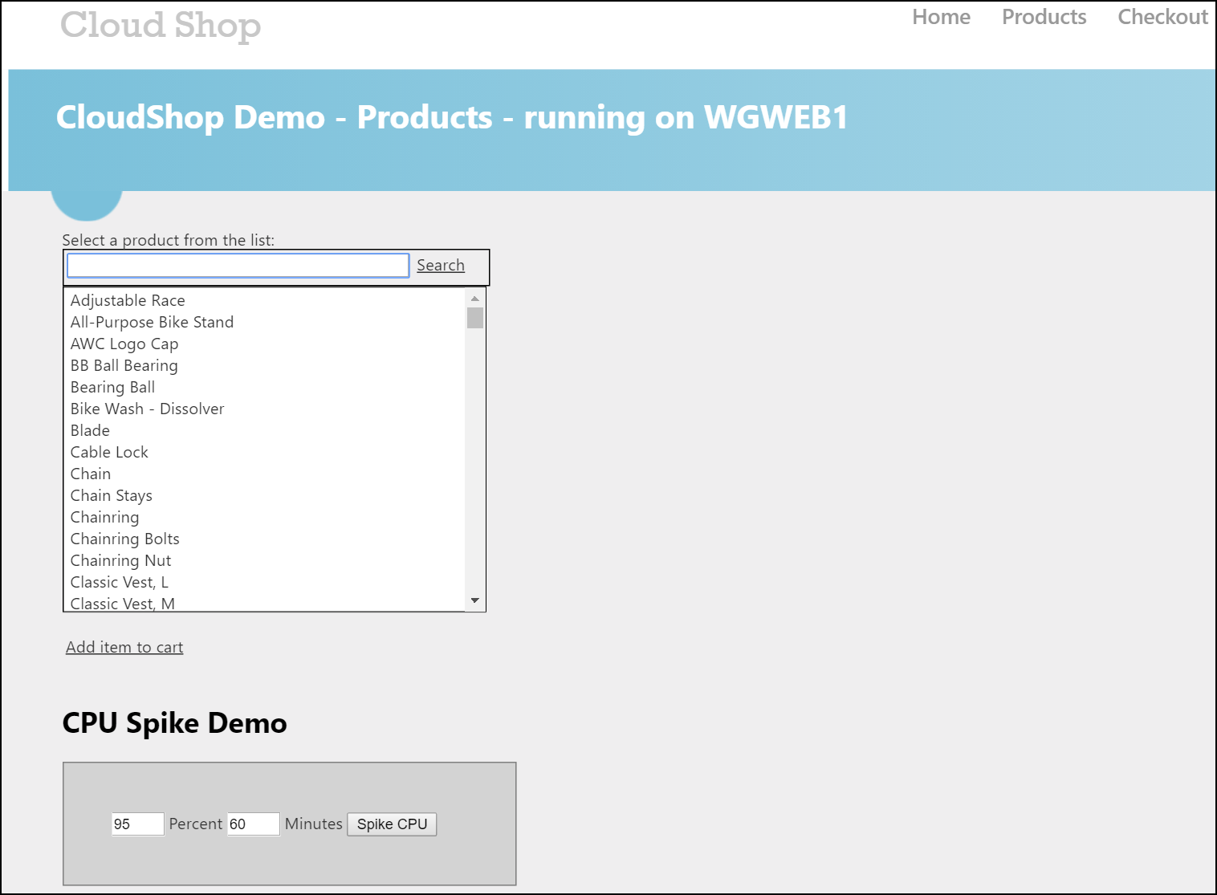

1. After the website is validated, remove the public IP addresses from the web servers.

### Exit criteria

* Two IIS-based web servers deployed in the Web tier subnet.
* One SQL server deployed in the Data tier subnet
* One internal load balancer with a static IP address deployed in the Web tier subnet, and configured with:
  + A backend pool containing both web servers
  + An HTTP health probe (checking website availability on both web servers)
  + A load balancing rule directing traffic to both web servers
* A functional CloudShop web application, accessible from both web servers and from the load-balancer internal IP (this will be validated later when access is made available through the firewall).

## Tack 4: Build the management station

### Tasks to complete

* Provision a server in the management subnet. This server will be used as a ‘jump box’ allowing administrators to RDP to other Azure-based servers from it. The server should not have a public IP address since RDP access will be accomplished using NATting through the firewall appliance (configured in a later task).

### Exit criteria

* A server is provisioned in the management subnet to function as a management station.

## Task 5: Provision and configure partner firewall solution

### Tasks to complete

* Before provisioning the firewall solution, associate the route tables created in Task 2 with their corresponding subnets. This step causes the routes to actively direct traffic.
* Provision a partner firewall solution from the Azure Marketplace into the Perimeter subnet. For this PoC the firewall solution does not need to be an HA pair. A firewall with a single network interface is sufficient, as the Azure fabric will handle routing.
* The network interface assigned to the firewall must have both a public IP address and a private IP address. It is recommended to configure the public IP address as static.
* Note the network interface assigned to the firewall appliance must have IP Forwarding enabled.
* Configure partner firewall NATting and firewall rules to accomplish the following goals
  + Only one IP address is exposed to the Internet. All other servers in the environment should **not** have public IP addresses at this point.
  + CloudShop website is accessible from the Internet, served from the internal load-balancer IP (NATted through the firewall)
  + From the Internet, RDP access will only be available to the management station. RDP access to the Azure-based servers from the management station will be enabled.

At this point, if all tasks are accomplished, remove any public IP addresses from all servers with the exception of the firewall appliance.

### Exit criteria

* A partner firewall appliance is provisioned into a perimeter subnet with a single network interface (IP forwarding enabled).
* Appropriate NAT and firewall rules are in place to allow:
  + Internet connectivity over HTTP to the internal CloudShop application, served from the internal load balancer (should see both server names after several page refreshes). See the following screenshot for more details.

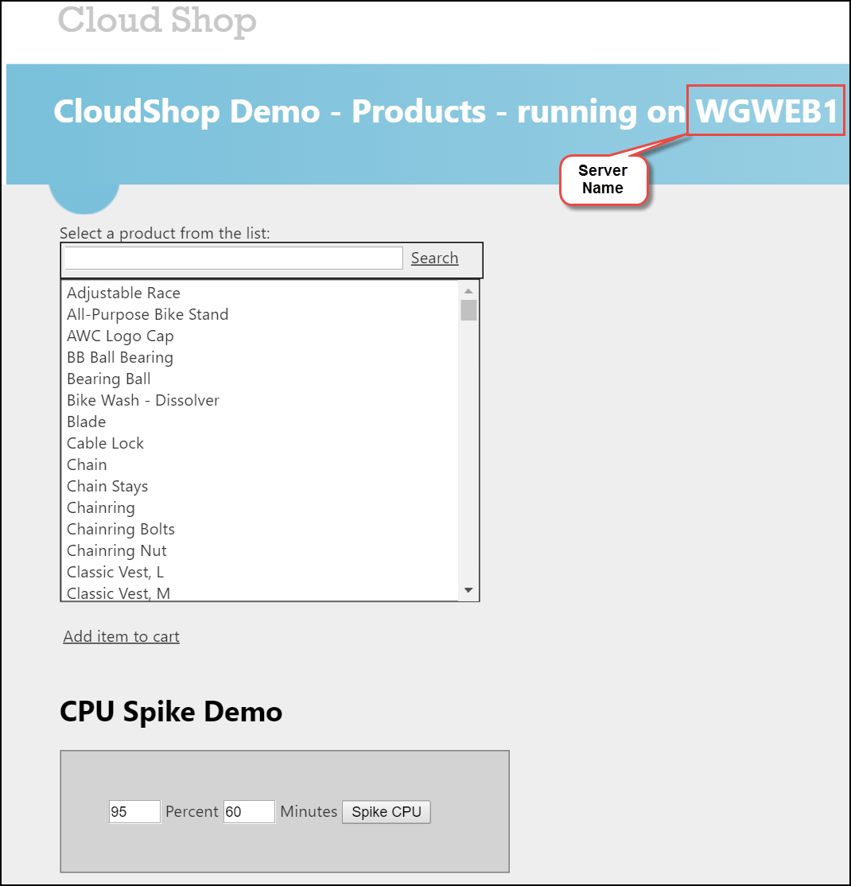

* + RDP access from the Internet to the management station
  + RDP access to all Azure-based servers in this solution from the management station only.

## Task 6: Site-to-site connectivity

### Configure another Azure virtual network

In this task, we will set up another virtual network in a separate Azure region. This will simulate an on-premises connection. Then we will connect the two virtual networks via a site-to-site connection. Finally, we will set up a virtual machine in the new virtual network to simulate on-premises connectivity to the internal load-balancer.

* Create a new Azure virtual network in a separate Azure region. This VNet only needs a single subnet.
* Create a Site-to-Site connection between the two virtual networks.
* Create a route table with appropriate route rules to direct VNet to VNet traffic to the firewall appliance configured earlier.
* Create a virtual machine in this new virtual network. It should have a public IP address enabling direct RDP connectivity to it.

### Exit criteria

* One new Azure virtual network with a single subnet
* Site-to-site connectivity between the VNets
* One route table with appropriate routes associated with the subnet just created
* From the VM in your ‘on-premises’ VNet, validate that you can browse to the internal load balancer IP address, through a NAT configuration on the firewall, and see the CloudShop application.

# Enterprise-class Networking in Azure Hackathon answers

## Overview

This portion of the lab is designed to help *only* if you are blocked or do not have any experience with Azure tools or services.

## Task 1: Create a virtual network and provision subnets

1. In the Azure Portal, click on **New** and in the list of Marketplace categories click **Networking**. Then click on **Virtual Network**. See the following screenshot for more details.

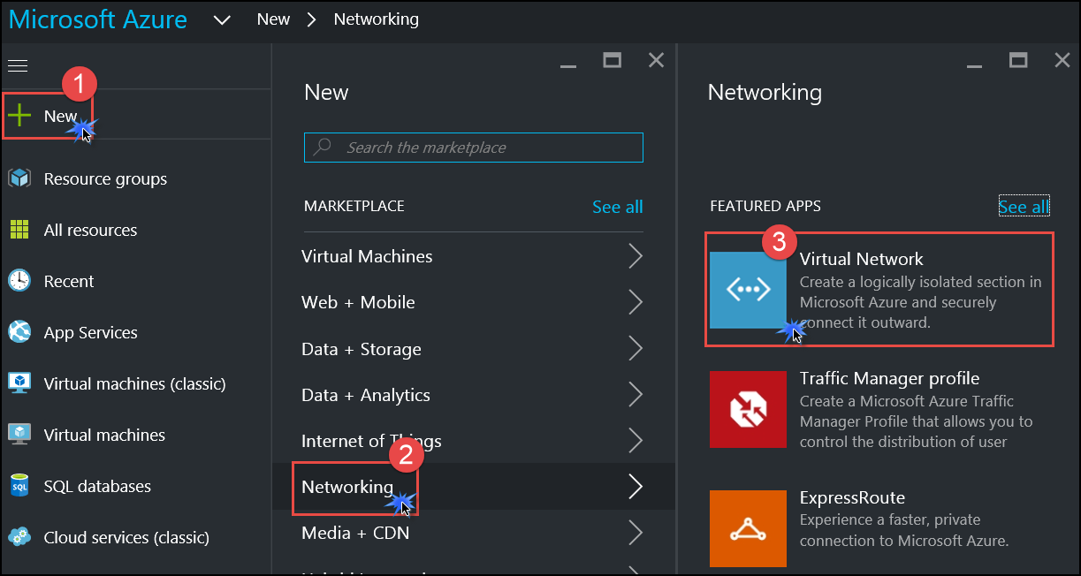

1. On the **Virtual Network** marketplace offer, ensure **Resource Manager** is the selected deployment model, and then click **Create**. See the following screenshot for more details.

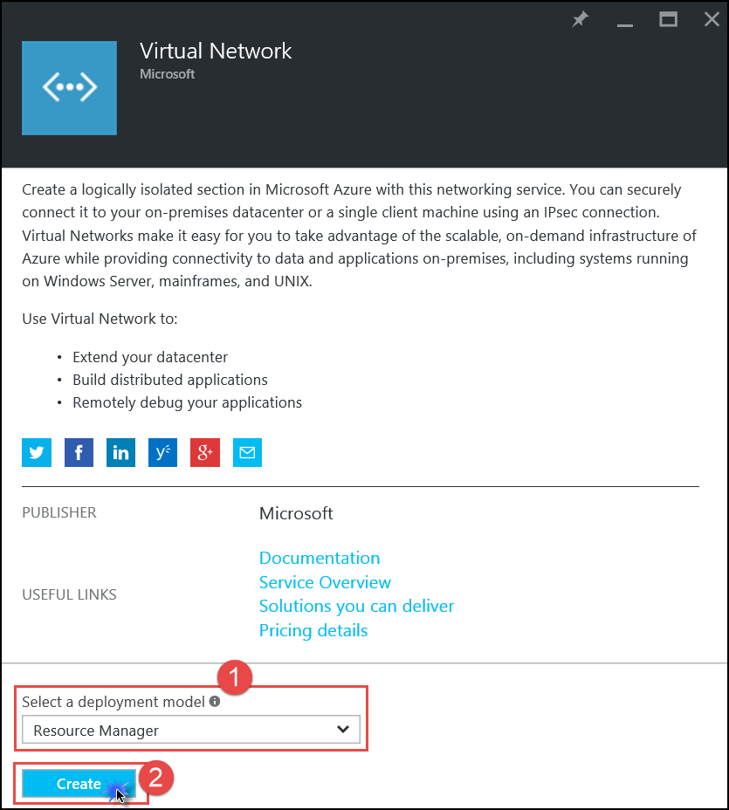

1. On the **Create virtual network** blade, enter the following information:
   1. Name: **WGVNet**
   2. Address space: **10.7.0.0/16**
   3. Subnet name: **Perimeter**
   4. Subnet address range: **10.7.0.0/29**
   5. Subscription: **Choose your subscription**
   6. Resource group: Select **Create new** and enter the name **WGVNetRG**
   7. Location: **West US**

When complete it should look like the following screenshot. Validate that the information is correct and click **Create**.

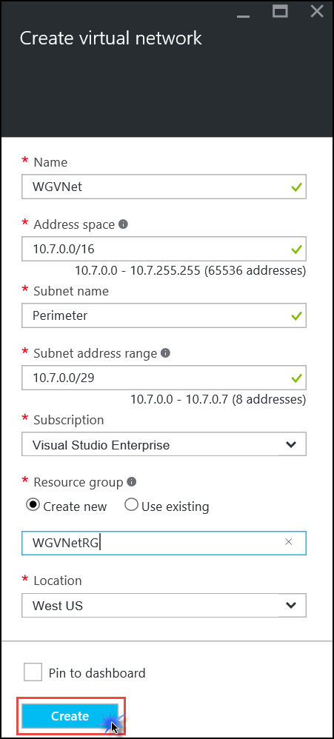

1. Monitor the deployment status by clicking on the **Notifications** button in the portal. In a minute or so, you should see a confirmation of the successful deployment.

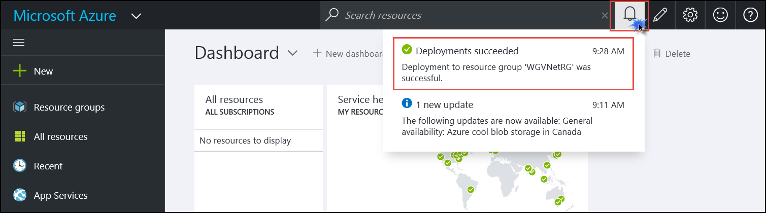

1. Open the properties of the virtual network by clicking on **More services** and typing **virtual network** into the search window. Click the option in the list called **Virtual networks**.

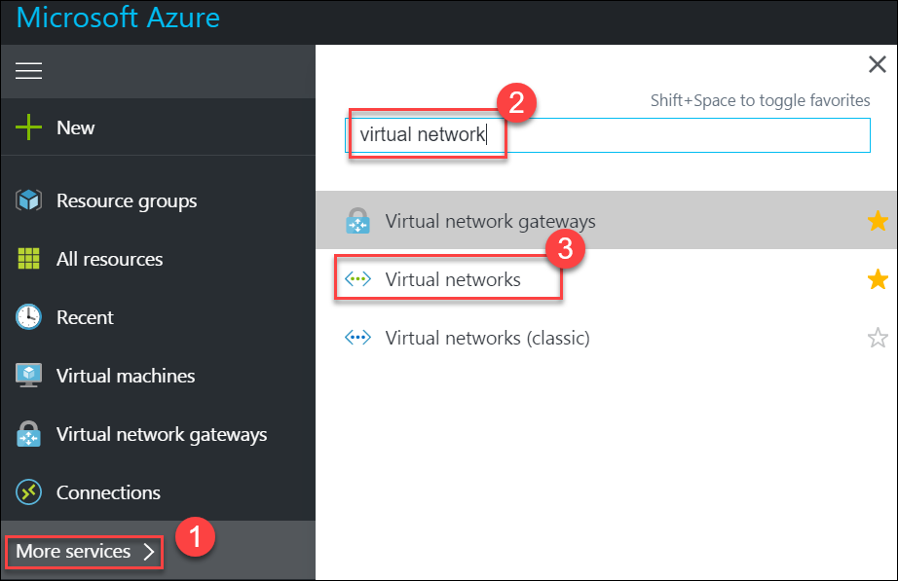

1. Click on **WGVNet** to open its **Essentials** and **Settings** blades.

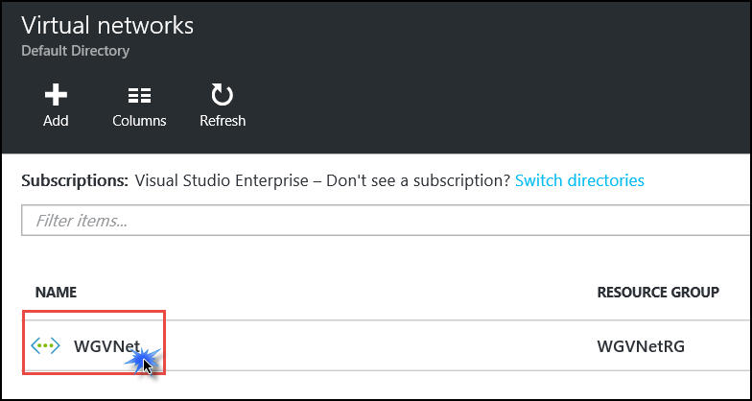

1. On the **Settings** blade click on **Subnets**.

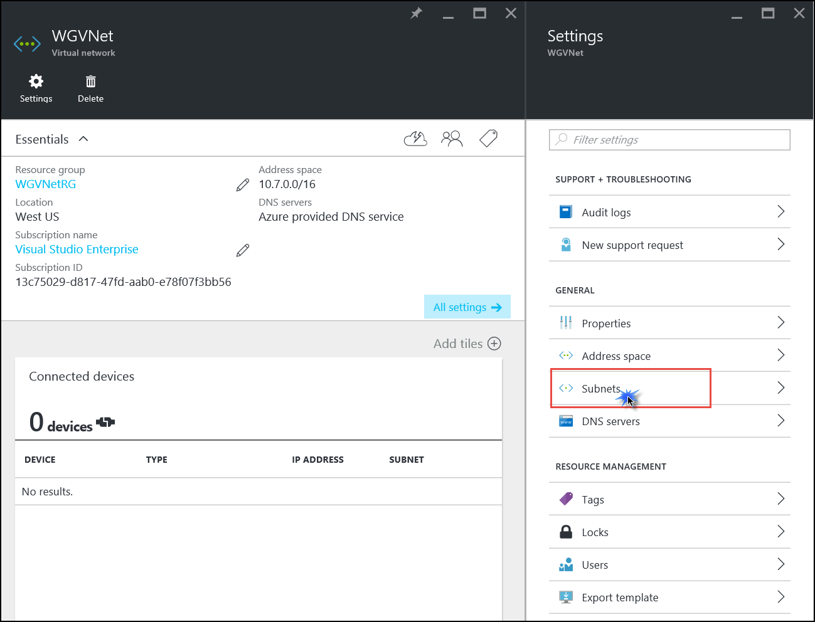

1. In the **Subnets** blade click on the icon to add a subnet

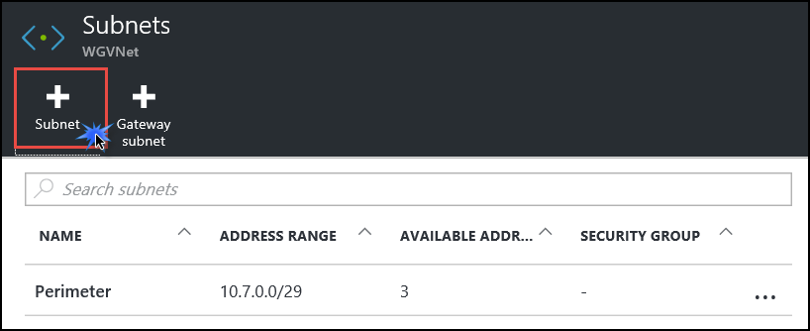

1. On the **Add subnet** blade enter the following information:
   1. Name: **Management**
   2. Address range: **10.7.0.8/29**
   3. Network security group: **None**
   4. Route table: **None**

When your dialog looks like the following screenshot, click **OK** to create the subnet.

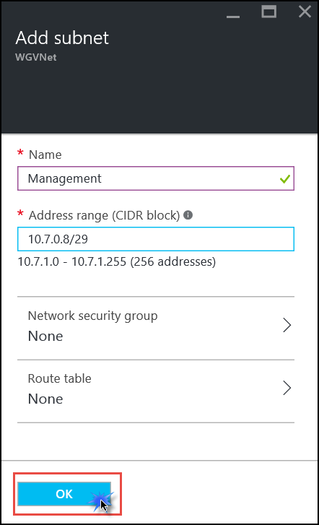

1. Repeat steps 8 and 9 to create the **WebTier** subnet.
   1. Name: **WebTier**
   2. Address range: **10.7.1.0/24**
   3. Network security group: **None**
   4. Route table: **None**
2. Repeat steps 8 and 9 to create the **DataTier** subnet.
   1. Name: **DataTier**
   2. Address range: **10.7.2.0/24**
   3. Network security group: **None**
   4. Route table: **None**

The end result should look like the following screenshot. Take special note of the highlighted section:

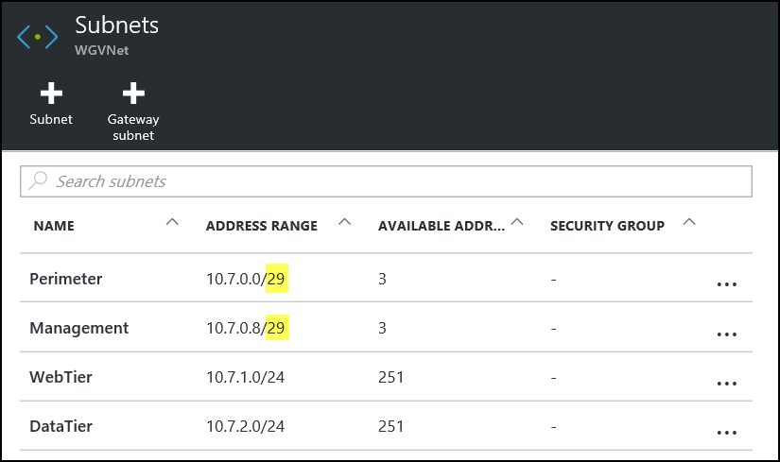

## Task 2: Create route tables

Route Tables are containers for User Defined Routes (UDRs). The route table is created and associated with a subnet. UDRs allow you to direct traffic in ways other than normal system routes would. In this case, UDRs will direct traffic from ‘internal’ subnets to the firewall appliance.

1. On the main portal menu to the left, click **More services**, located at the bottom of the menu. Type **route** into the search box and click on **Route tables**.

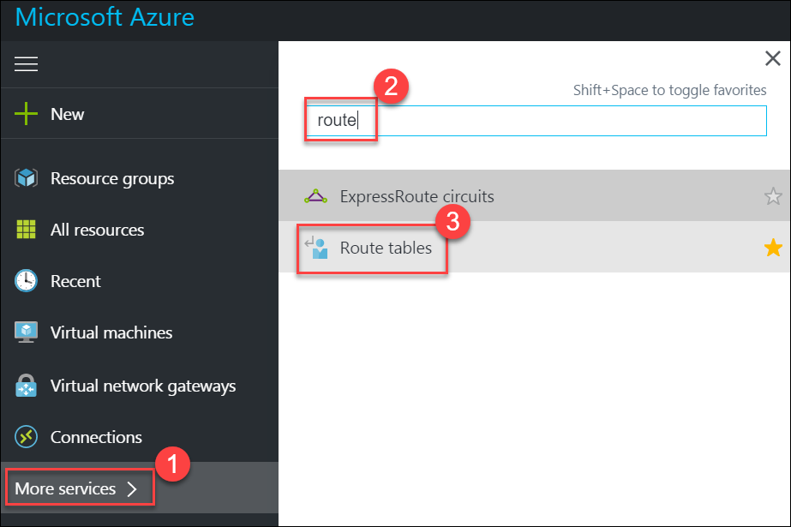

1. On the **Route tables** blade click **Add**.

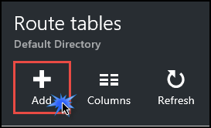

1. On the **Route table** blade enter the following information:
   1. Name: **MgmtRT**
   2. Subscription: **Choose your subscription**
   3. Resource group: Select **Use existing**, click the drop down menu and select **WGVNetRG**
   4. Location: **West US**

When the dialog looks like the following screenshot, click **Create**.

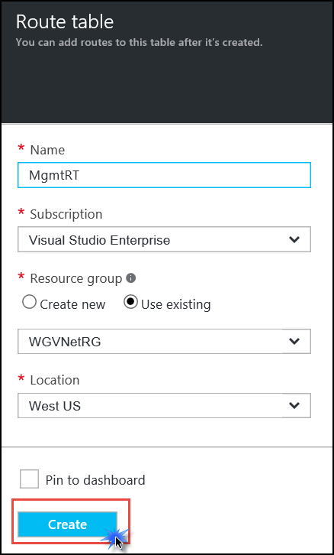

1. After a few seconds, if the new route table does not show in the portal, click **Refresh**.

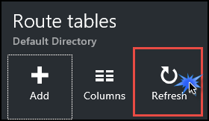

1. After you see the route table you created, complete steps 2 and 3 again to create the **DataRT** route table:
   1. Name: **DataRT**
   2. Subscription: **Choose your subscription**
   3. Resource group: Select **Use existing**, click the drop down menu and select **WGVNetRG**
   4. Location: **West US**
2. After you see the **DataRT** route table created (you may need to click **Refresh** again), complete steps 2 and 3 again to create the **WebRT** route table:
   1. Name: **WebRT**
   2. Subscription: **Choose your subscription**
   3. Resource group: Select **Use existing**, click the drop down menu and select **WGVNetRG**
   4. Location: **West US**
3. After all route tables are created your **Route tables** blade should look like the following screenshot:

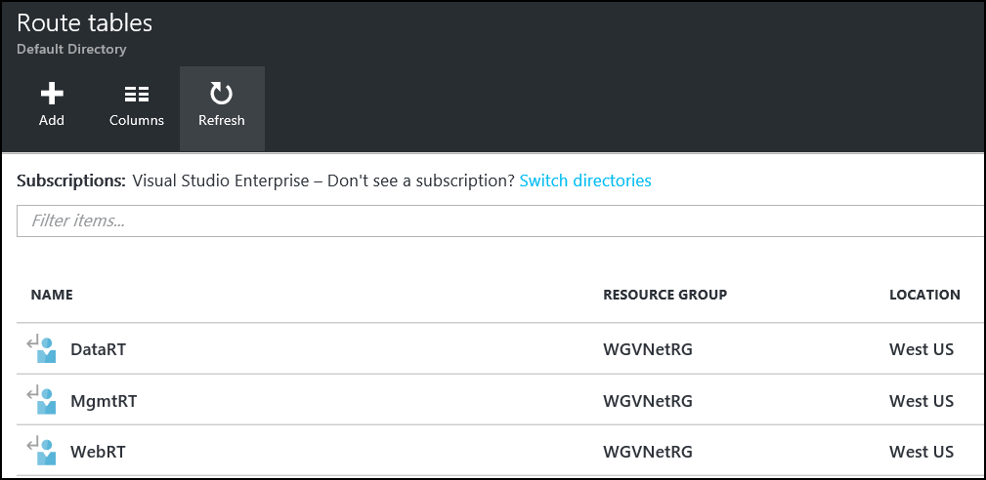

## Task 3: Add routes to each route table

1. Add routes to each route table. Click on the **DataRT** route table. This will open the **Essentials** and **Settings** blades. On the **Settings** blade, click **Routes**.

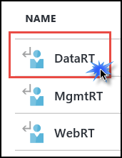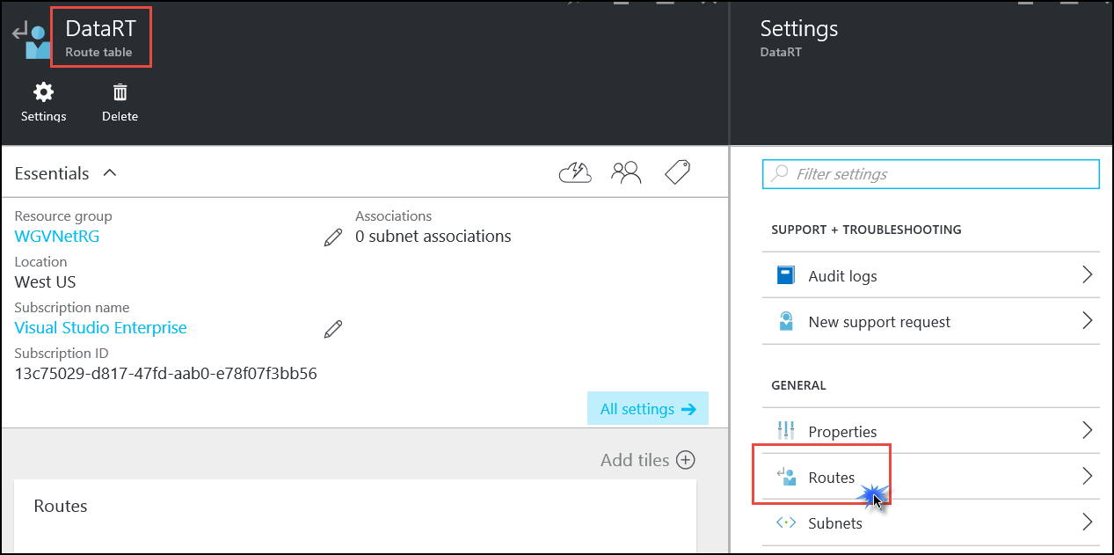

1. On the **Routes** blade, click the **Add** button. Enter the following information then click **OK**:
   1. Route name: **DataToInet**
   2. Address prefix: **0.0.0.0/0**
   3. Next hop type: **Virtual appliance**
   4. Next hop address: **10.7.0.4**
2. Complete step 2 to add the **DataToMgmt** route using the following information:
   1. Route name: **DataToMgmt**
   2. Address prefix: **10.7.0.8/29**
   3. Next hop type: **Virtual appliance**
   4. Next hop address: **10.7.0.4**
3. Complete step 2 to add the **DataToWeb** route using the following information:
   1. Route name: **DataToWeb**
   2. Address prefix: **10.7.1.0/24**
   3. Next hop type: **Virtual appliance**
   4. Next hop address: **10.7.0.4**

When complete your routes in the DataRT route table should look like the following screenshot:

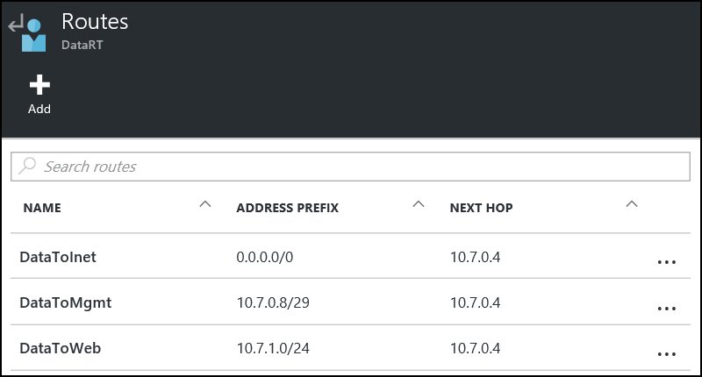

1. Using the breadcrumb menu at the top of the portal, click on **Route tables** to go back to that blade.



1. Click on **WebRT**. The **Essentials** and **Settings** blades will open. On the **Settings** blade, click **Routes**.

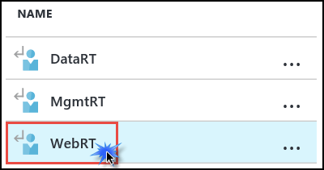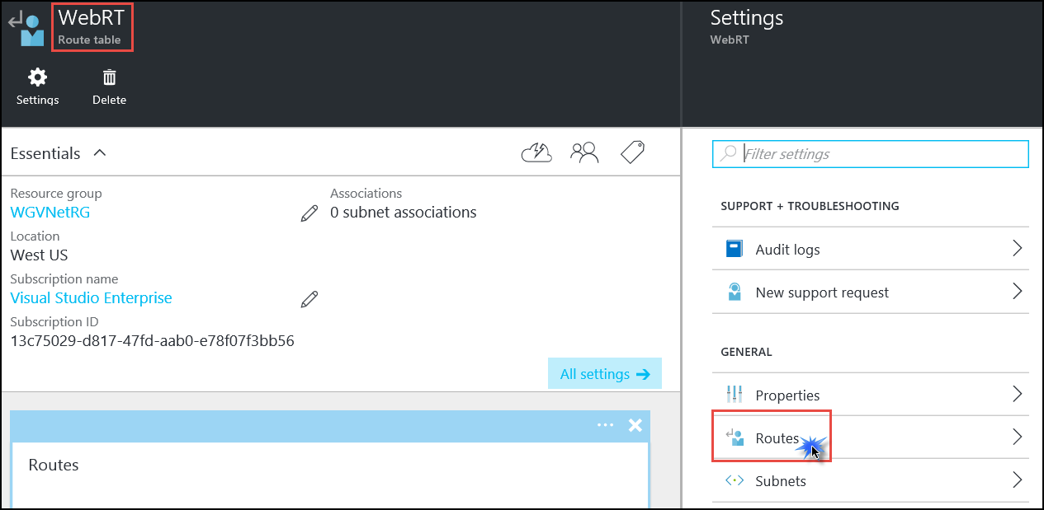

1. On the **Routes** blade, click the **Add** button. Enter the following information then click **OK**:
   1. Route name: **WebToInet**
   2. Address prefix: **0.0.0.0/0**
   3. Next hop type: **Virtual appliance**
   4. Next hop address: **10.7.0.4**
2. Complete step 7 to add the **WebToData** route using the following information:
   1. Route name: **WebToData**
   2. Address prefix: **10.7.2.0/24**
   3. Next hop type: **Virtual appliance**
   4. Next hop address: **10.7.0.4**
3. Complete step 7 to add the **WebToMgmt** route using the following information:
   1. Route name: **WebToMgmt**
   2. Address prefix: **10.7.0.8/29**
   3. Next hop type: **Virtual appliance**
   4. Next hop address: **10.7.0.4**

When complete your routes in the **WebRT** route table should look like the following screenshot:

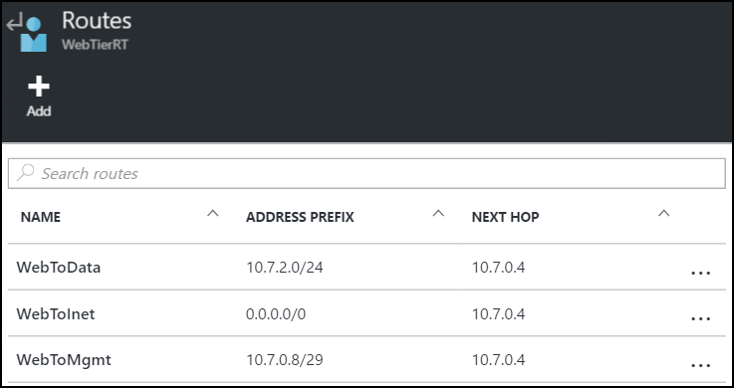

1. Using the breadcrumb menu at the top of the portal, click on **Route tables** to go back to that blade.



1. Click on **MgmtRT**. The **Essentials** and **Settings** blades open. On the **Settings** blade, click **Routes**.

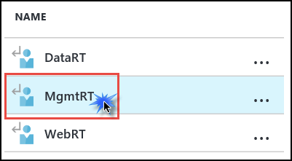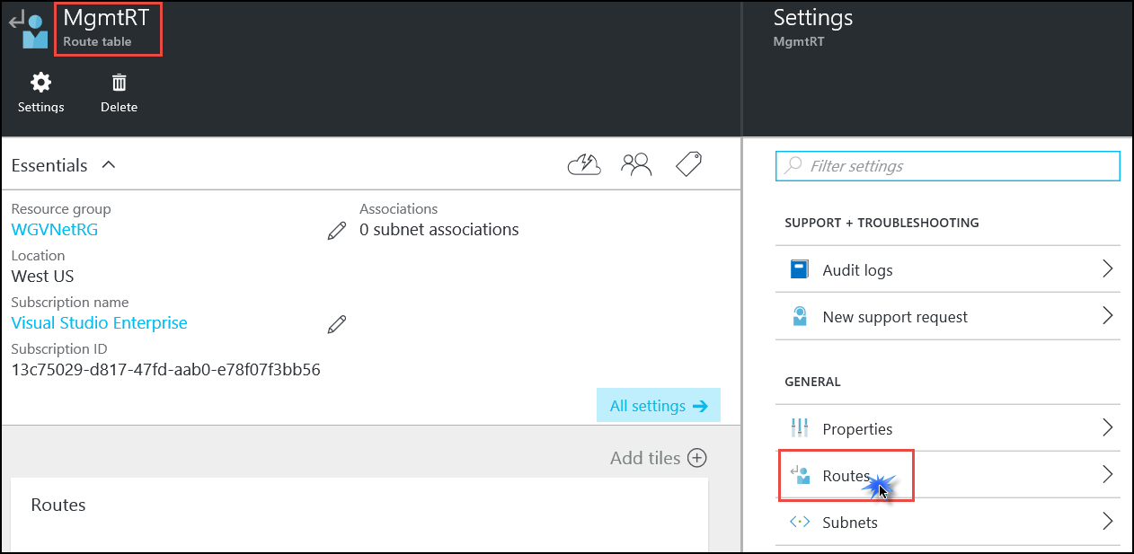

1. On the **Routes** blade, click the **Add** button. Enter the following information then click **OK**:
   1. Route name: **MgmtToInet**
   2. Address prefix: **0.0.0.0/0**
   3. Next hop type: **Virtual appliance**
   4. Next hop address: **10.7.0.4**
2. Complete step 12 to add the **MgmtToData** route using the following information:
   1. Route name: **MgmtToData**
   2. Address prefix: **10.7.2.0/24**
   3. Next hop type: **Virtual appliance**
   4. Next hop address: **10.7.0.4**
3. Complete step 12 to add the **MgmtToWeb** route using the following information:
   1. Route name: **MgmtToWeb**
   2. Address prefix: **10.7.1.0/24**
   3. Next hop type: **Virtual appliance**
   4. Next hop address: **10.7.0.4**

When complete your routes in the **MgmtRT** route table should look like the following screenshot:

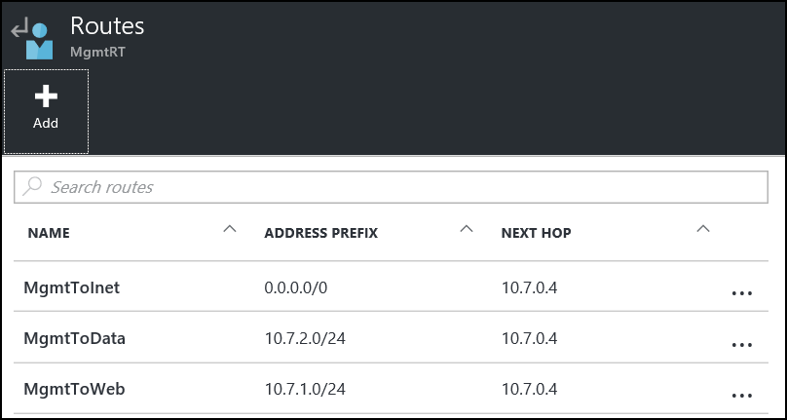

**Note:** The route tables and routes we have just created are not associated with any subnets yet, so they are not impacting any traffic flow yet. This will be accomplished later in the lab.

## Task 4: Create n-tier application and validate functionality

In this task, we will provision the Cloud Shop application. This application has a web tier and a data tier.

1. On the machine where you have Azure PowerShell installed, open an Internet browser and navigate to the following link: <https://opsgilityweb.blob.core.windows.net/cebootcamp-feb-2017/Enterprise%20Class%20Networking%20in%20Azure%20Hackathon%20-%20Student%20Files.zip>
2. This will download a zipped folder to your computer. Extract this compressed file into **C:\ECN-Hackathon**.

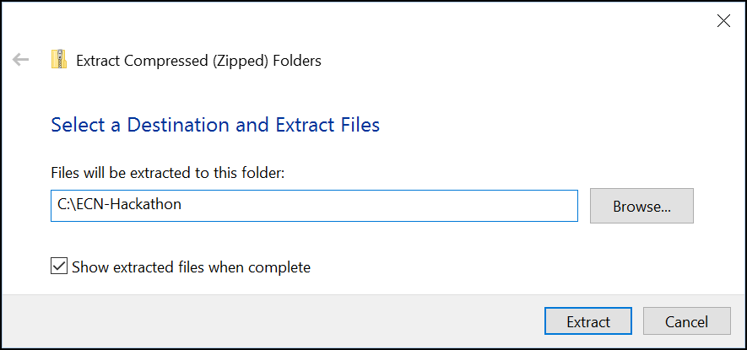

1. After the files are extracted, open the folder.
2. You should see a PowerShell script called **create-azure-vms.ps1**.
3. ***Right-click*** on the script and choose **Edit**.

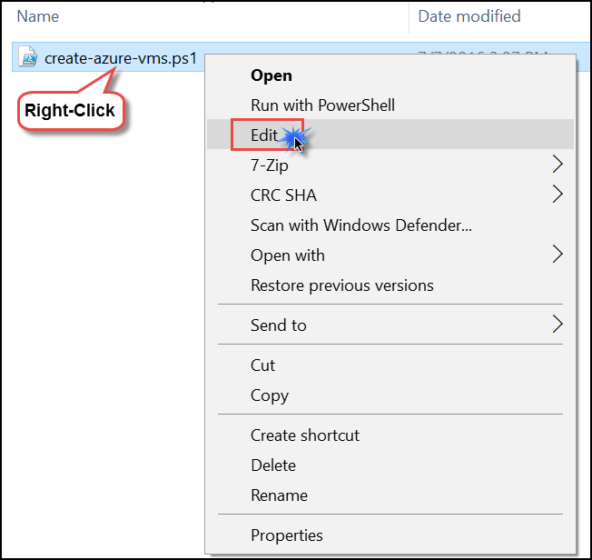

1. This will open **PowerShell ISE** (or the script editor configured on your system).
2. Within the console pane, set an execution policy that will allow the script to run, such as:

Set-ExecutionPolicy –ExecutionPolicy ByPass –Scope CurrentUser

1. On the **Execution Policy Change** pop up, click **Yes**.

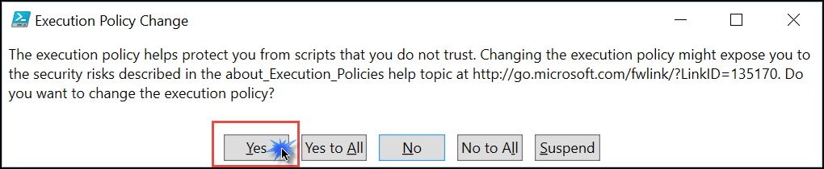

1. Take some time to review the script contents. It will create two web servers and one SQL server within your Azure subscription. These servers make up the 2-tier application we will use in our proof of concept environment.

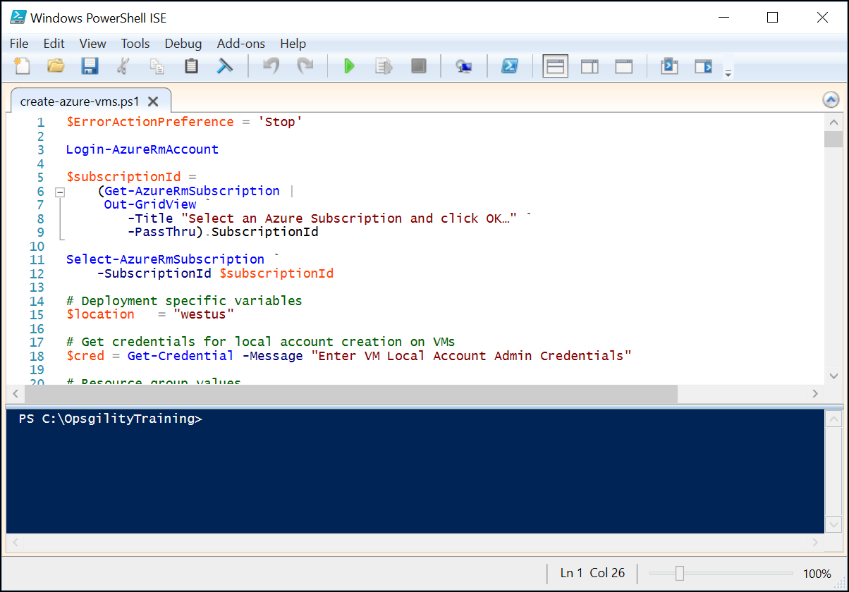

1. After reviewing the contents of the script, click on the green arrow or press your F5 key to run the script.

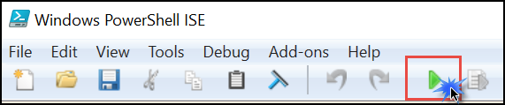

1. You will first be prompted to log in. Be sure to use the same credentials with which you logged into the Azure portal. After your credentials are entered, click **Sign in**.
2. You may be prompted to select whether the account is an organizational account or a personal account. If it is an account you created, it is probably a personal account. If your IT department created the account, it is likely an organizational account. Select the appropriate account type.

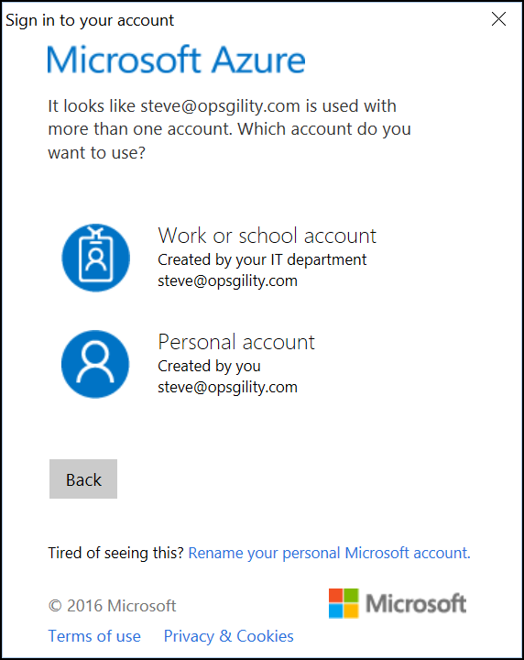

1. You will then be prompted to choose which subscription you would like to work with. You should select the same subscription where you created the virtual network and route tables earlier. With the correct subscription highlighted, click **OK**.

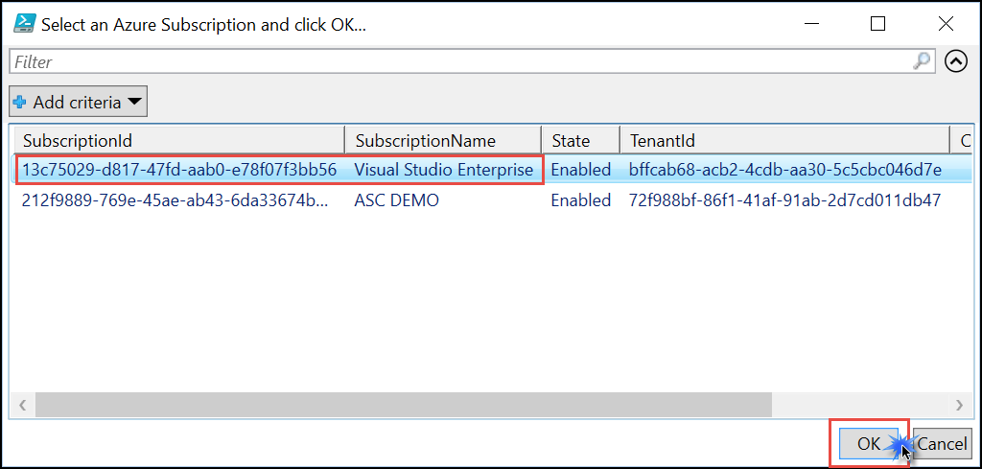

1. You will then be prompted for a new set of credentials. These will be used to create a local account on each VM. You will need these credentials to log on via RDP to your servers. Use the following data:
   1. User name: **demouser**
   2. Password: **demo@pass123**

Click **OK**.

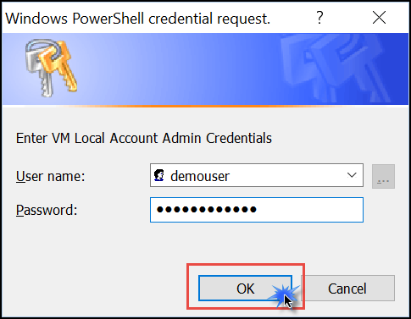

1. The rest of the script should proceed without further intervention. It will take approximately 30 minutes to complete.

## Task 5: Provision and configure partner firewall solution

In this section, we will provision and configure a pfSense firewall appliance in Azure. This appliance is offered as a ‘Free Trial’ but deployments with only a single CPU core are free. Our deployment will be using a single CPU core. However, ‘Free Trials’ in Azure require that your subscription does not have a spending cap in place and that a credit card is associated with your subscription. The first section under this task walks through removing a spending cap and associating a credit card with the subscription. If your subscription already has no spending cap and has a credit card associated with it, then you can skip the first section.

### Removing a spending cap and associating a credit card with your subscription

1. Navigate to the [Azure Account Center](https://account.windowsazure.com/Home/Index) and click on **Account Center** link. You may need to log on. If so, use the same credentials that you are using to log into the Azure portal.

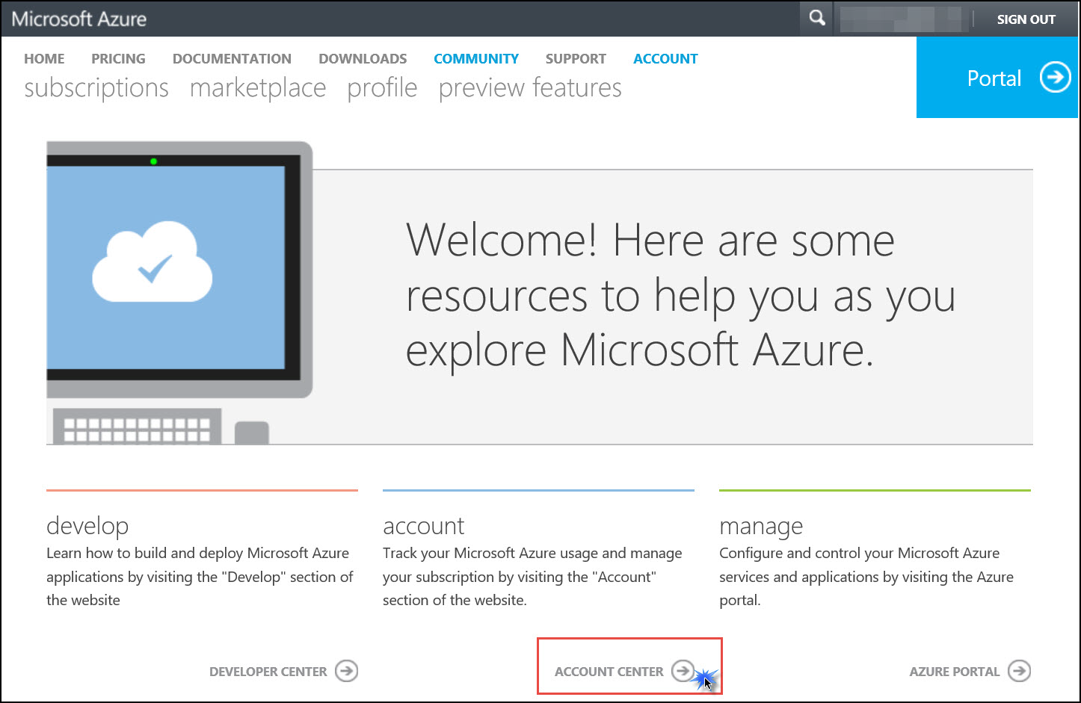

1. Here you will see your subscription and a message indicating it has a spending limit on it. Click to change this limit. See the following screenshot for details.

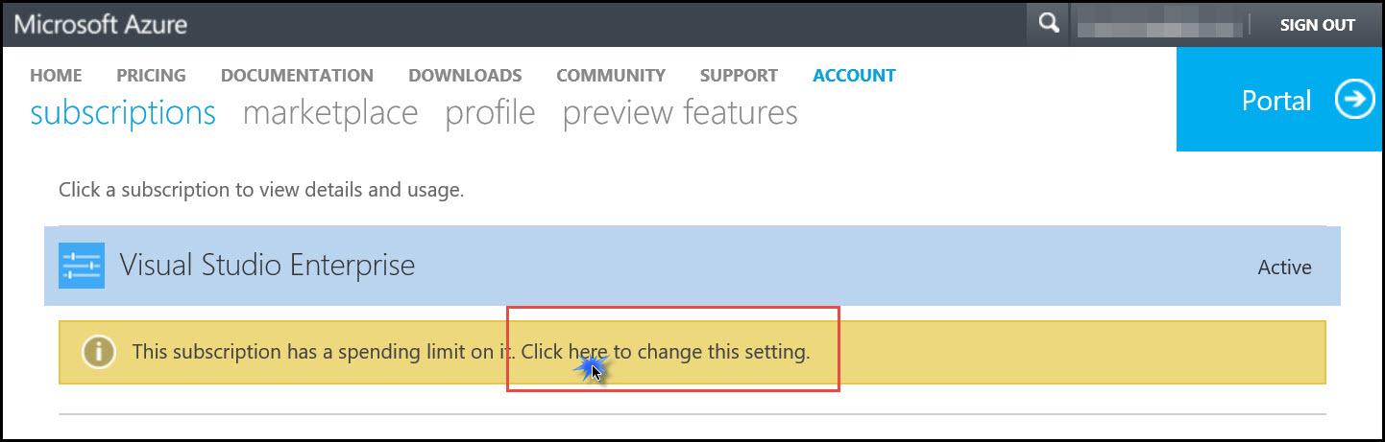

1. On the **Remove spending limit** dialog select **Yes, remove the spending limit** then choose which option is best for your needs. Then click **add payment method**.

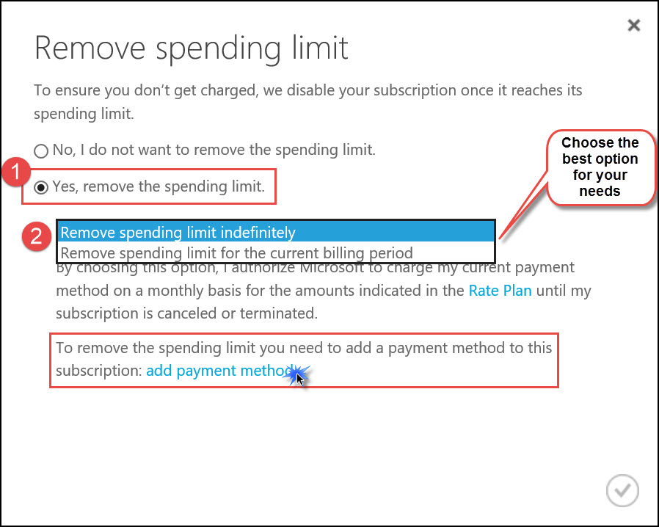

1. On the **Choose a payment method** dialog enter your credit card information and click **Next**.
2. Now the **Remove spending** limit dialog should reflect your credit card info. Click the check mark in the lower right.
3. After a few minutes, your subscription will reflect the new status.

Note**:** the credit associated with the subscription remains, and this will be consumed first.

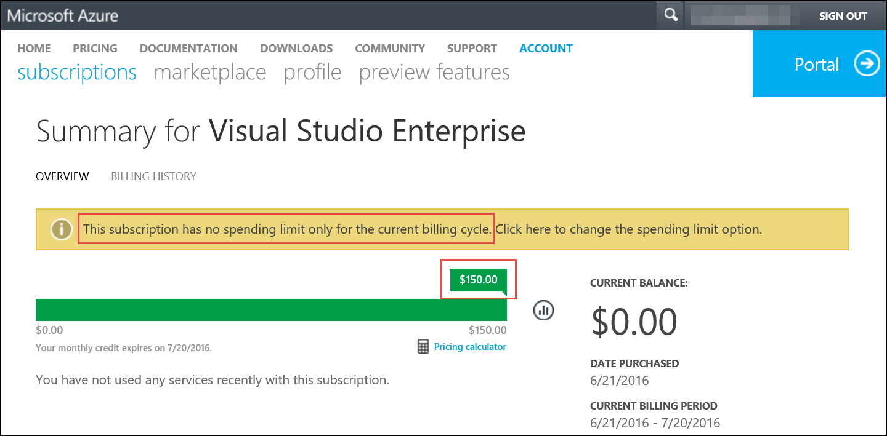

For a more thorough walkthrough of this process visit: <https://www.opsgility.com/blog/2016/06/21/azure-marketplace-free-trials-and-subscription-spending-limits/>

### Provision the firewall appliance

1. Within the Azure portal, click **New** in the upper left corner of the portal. In the search dialog type **pfSense** then press the **Enter** key on your keyboard.

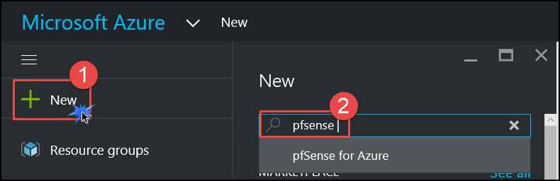

1. A list of Marketplace offers is returned. Find the one called **pfSense for Azure** and click that option.

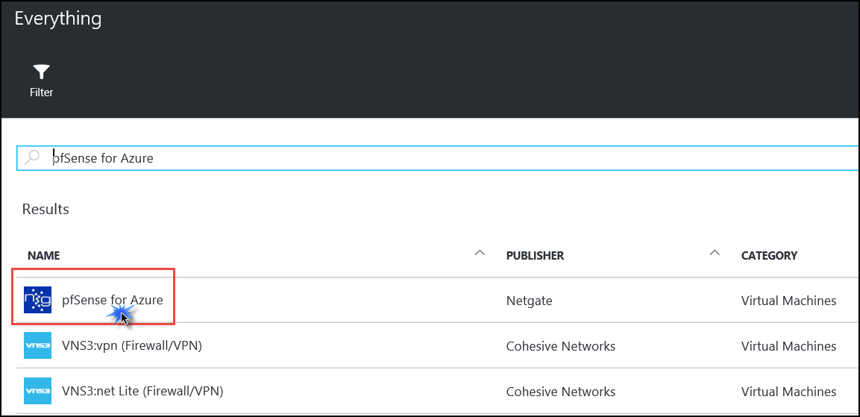

1. The marketplace description of the offer is returned. pfSense is offered as a free trial but deployments with only a single CPU core are free. Click **Create**.

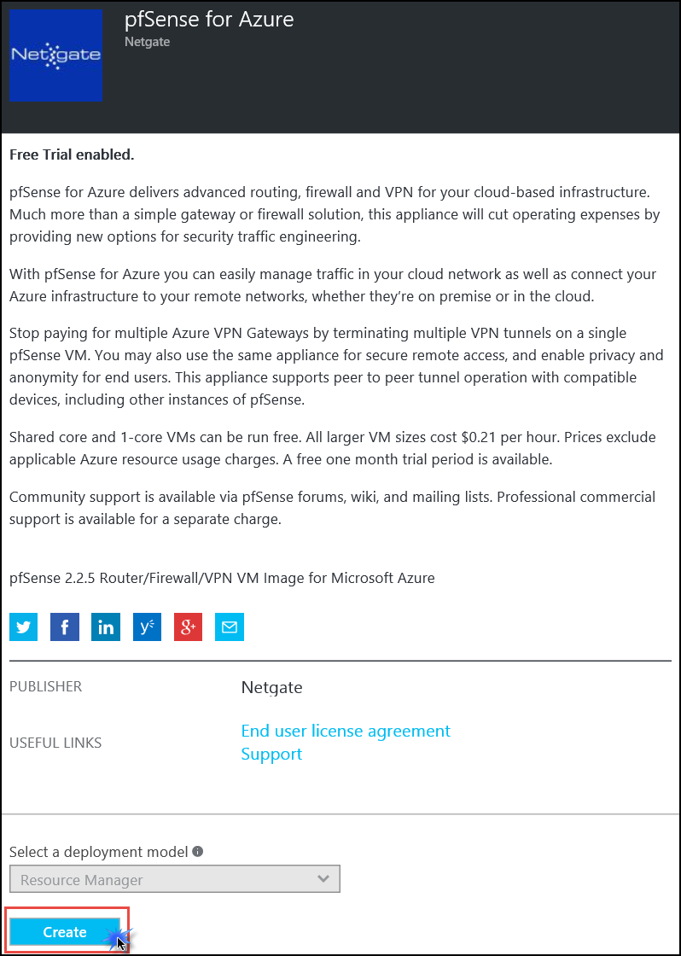

1. On the **Basics** blade, shown in the following screenshot, enter the following information:
   1. Name: **WGpfSense1**
   2. User name: **demouser**
   3. Authentication type: Select **Password**
   4. Password: **demo@pass123**
   5. Subscription: **Select your subscription**
   6. Resource group: Select **Create New** and enter the name **WGFWRG**
   7. Location: **West US**

Click **OK**.

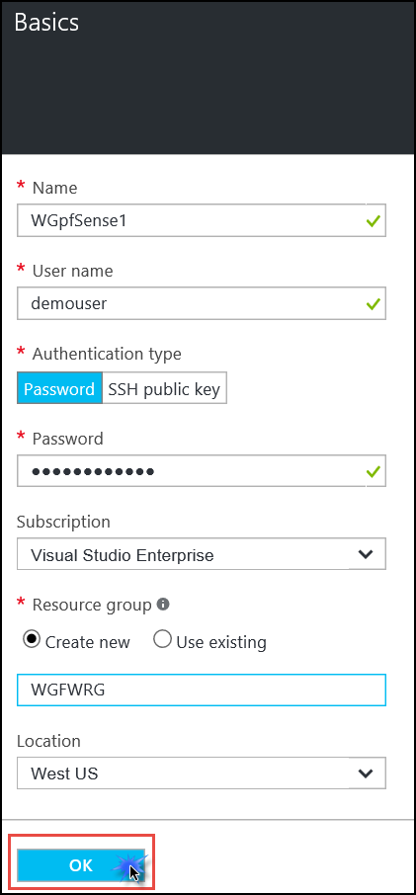

1. Choose the **D1_V2 Standard** instance size on the **Size** blade, and then click **Select** at the bottom of the blade.

**Note**: You may have to click the **View All** link to see the instance sizes.

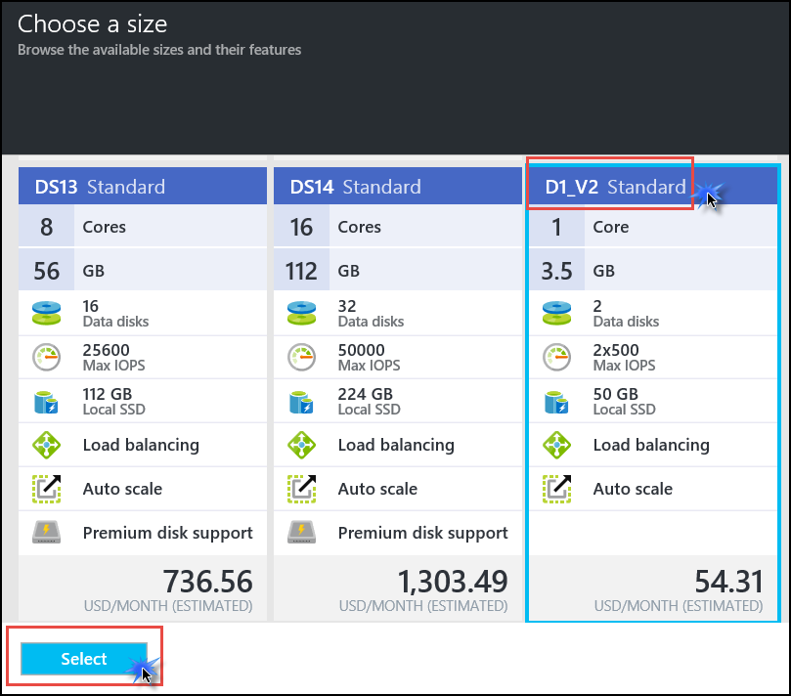

1. On the **Settings** blade click the virtual network name that was pre-populated.

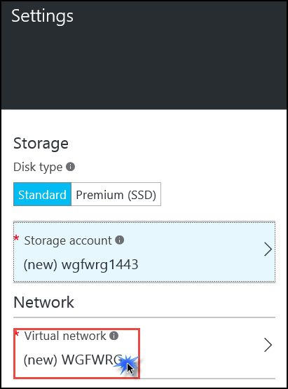

1. The **Choose virtual network** blade opens. Click on **WGVNet** to select the virtual network you created earlier in this Hackathon.

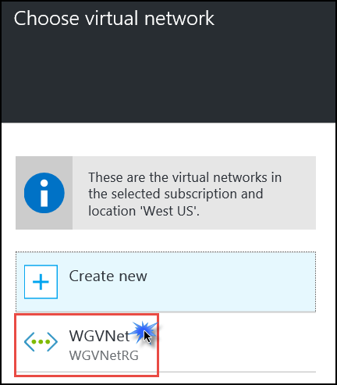

1. Back on the **Settings** blade, take note of the subnet that was selected. If it is not set to **Perimeter** then click on the subnet name and change it **Perimeter**.

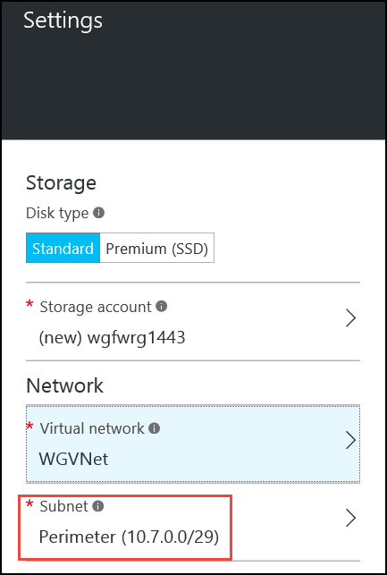

1. Back on the **Settings** blade, under **Public IP Address**, click on the name that was pre-assigned. This opens the **Choose public IP address** and **Create public IP address** blades. Change the name to **WGpfSense1PIP** and under **Assignment** select **Static**. Click **OK**.

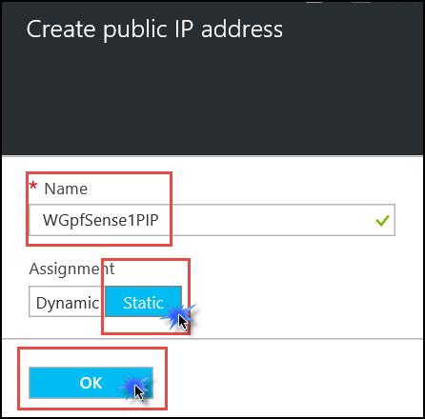

1. Back on the **Settings** blade, click the **Network security group** section, and in the **Choose network security group** blade, click **None**.

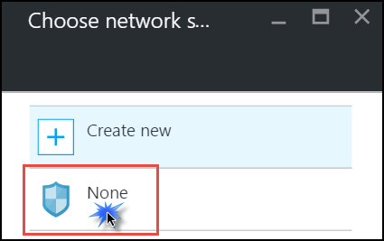

**Note**: This server is a hardened firewall that has built in security at the network layer. As such, an NSG is not required.

1. All remaining settings on the **Settings** blade are correct. Click **OK** to accept these settings.
2. On the **Summary** blade, ensure the validation passes, and then click **OK**.

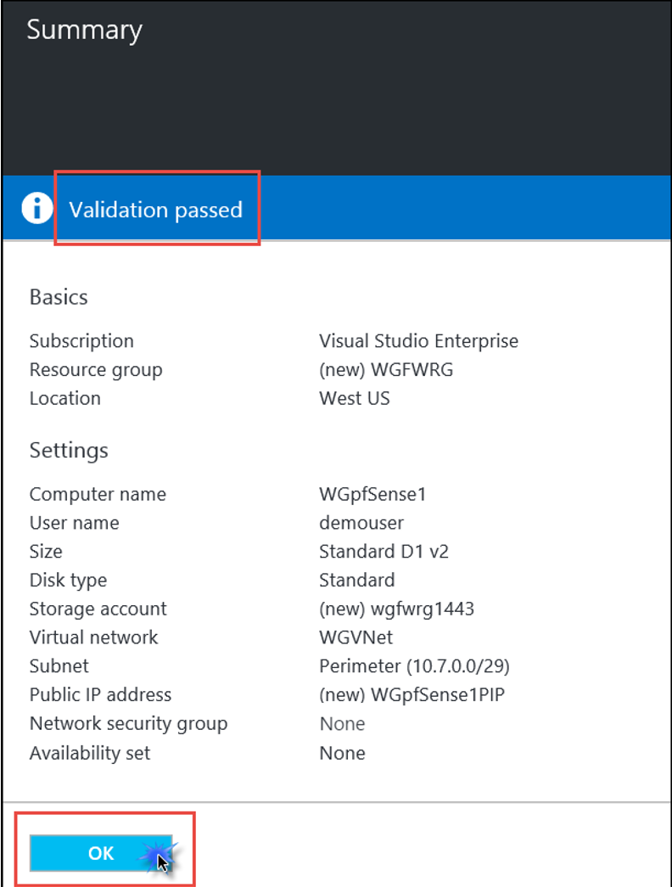

1. On the **Purchase** blade, note that the cost of Azure Marketplace partner offers have separate costs from the compute charges. Although the pfSense appliance is a ‘Free Trial’, it continues to be free (minus compute costs) as long as it is a single CPU core VM. After you have reviewed this information click **Purchase**.

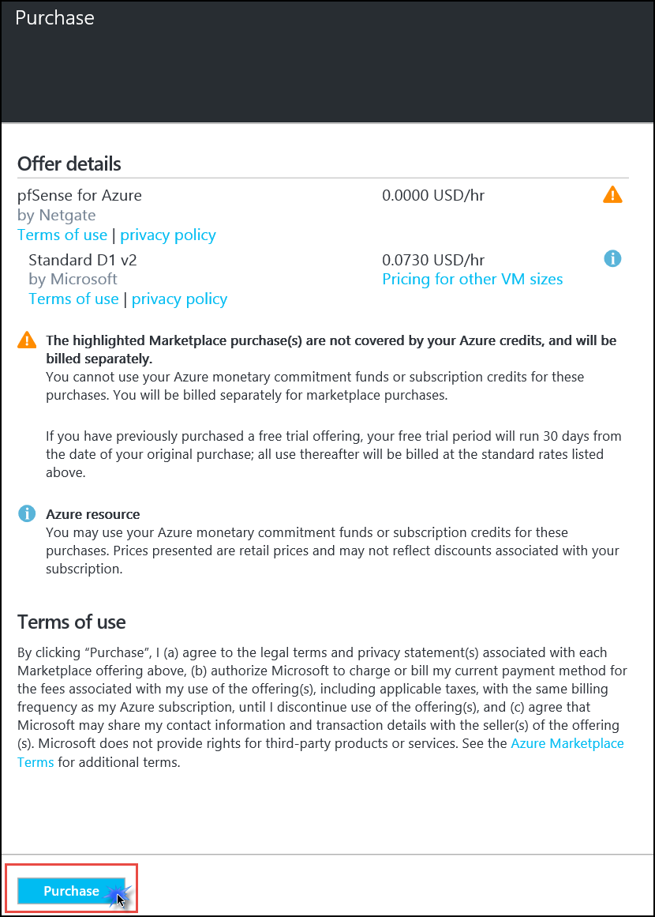

### Enable IP forwarding on the firewall network interface

Within 1-2 minutes, the resource group **WGFWRG** will be created and the appliance will be in the creation process. Next, we will edit settings on the network interface associated with the firewall.

1. On the main Azure menu click on **Resource groups**.

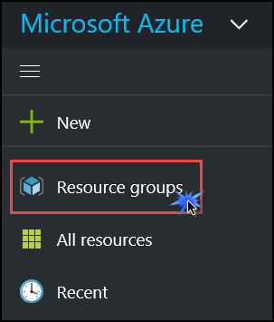

1. Click on the **WGFWRG** resource group. This resource group contains the objects associated with the firewall appliance. Click on the network interface.

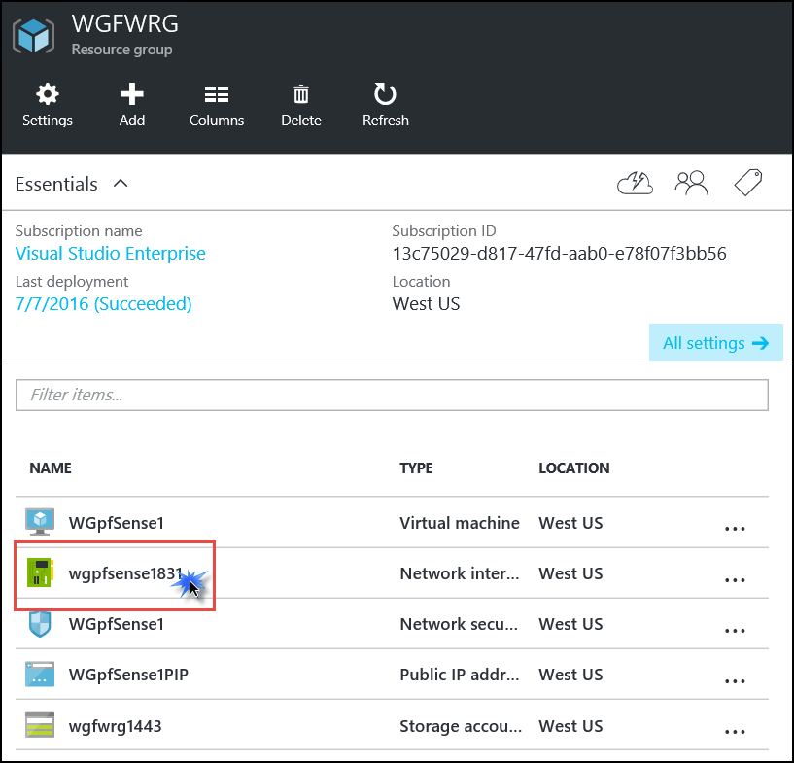

1. This opens the **Essentials** and **Settings** blade for the network interface. On the **Settings** blade click, **IP addresses**.

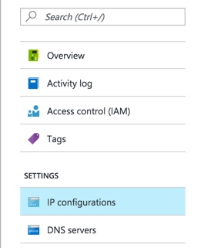

1. On the **IP configurations** blade scroll to the bottom and under **IP forwarding settings** click **Enabled**. Then click **Save** at the top of the blade.

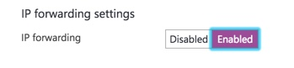

## Task 6: Build the management station

In this scenario, management of the Azure-based systems will only be available from a management ‘jump box.’ In this section, you will provision this server.

1. In the Azure portal click on the **New** button in the upper left of the portal. In the Marketplace category list, choose **Compute**. In the Featured Apps list, click **Windows Server 2012 R2 Datacenter**.

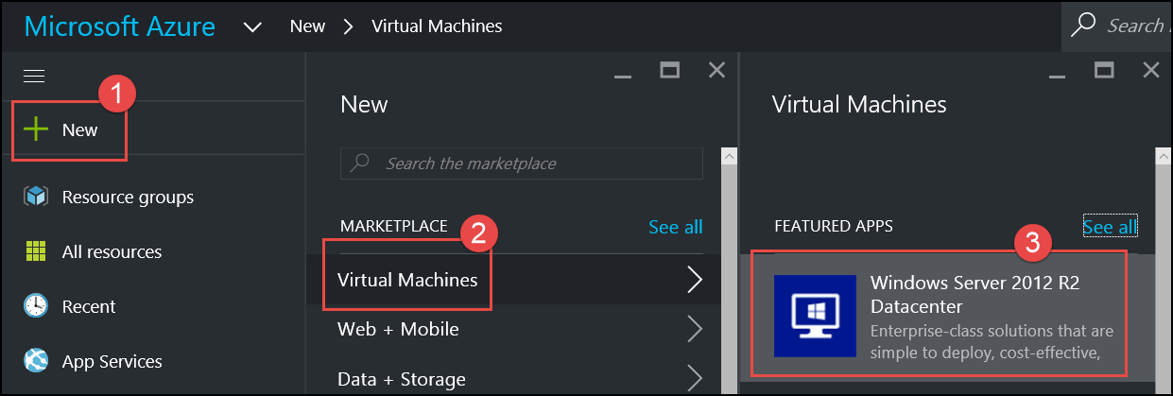

1. On the marketplace offer blade, ensure the deployment model is set to **Resource Manager** (this is the default option) and click **Create**.

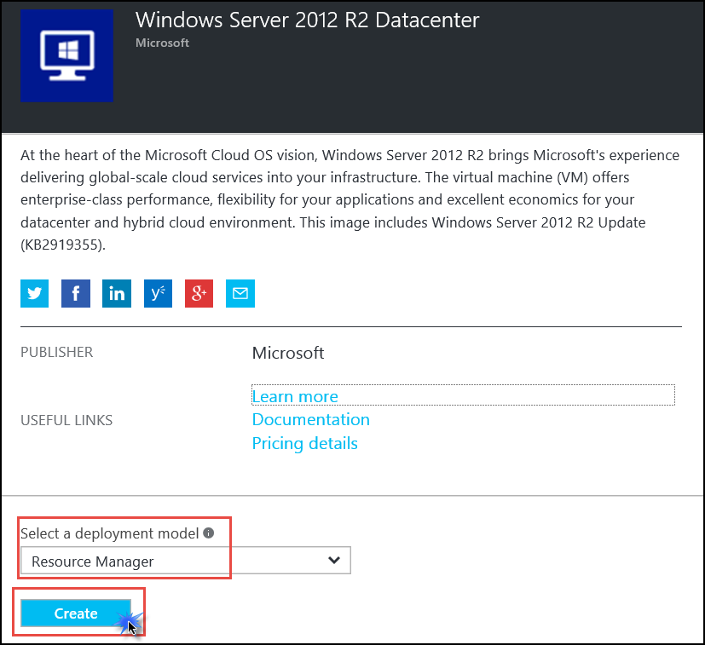

1. On the **Basics** blade, shown in the following screenshot, enter the following information and click **OK**.
   1. Name: **WGMGMT1**
   2. User name: **demouser**
   3. Password: **demo@pass123**
   4. Subscription: **Choose your subscription**
   5. Resource group: Choose **Create new** and enter **WGMGMTRG**
   6. Location: **West US**

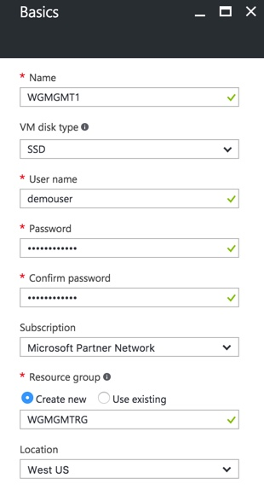

1. On the **Choose a size** blade click **F1** (you will need to click **View all** and scroll down to find the F1 size), then click **Select**.

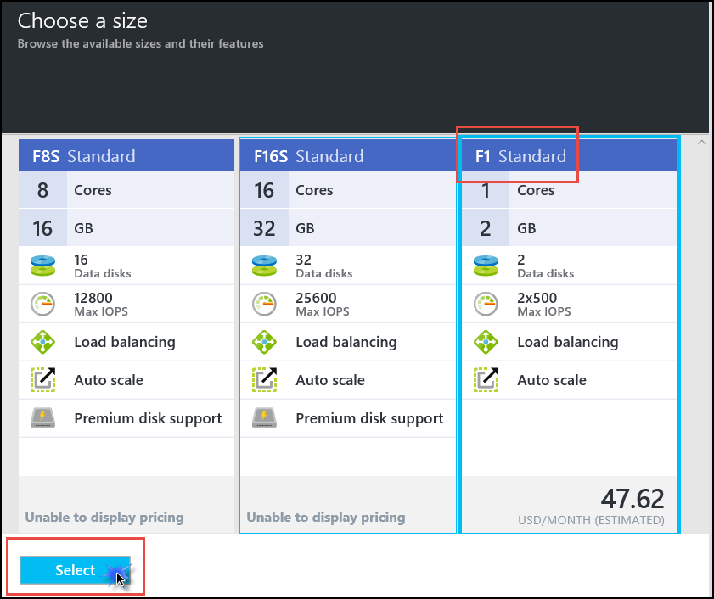

1. On the **Settings** blade click on the Virtual network section. On the **Choose virtual network** blade click on **WGVNet**.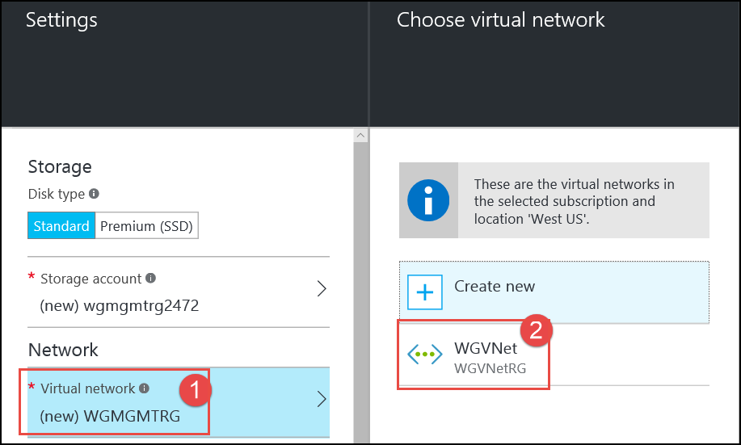
2. In the **Subnet** section, click the subnet that was chosen and choose **Management**.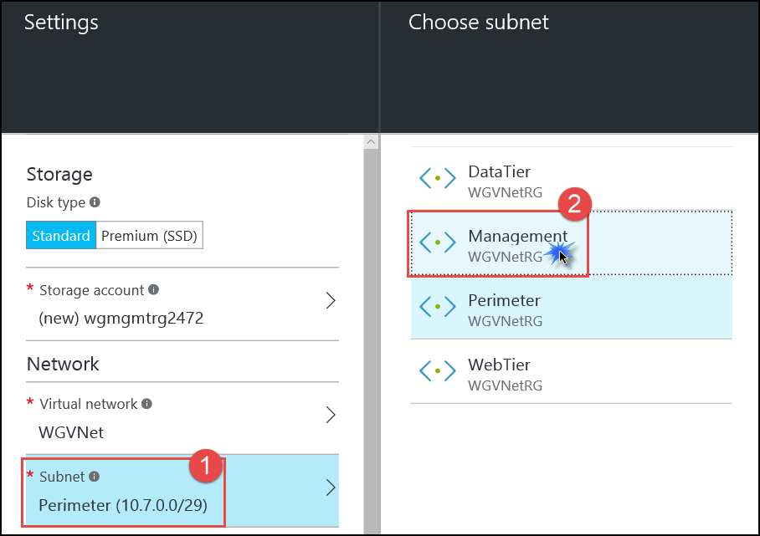
3. In the **Public IP address** section, click the name that was pre-populated, then click the **Choose public IP address** blade, and then click **None**.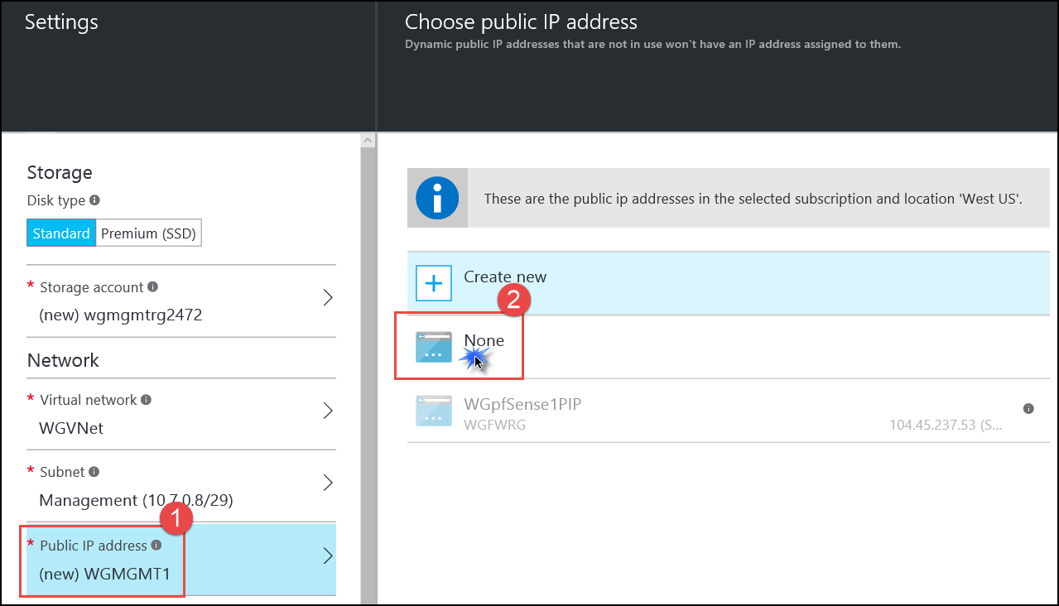
4. Click on the **Network security group** section, and in the **Choose network security group** blade, click **None**.



**Note:** Because this server has no Public IP address and is only accessible through a firewall, an NSG is not required.

1. The remaining sections of the **Settings** blade are correct. Click **OK**. See the following screenshot for details.

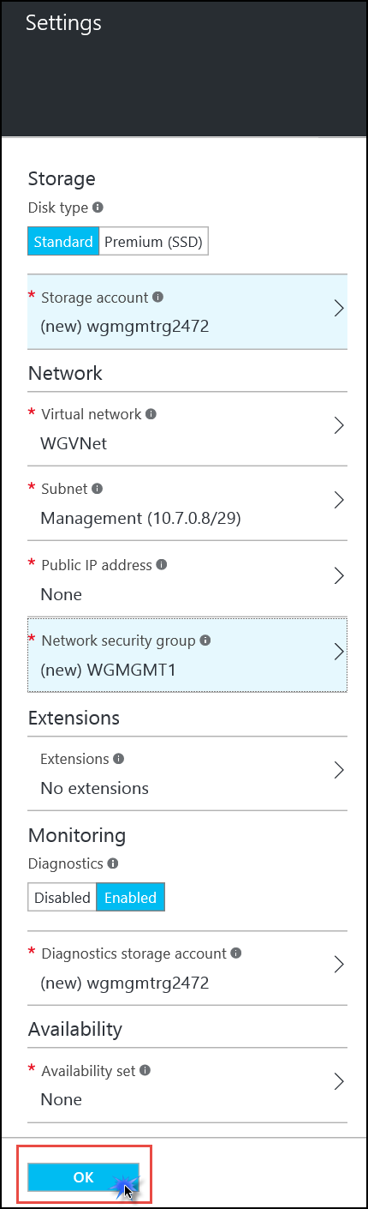

1. On the **Summary** blade, ensure the validation passes then click **OK**. The virtual machine will take 5-10 minutes to provision.

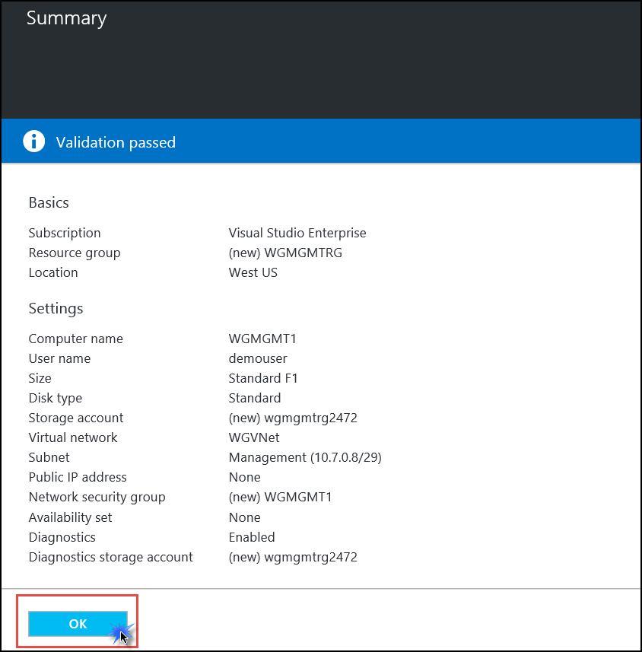

## Task 7 Complete the n-tier application configuration

### Use PowerShell DSC to customize the webservers and the SQL Server

In this section, we will use DSC configurations downloaded in an earlier section.

1. Open to the **WGVMRG** resource group by clicking **Resource Groups** and then clicking the resource group name.

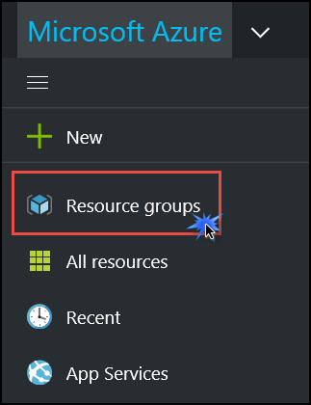

1. Click the **WGWEB1** virtual machine.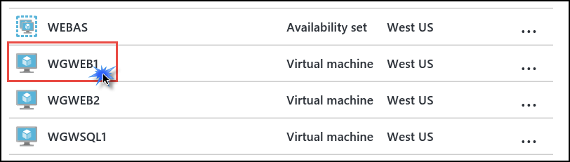
2. On the **Settings** blade, click **Extensions**.

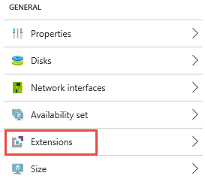

1. Click **Add** on the toolbar.



1. Click the **PowerShell Desired State Configuration** tile.

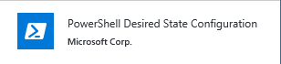

1. Click **Create**.
2. Specify the following configuration for the extension and click **OK**.

|  |  |
| --- | --- |
| For Configuration Modules or Script, browse to  **C:\ECN-Hackathon\WebConfig.zip**  Module-qualified Name of Configuration  **web-dsc-config.ps1\Main**  Version  **2.0**  Auto Upgrade Minor Version **Yes** |  |

1. Repeat steps 1-7 on **WGWEB2**.
2. Repeat steps 1-6 on **WGSQL1**, and then use the following settings for the extension configuration.

|  |  |
| --- | --- |
| For Configuration Modules or Script, browse to **C:\ECN-Hackathon \SQLConfig.zip**  Module-qualified Name of Configuration  **sql-dsc-config.ps1\Main**  Version  **2.0**  Auto Upgrade Minor Version **Yes** |  |

### Create a Load Balancer to distribute load between the web servers

1. Click **New** in the upper left hand corner. In the search menu, type **Load Balancer**. Click to select the first option.

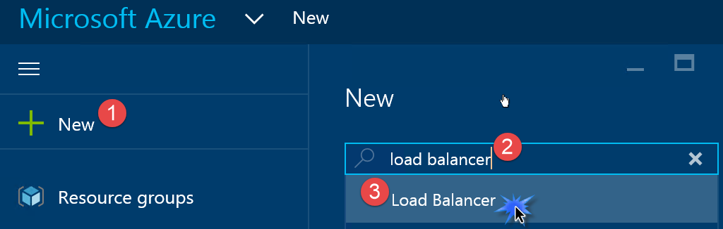

1. In the chooser dialog that opens, choose the **Load Balancer** with Microsoft listed as the Publisher.

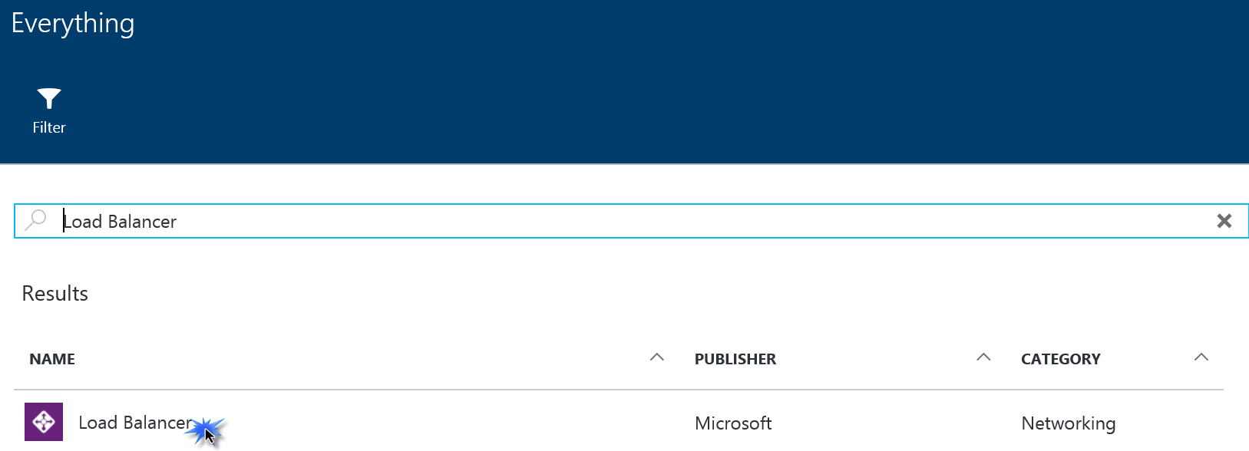

1. In the dialog that opens, click **Create** at the bottom.
2. In the Create load balancer dialog, enter **WGWEBLB** for the name. Change the **Scheme** to **Internal**. See the following screenshot for details.
3. Click **Virtual network** then choose **WGVNet**.
4. Click **Subnet** and choose **WebTier**.
5. Under **IP address assignment** click **Static** and enter the IP address **10.7.1.10**.
6. Ensure the correct subscription is selected. Under Resource group click **Use existing** and select **WGVMRG**.
7. Set **Location** to **West US**. Ensure your **Create load balancer** dialog looks like the following, then click **Create**.

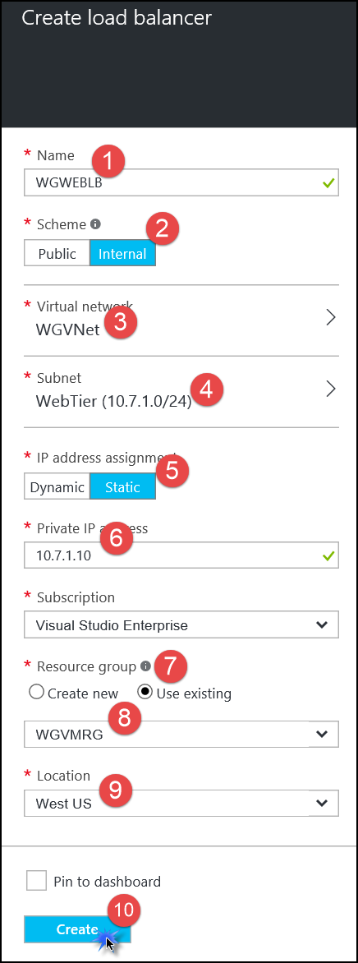

### Configure the load balancer

1. From the main Azure portal menu click on **More services**. In the **filter** box at the top type in **Load**. The list will filter and only display **Load Balancers**. Click **Load Balancers**.

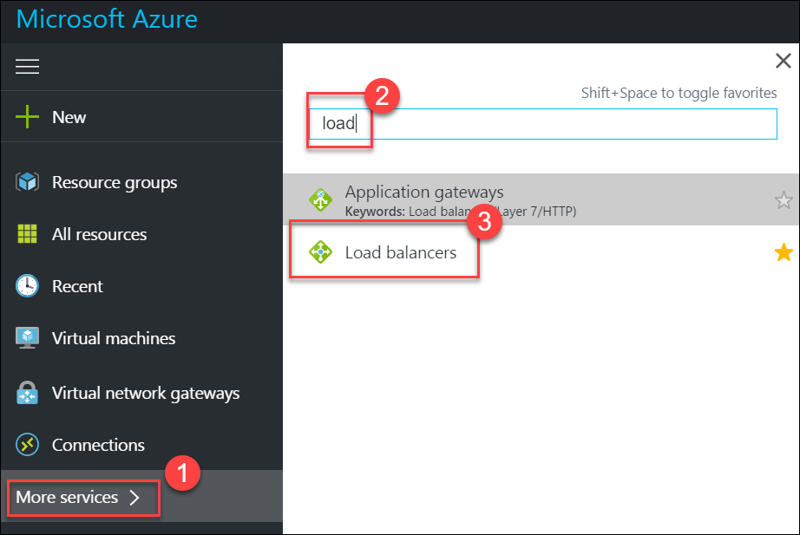

1. In the Load balancers dialog click on **WGWEBLB**. The settings for **WGWEBLB** are displayed. Click **Backend pools** and then click **Add** at the top.

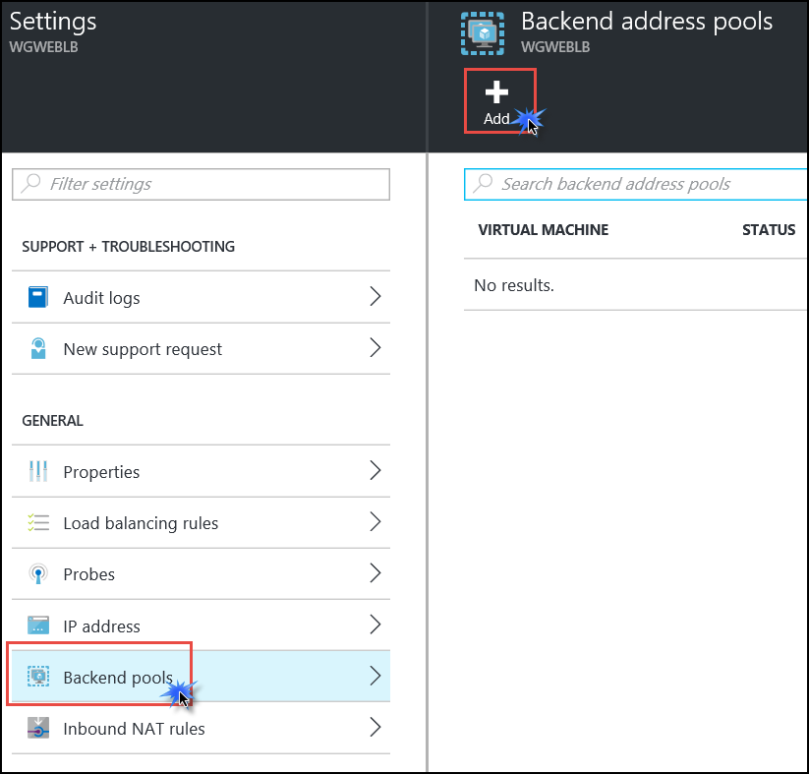

1. Enter **LBBE** for the pool name.
2. Click **Add a virtual machine**.
3. Click **Choose an availability set**.
4. Click **WEBAS**. This is the availability set that was created when the Web servers were created earlier in the lab.

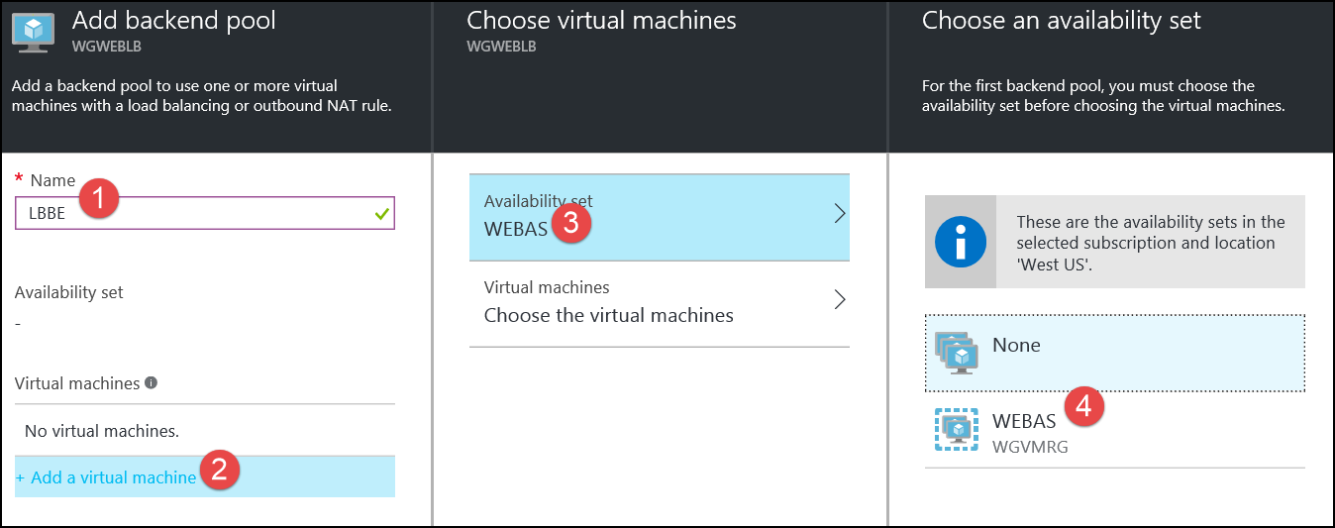

1. Back on the **Choose virtual machines** blade, click **Choose the virtual machines**. Select both web VMs and click **Select** at the bottom.

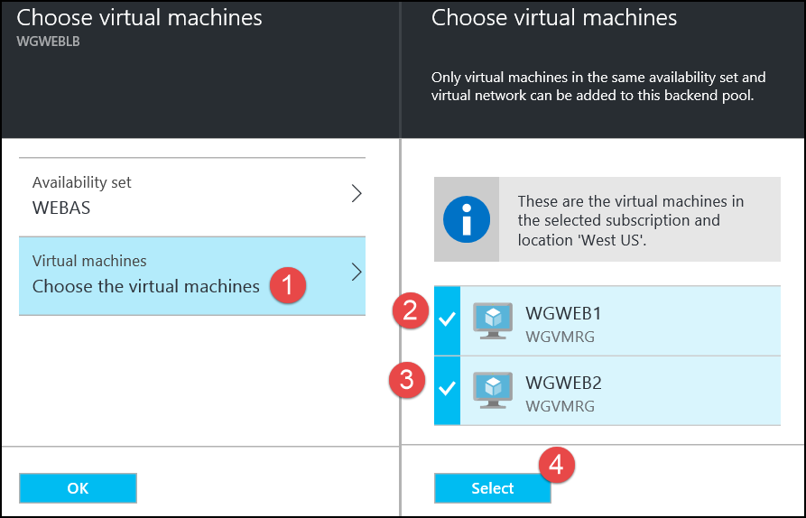

1. Click **OK** on the **Choose virtual machines** blade and **OK** on the **Add backend pool** blade.
2. Click on the **Notifications** menu to monitor progress.

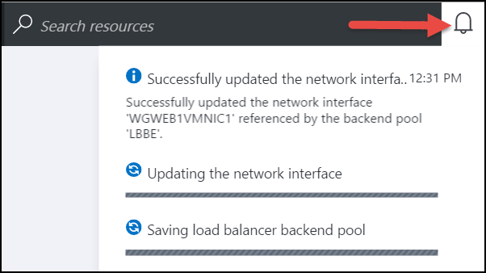

After a few minutes, you should see a success status.

***Wait for these 3 ‘Success’ messages before proceeding.***

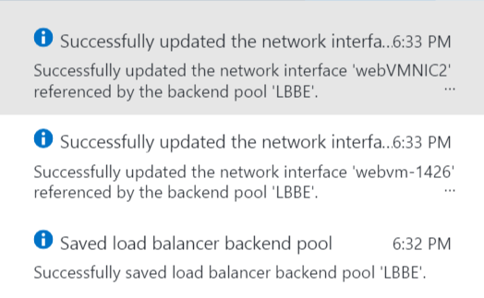

Close the **Backend address pools** blade.

1. Next, in the **Settings** tab click on **Probes**. Click **Add**, use the following information to create a health probe, and then click **OK** to create the probe.

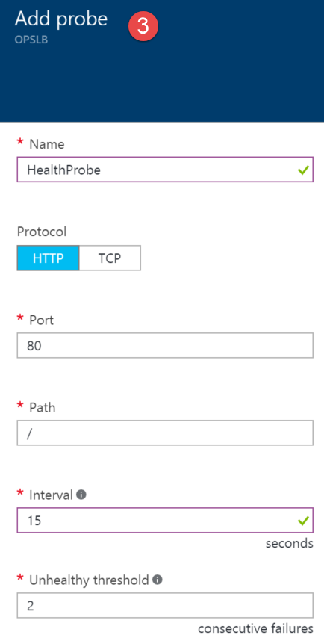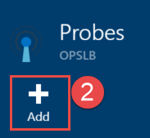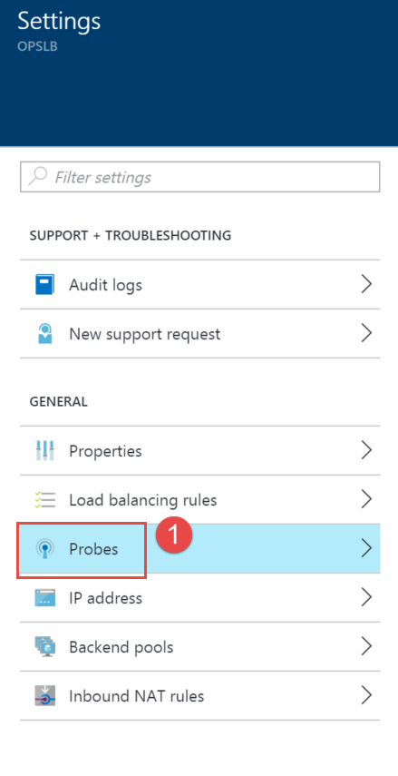

1. Back on the **Settings** blade click **Load balancing rules**. Click **Add** at the top of the **Load balancing rules** blade, complete the configuration as shown below, and then click **OK**.

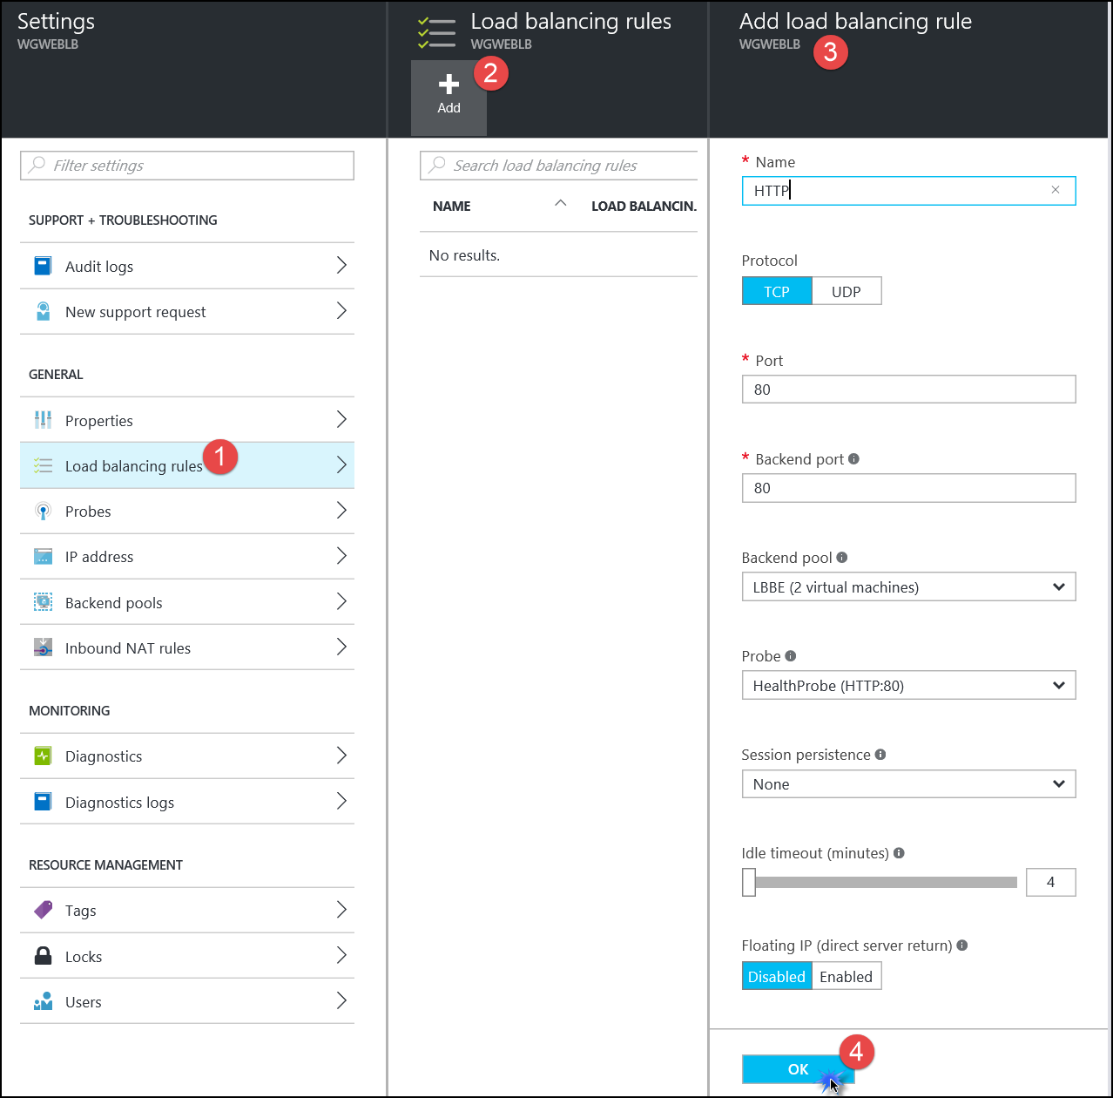

**It will take 2-3 minutes for the changes to save.**

1. Close the **Load balancing rules** and **Settings** blade. The **Essentials** panel shows you a high-level view of how many virtual machines are in the backend pool and other information.

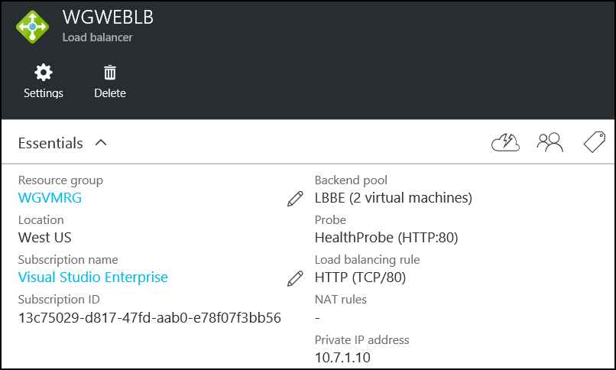

## Task 8 Configure the firewall to control traffic flow

In this section of the Hackathon you will configure the firewall appliance to allow the necessary traffic to flow so that:

* + The web application is accessible from the Internet.
  + Application traffic can flow between the tiers.
  + An administrator can RDP into the management station and from there, RDP into other servers for management purposes.

### Logon to pfSense and Add Aliases

1. When the provisioning of the pfSense appliance is finished, its **Essentials** blade and **Settings** blade will open in the portal. Take note of the **Public IP address** in the **Essentials** blade.

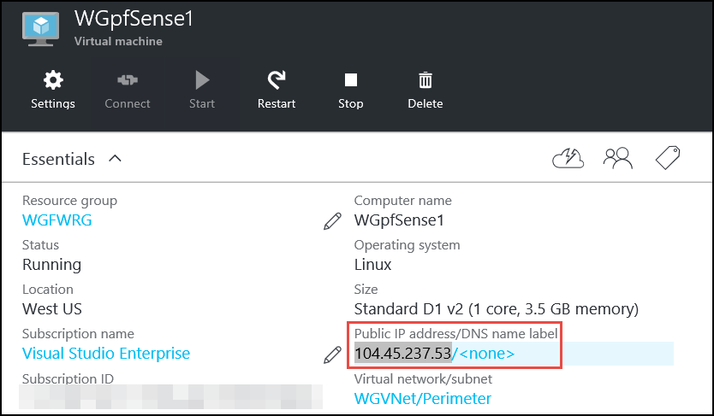

1. Open a web browser and navigate to the public IP address listed on the appliance essentials blade. **You will receive a certificate warning.** Continue to the page. You should now see the pfSense management GUI and the logon screen. Enter the credentials you provided when you provisioned the appliance.
   1. Username: **demouser**
   2. Password : **demo@pass123**

Click **Login**.

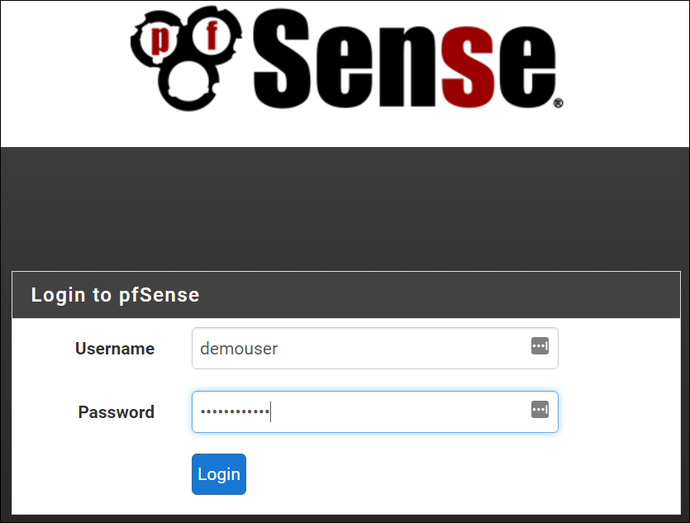

1. Click on **Firewall** then **Aliases**.

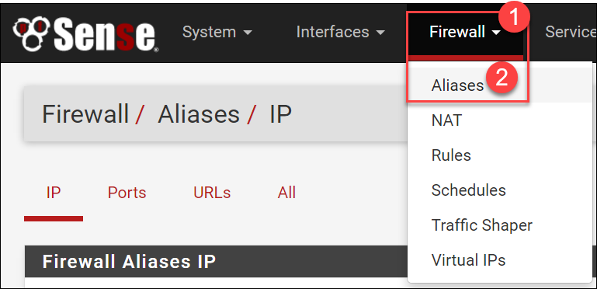

Aliases allow you to define a name that references one or more IP addresses. Using aliases simplifies NAT and Firewall rule creation.

1. On the **Firewall: Aliases** page, and while focused on the **IP** tab, click **Add** to add an IP alias.

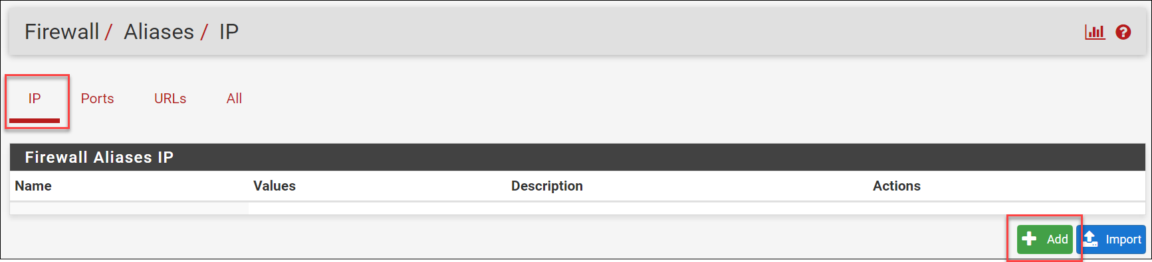

1. On the **Firewall: Aliases: Edit** page enter the following:
   1. Name: **WGMGMT1**
   2. Description: **WG Management Station**
   3. Type: **Host(s)**

In the **Host(s)** section, enter the private IP address for the management server (10.7.0.12), and a description. Click **Save**. See the following screen shot for more details.

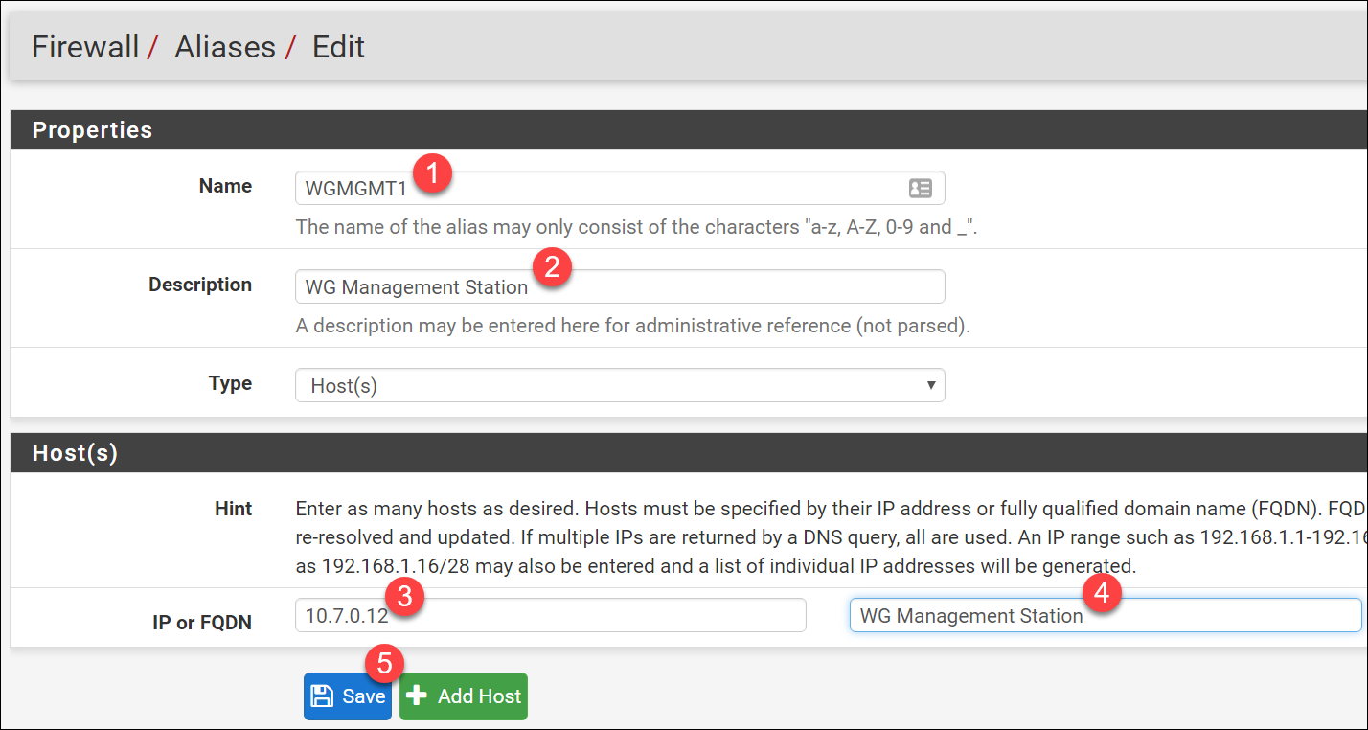

1. Complete steps 4 and 5 to add the following Aliases:

|  |  |  |  |  |
| --- | --- | --- | --- | --- |
| **Name** | **Description** | **Type** | **IP** | **Description** |
| WGSQL1 | Woodgrove SQL Server | Host(s) | 10.7.2.4 | Woodgrove SQL Server |
| WGWEB1 | WG Web Server 1 | Host(s) | 10.7.1.4 | WG Web Server 1 |
| WGWEB2 | WG Web Server 2 | Host(s) | 10.7.1.5 | WG Web Server 2 |
| WGWEBLB | Internal Web Tier Load balancer | Host(s) | 10.7.1.10 | Internal Web Tier Load balancer |
| **WGWEBSRVS** | **Woodgrove Web Servers** | **Host(s)** | **WGWEB1**  **WGWEB2** | **Woodgrove Web Server 1** |

**Note:** The last alias (**bolded**) uses previously created aliases instead of IP addresses.

The creation screen of the last alias should look like the below:

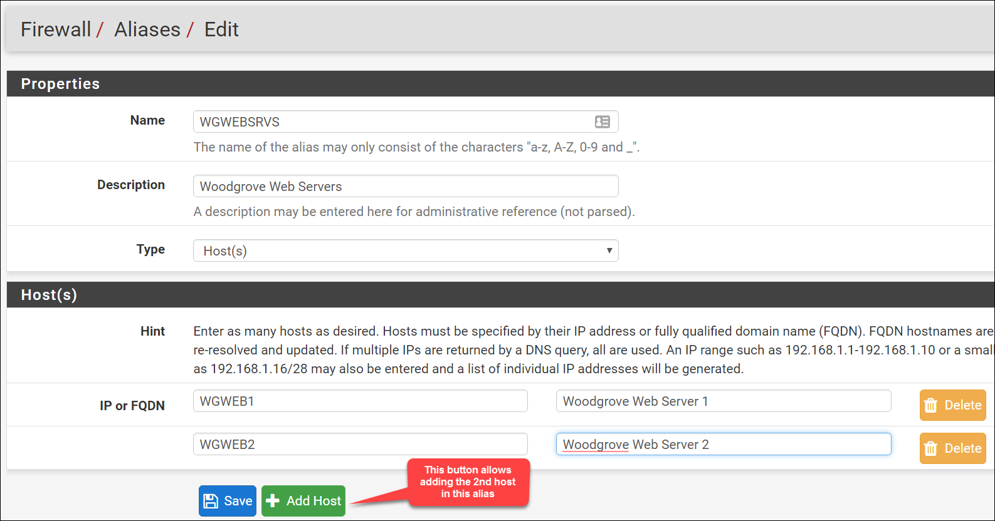

When complete your Aliases should look like this:

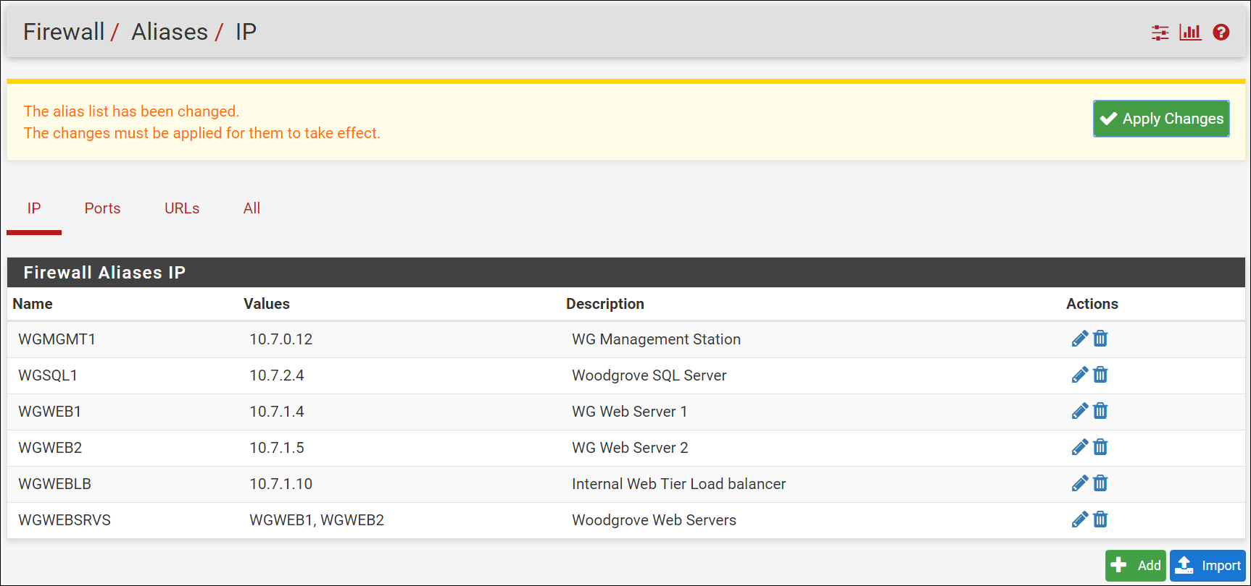

1. When all the aliases are added click **Apply changes**.



### Add NAT rules

1. From the pfSense dashboard click on **Firewall** and **NAT**.

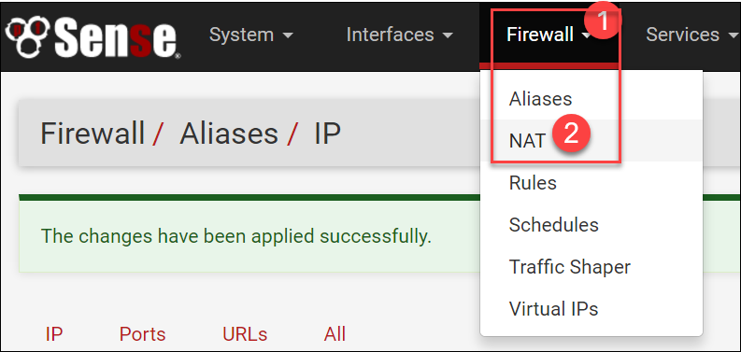

1. Click on the **Outbound** tab.

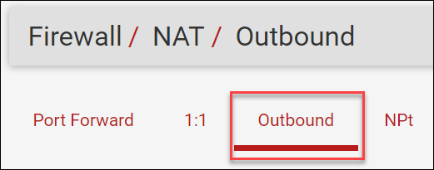

1. Change the **Mode** from **Automatic outbound NAT rule generation** to **Manual outbound NAT rule generation**. Click **Save**.

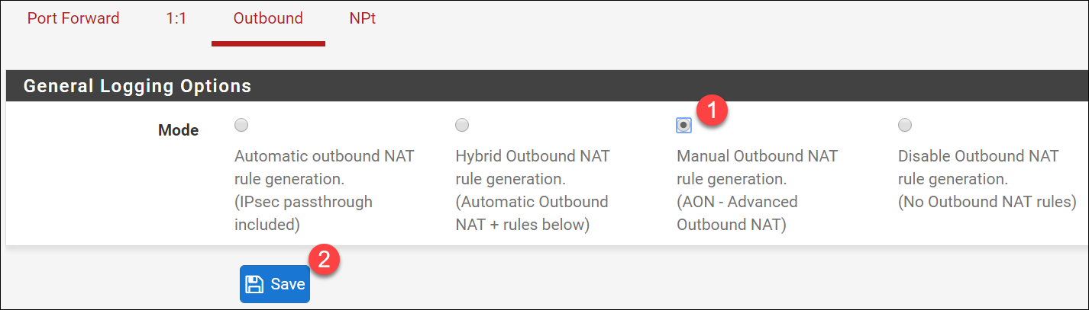

1. In the **Mappings** section, click the **Add** button to add an outbound NAT rule.

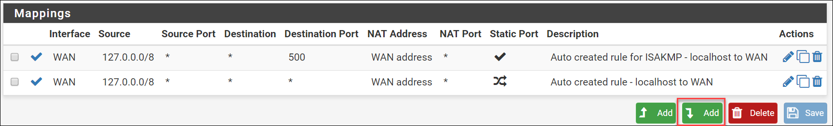

1. On the **Firewall: NAT: Outbound: Edit** screen, enter the following:
   1. Source: **Network**
   2. Address: **10.7.0.0/16**

In the **Description** section, enter **Outbound to Internet**. Click **Save**.

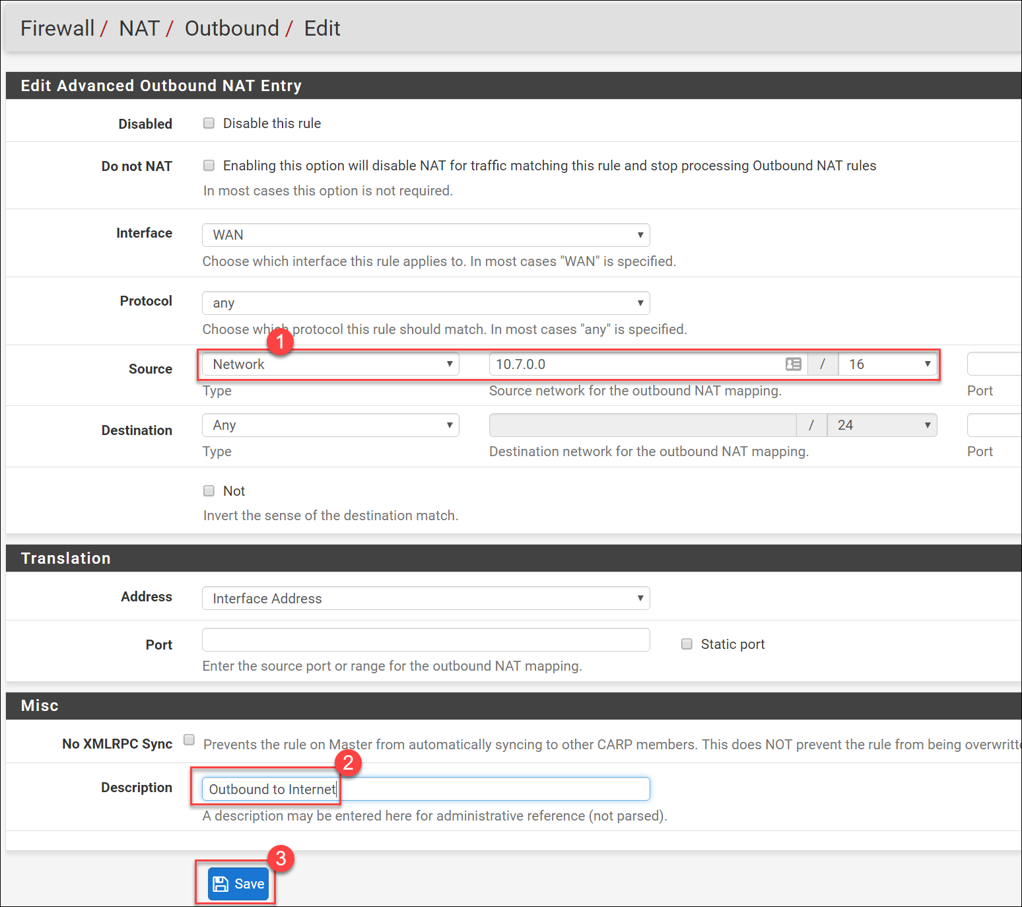

1. Click **Apply changes**.



1. Click on the **Port Forward** tab then click the **+** to add a port forward rule**.**

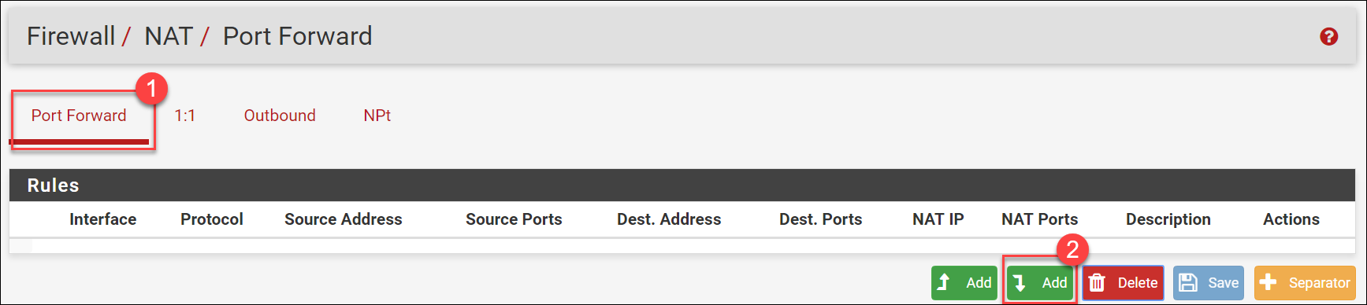

1. In the **Firewall: NAT: Port Forward: Edit** screen make the following changes:
   1. Protocol: **TCP**
   2. Destination port range: drop down **from** and choose **HTTP**
   3. Redirect target IP: **WGWEBLB**
   4. Redirect target port: from drop down choose **HTTP**
   5. Description: **HTTP to WGWeb Load Balancer**

The remaining sections are correct. Click **Save**.

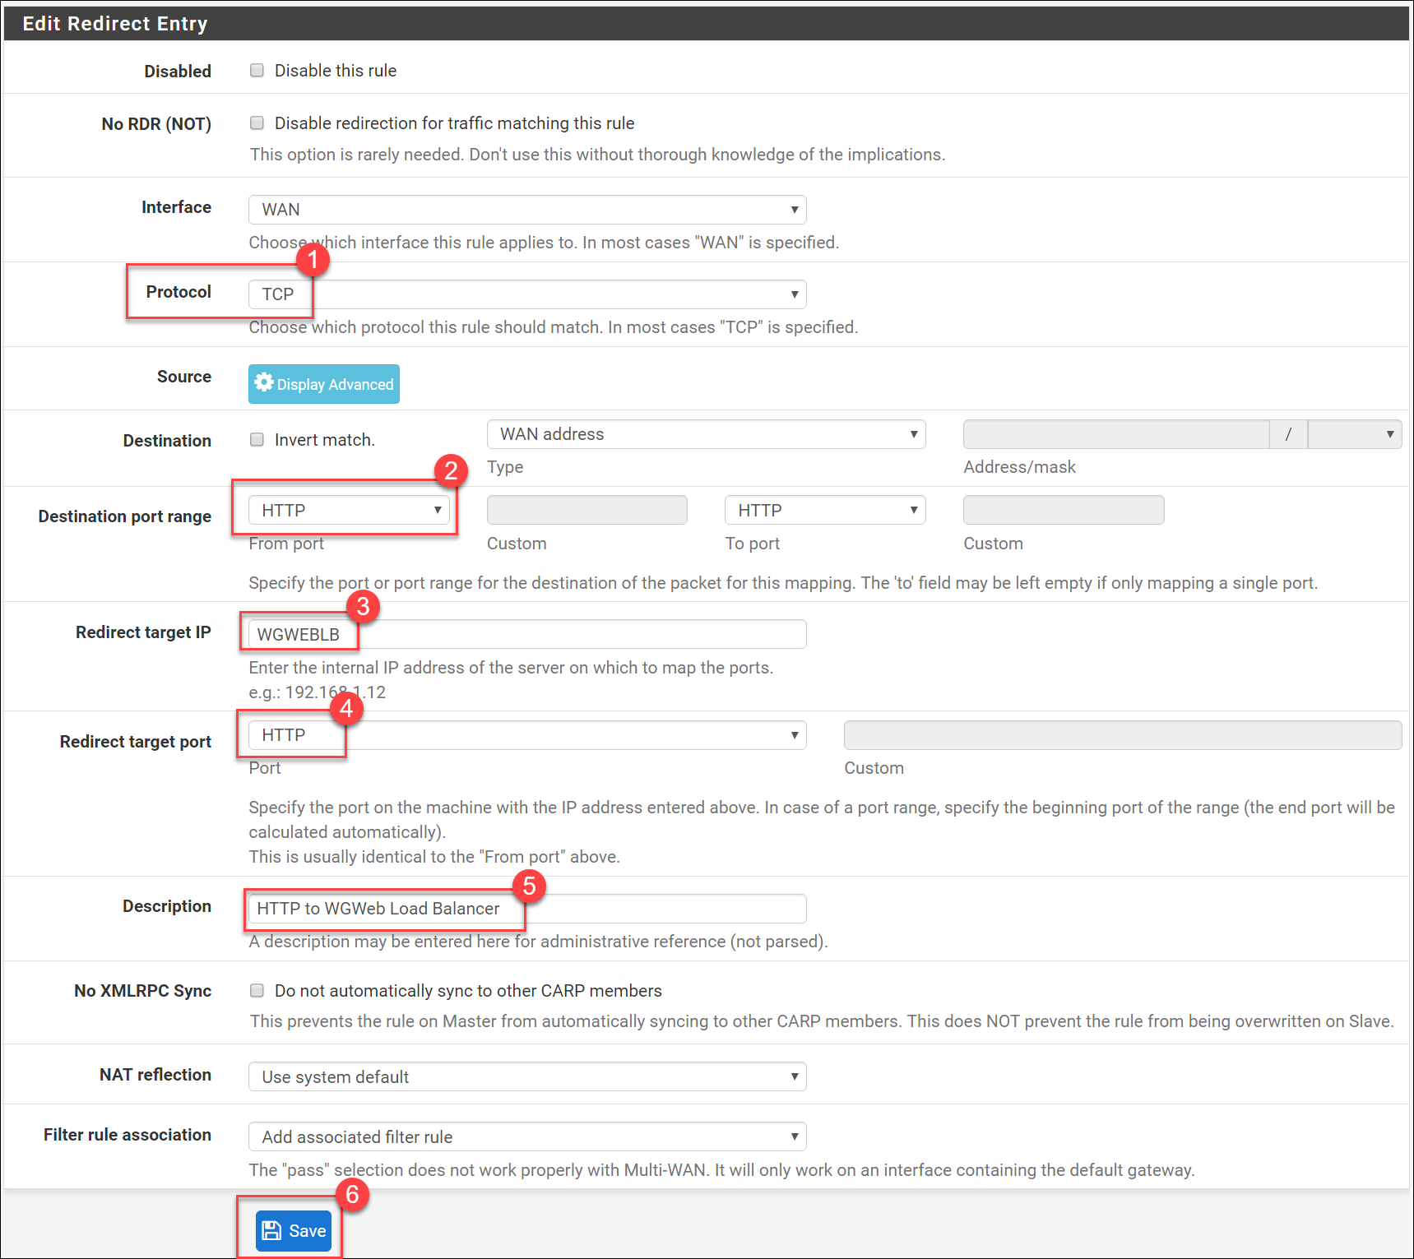

1. Create another NAT rule by repeating steps 7 and 8, using the following information:
   1. Protocol: **TCP/UDP**
   2. Destination port range: Manually enter **3445** in the **from** section
   3. Redirect target IP: **WGMGMT1**
   4. Redirect target port: From dropdown select **MS RDP**
   5. Description: **RDP to MGMT server**

The remaining sections are correct. Click **Save**.

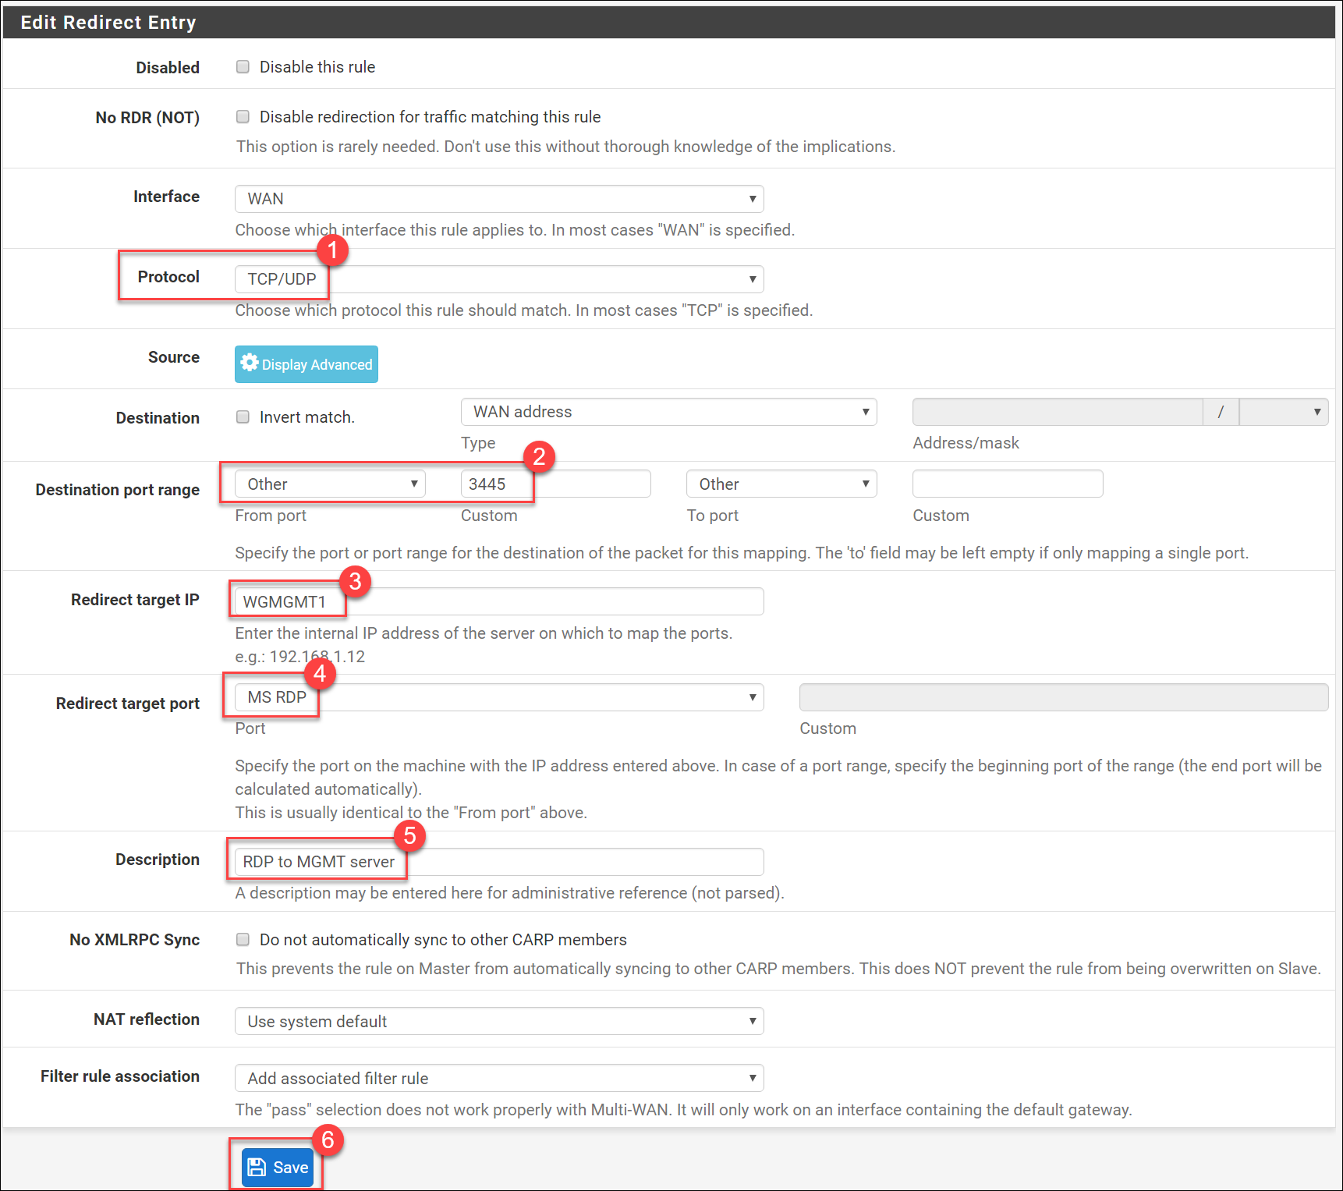

1. Click **Apply changes**.



### Configure Firewall Rules

We have aliases and NAT rule configured. Now we will create the firewall rules that will allow or block traffic.

1. Click **Firewall**, and then click **Rules**.

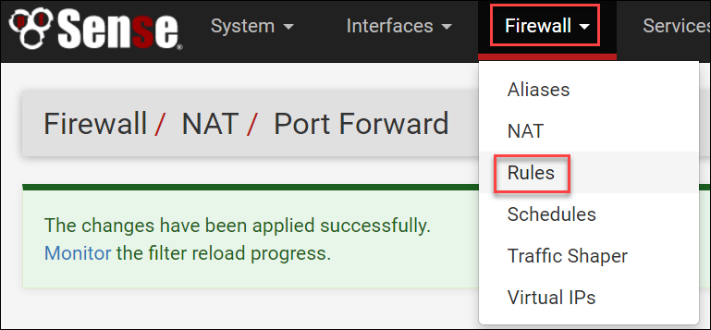

1. Note that several rules already exist. Some are **default** rules (note the description field) and the last two rules were added automatically based on the NAT rules we configured.

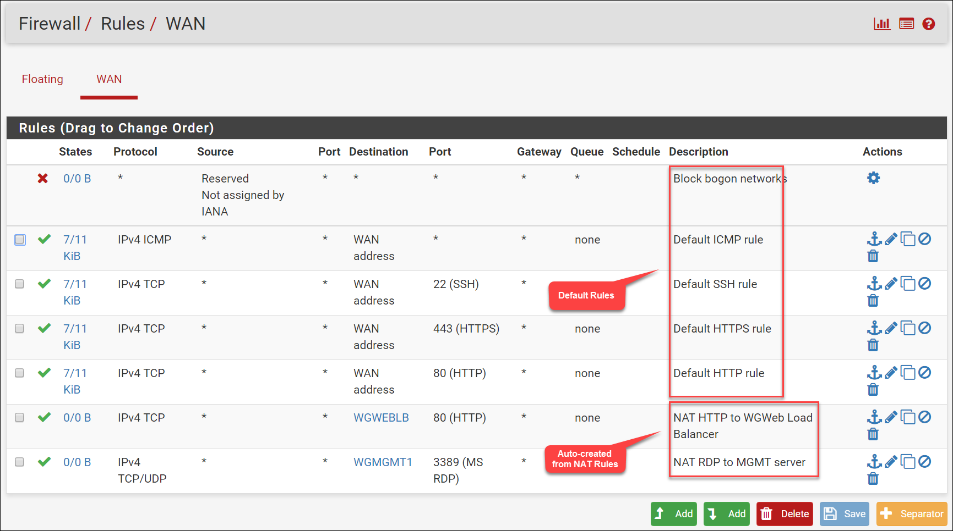

1. Now add a rule that will allow the management UI of the firewall to respond on a different port. At the bottom-right of the list of rules, click on the **Add** to add a rule.

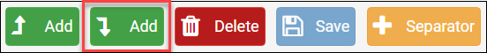

1. Enter the following information to define the new rule:
   1. Destination: From dropdown menu, choose **WAN address**.
   2. Destination port range: Enter **8443** in the **from** box.
   3. Description: **MGMT HTTPS rule**
   4. Click **Save**.

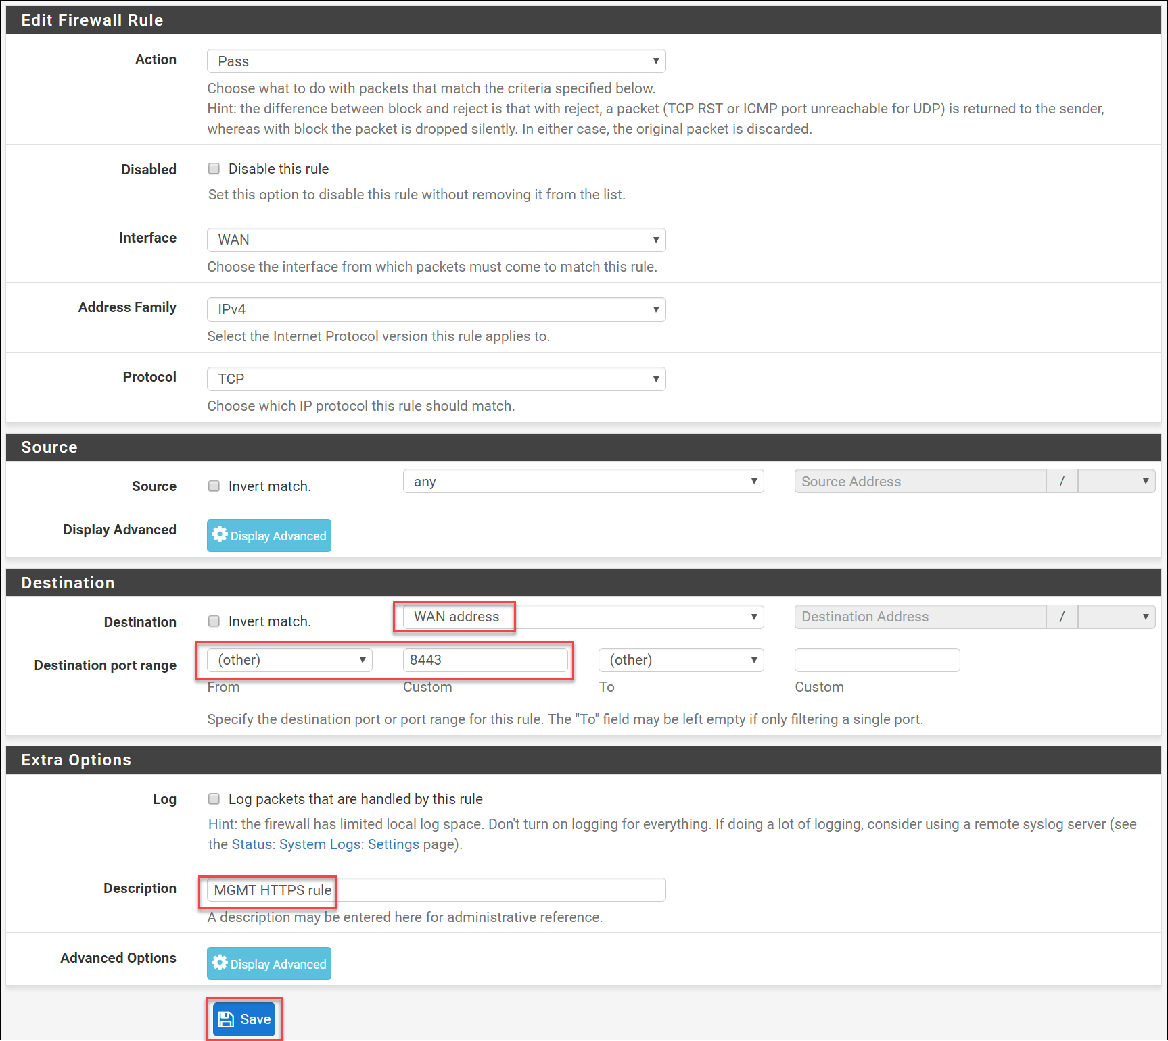

1. Click **Apply changes**.



1. Click on **System** then **Advanced**.

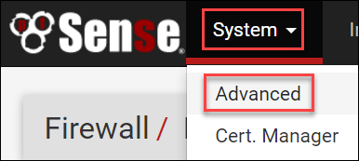

1. Under **webConfigurator** make the following changes:
   1. Locate **TCP port**. In the box beside this field, enter **8443**.
   2. Locate **WebGUI redirect** and check the box beside **Disable webConfigurator redirect rule**.
   3. Scroll down to the bottom of the page and click **Save**.

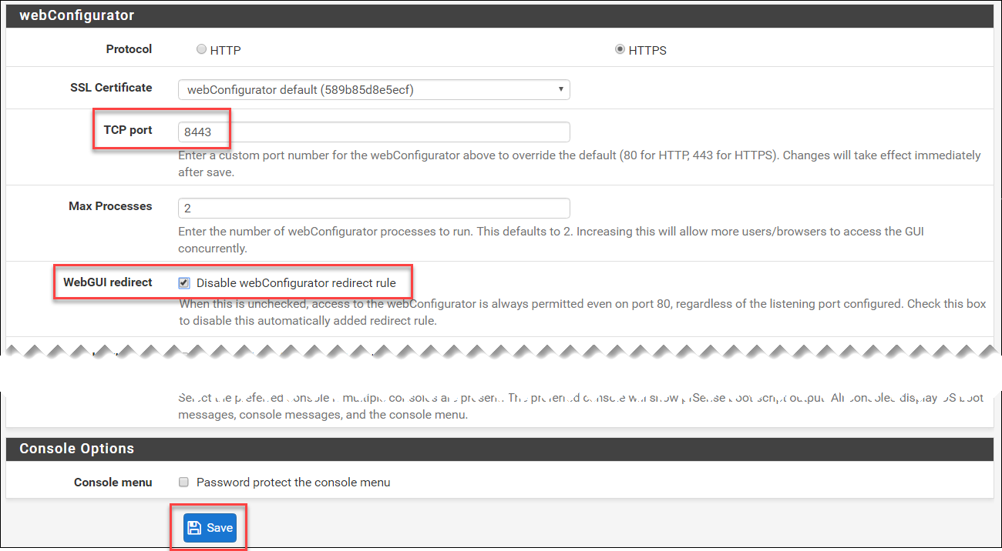

1. You will be prompted that the webConfigurator will restart using the new management port:

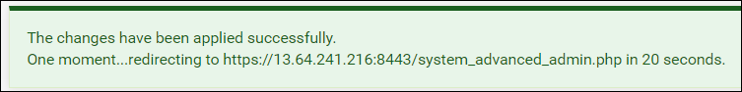

After the webConfigurator refreshes using the new port, proceed to the next step.

1. Click **Firewall**, and then click **Rules**.

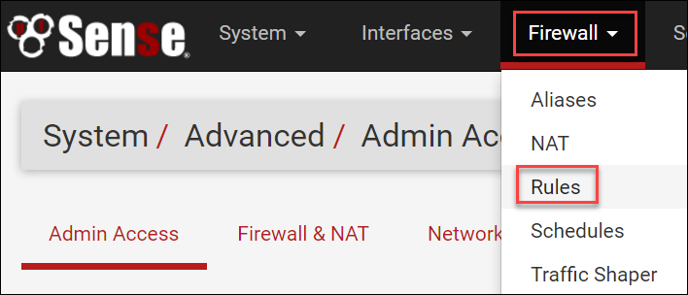

1. Locate a rule with the description, “**Default HTTPS rule**”. Click the **x** beside this rule to delete it.



You will be prompted to confirm. Click **OK** to delete the rule.

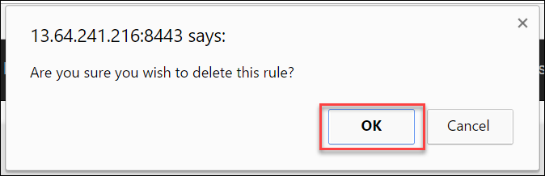

1. Locate a rule with the description, “**Default SSH rule**”. Click on the pencil icon to edit this rule.



1. In the section called **Disabled** check the box beside **Disable this rule**. Click **Save** at the bottom of the page.

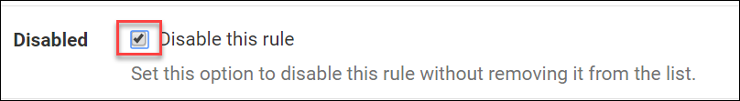

**Note**: We disable this rule as it is a favorite vector for attack. If we need to SSH into the firewall, we can enable here, do the required work, and then disable it again.

1. Click **Apply changes**.



1. Locate a rule with the description, “**Default HTTP rule**”. Click on the **x** to delete this rule.



You will be prompted to confirm. Click **OK** to delete the rule.



1. On the **Firewall: Rules: WAN** page, underneath the rules and to the right, click on the **Add** to add a new rule.

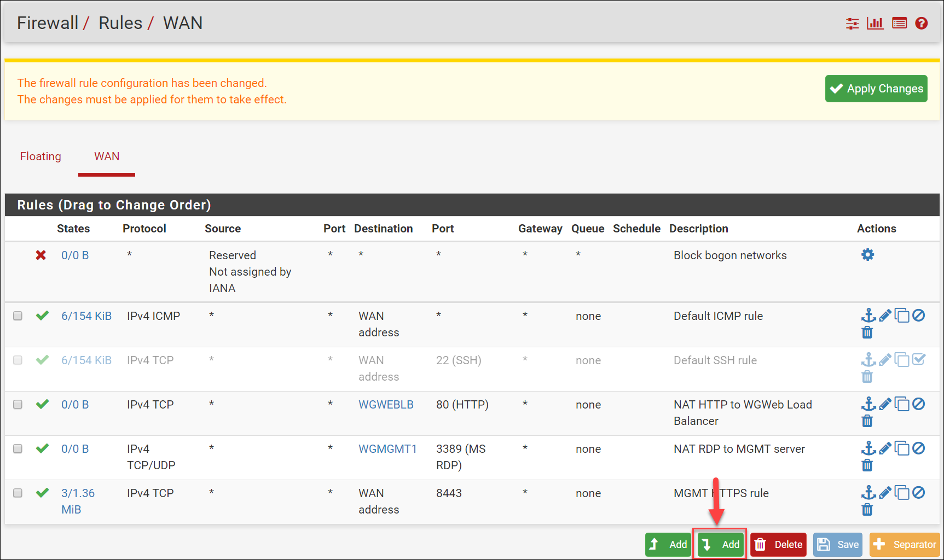

1. On the **Firewall: Rules: Edit** page make the following changes, then click **Save**.
   1. Source: Drop down **Type** and choose **Network**. In the **Address** box enter **10.7.0.0/16**
   2. Destination port range: in ‘from:’ choose **HTTP** from dropdown menu
   3. Description: **VNet to Any (HTTP)**
   4. At the bottom click **Save**.

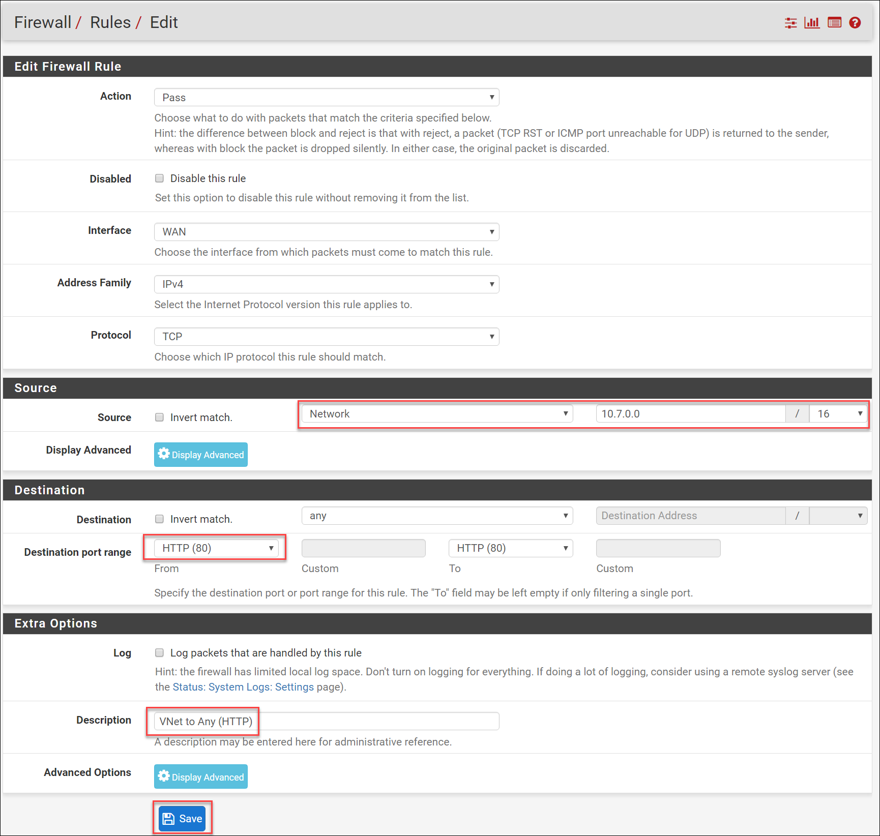

1. Repeat steps 15 and 16 to create an additional rule, using the following information:
   1. Protocol: **TCP**
   2. Source:
      1. Type: **Network**
      2. Address: **10.7.0.0/16**
   3. Destination port range:
      1. From: Choose **HTTPS** from the dropdown menu
   4. Description: **VNet to Any (HTTPS)**
   5. Click **Save** at the bottom.
2. Repeat steps 15 and 16 to create an additional rule, using the following information:
   1. Protocol: **TCP**
   2. Source:
      1. Type: **Single host or alias**
      2. Address: **WGWEBSRVS**
   3. Destination:
      1. Type: **Single host or alias**
      2. Address: **WGSQL1**
   4. Destination port range:
      1. From: Type **1433** in the box
   5. Description: **Allow Web Servers to SQL1 TCP1433**
   6. Click **Save** at the bottom.

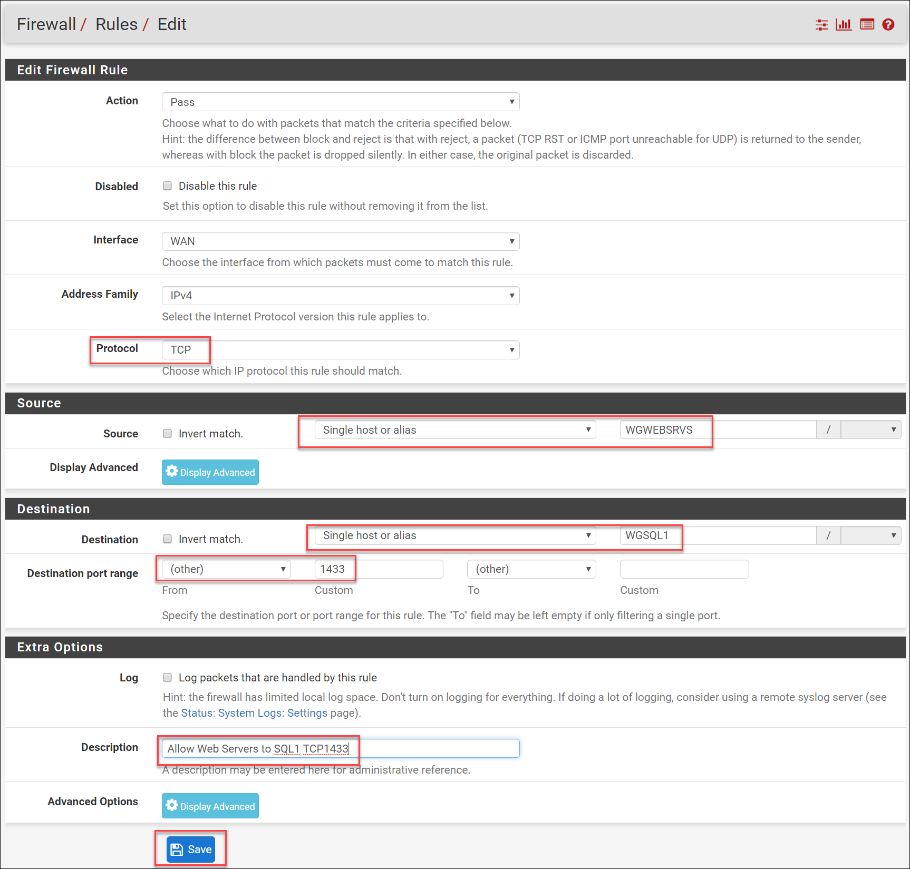

1. Repeat steps 15 and 16 to create an additional rule, using the following information:
   1. Protocol: **TCP/UDP**
   2. Source:
      1. Type: **Single host or alias**
      2. Address: **WGMGMT1**
   3. Destination:
      1. Type: **Single host or alias**
      2. Address: **WGWEBSRVS**
   4. Destination port range:
      1. From: Choose **MS RDP** from drop down
   5. Description: **Allow RDP from MGMT to Web Servers**
   6. Click **Save** at the bottom.

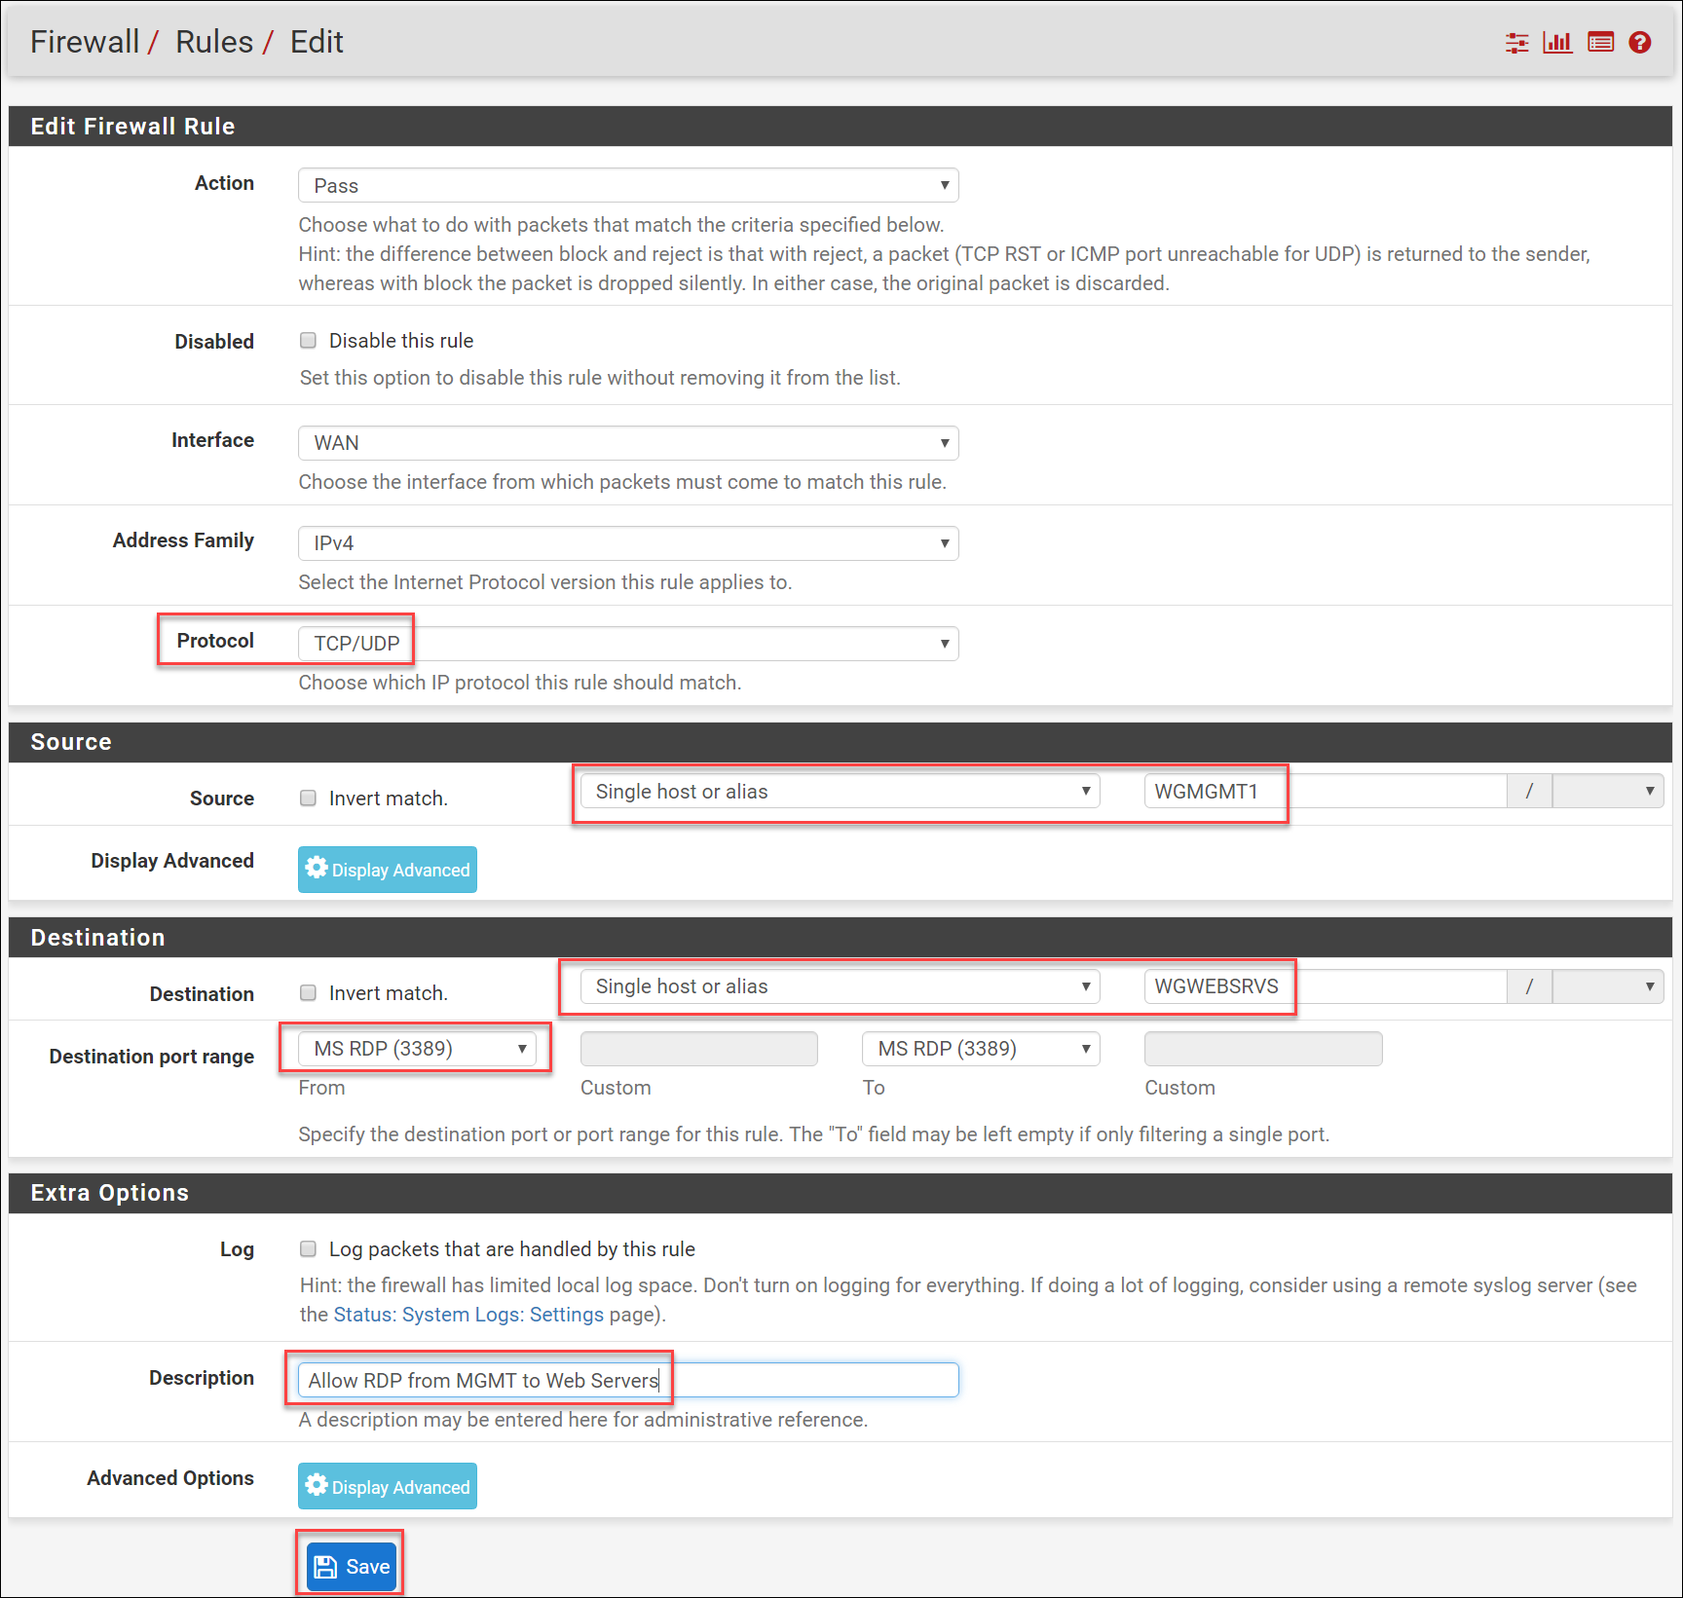

1. Click **Apply changes**.



1. When complete, your firewall rules should look like the following:

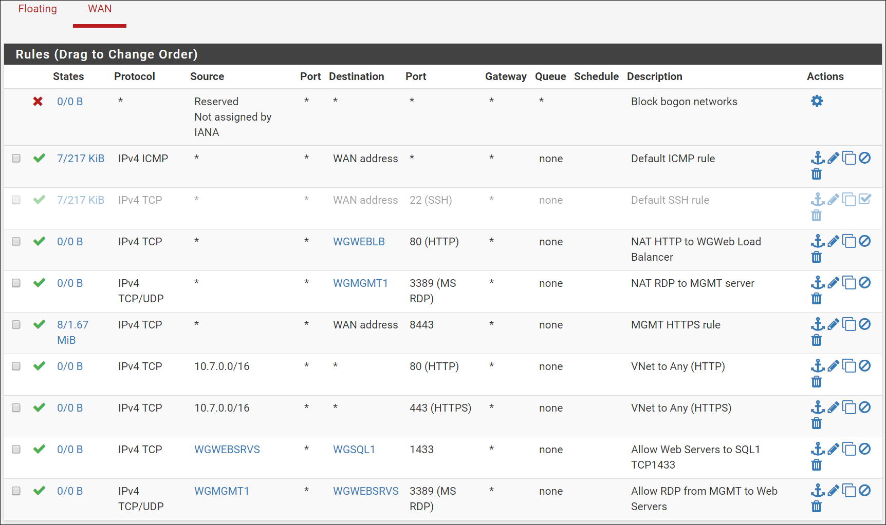

### Associate route tables to subnets

1. On the main Azure portal menu, click on **More services**. Enter **route** and click the option that is found called **Route tables**.



1. Click on **DataRT**. The **Essentials** and **Settings** blades open. On the **Settings** blade, click **Subnets**.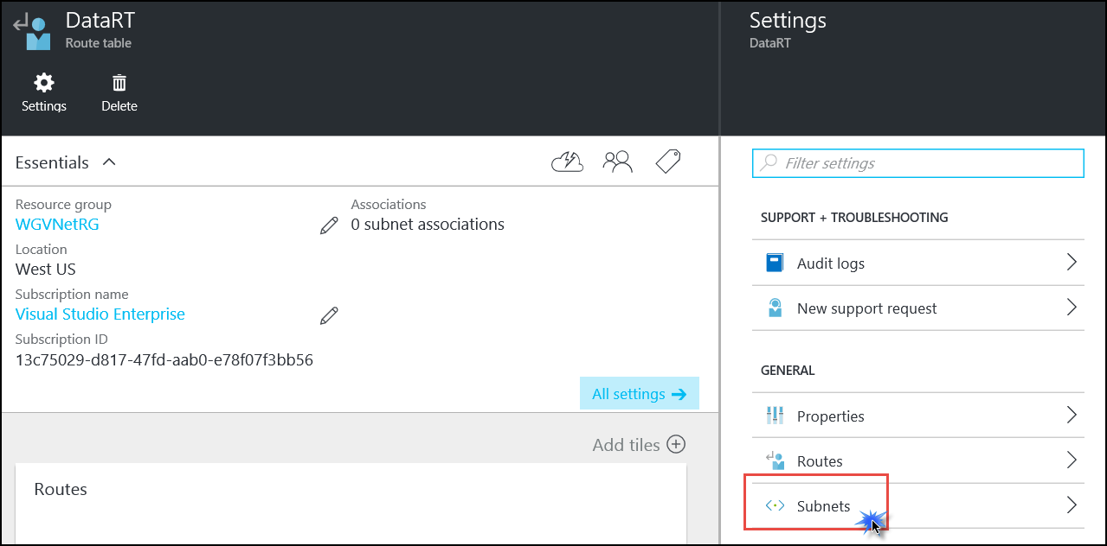
2. The **Subnets** blade opens. Click the 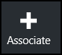 icon at the top.
3. On the **Associate subnet** blade click on **Virtual network**. Click on **WGVNet**.

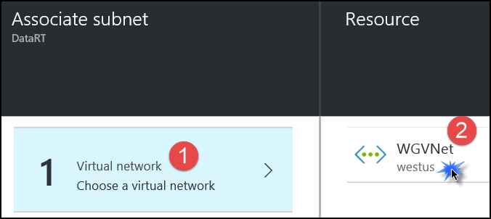

1. The **Choose subnet** blade opens. Click on **DataTier**.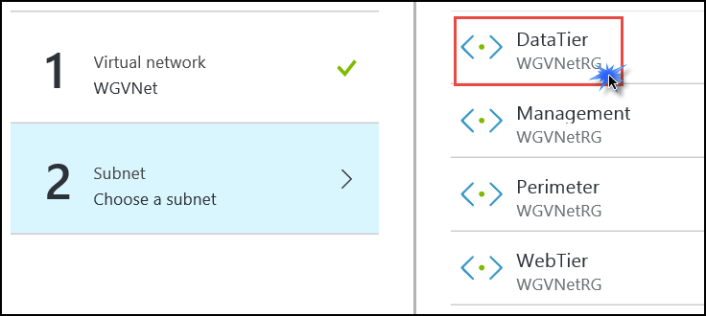
2. Click **OK** at the bottom of the **Associate subnet** blade.
3. In the breadcrumb menu at the top of the portal, click **Route tables** to return to that blade.



1. Click on **MgmtRT**. The **Essentials** and **Settings** blades will open. On the **Settings** blade, click **Subnets**.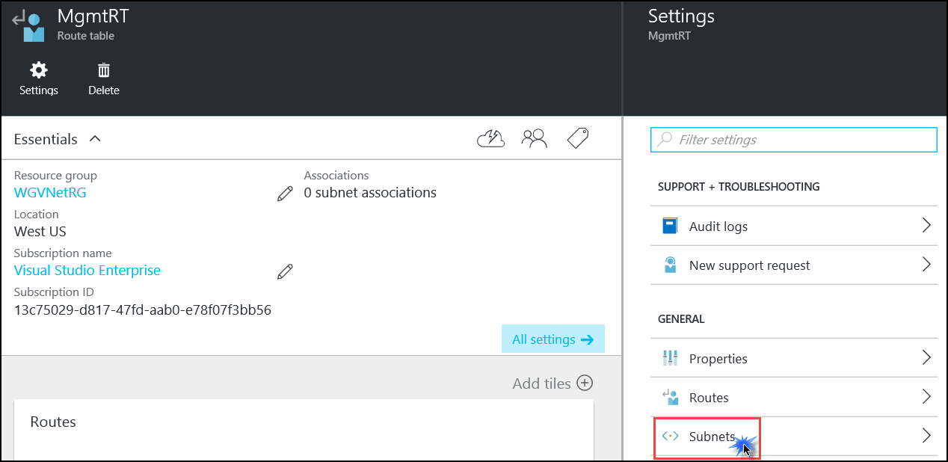
2. The **Subnets** blade opens. Click the  icon at the top.
3. On the **Associate subnet** blade click on **Virtual network**. Click on **WGVNet**.



1. The **Choose subnet** blade opens. Click on **Management**.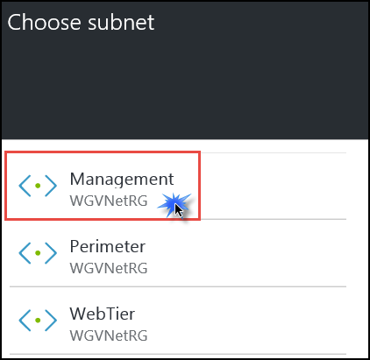
2. Click **OK** at the bottom of the **Associate subnet** blade.
3. In the breadcrumb menu at the top of the portal, click **Route tables** to return to that blade.



1. Click on **WebRT**. The **Essentials** and **Settings** blades open. On the **Settings** blade, click **Subnets**.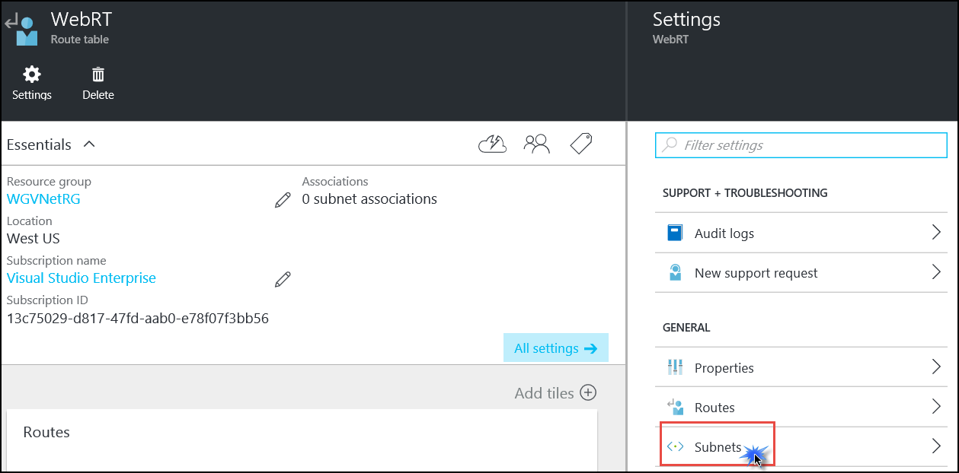
2. The **Subnets** blade opens. Click the  icon at the top.
3. On the **Associate subnet** blade click on **Virtual network**. Click on **WGVNet**.



1. The **Choose subnet** blade opens. Click on **WebTier**.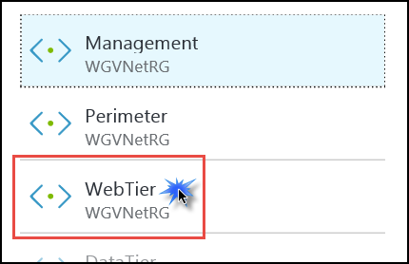
2. Click **OK** at the bottom of the **Associate subnet** blade.

### Validate connectivity

We need to validate that the configuration steps have resulted in the following connectivity:

* RDP from the Internet to the MGMT server using the firewall’s public IP address and port 3445
* While RDP’ed into the MGMT server, RDP to either of the WEB servers
* Browse the CloudShop web application from the Internet using the firewall’s public IP address and port 80.

#### RDP to MGMT server and from MGMT to WEB server

1. Click the Windows button and type in **mstsc** and hit the **enter** key. This should open the Remote Desktop client.
2. In the **Computer** section enter **<firewall public IP>:3445**, for example, **13.65.88.31:3445**
3. When prompted, enter the credentials:
   1. User: **demouser**
   2. Password: **demo@pass123**
4. At the security certificate warning, click **Yes** to connect.

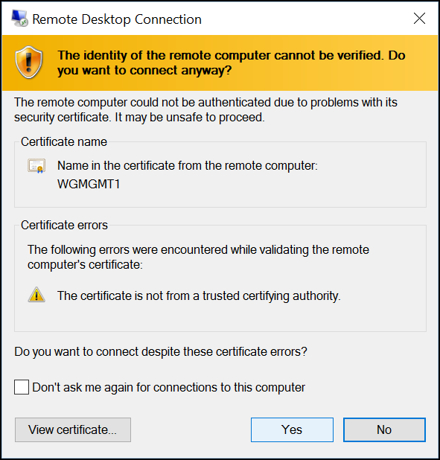

1. You should see the desktop of WGMGMT1 in a few seconds.
2. From within the RDP session, click on the Windows button of WGMGMT1 and type in **mstsc** and hit the **enter** key.
3. In the **Computer** section enter the private IP address of WGWEB1 (10.7.1.4) and click **Connect**.
4. When prompted, enter the credentials:
   1. User: **demouser**
   2. Password: **demo@pass123**
5. At the security certificate warning, click **Yes** to connect.
6. Connectivity is validated when you see the desktop of WGWEB1. Disconnect the RDP session to WGWEB1 (10.7.1.4).

#### Validate internal connectivity to CloudShop

1. While still RDP’ed into WGMGMT1, open **Server Manager** (if it is not already opened).

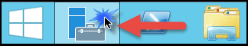

1. On the left, click **Local Server**.



1. On the right side of the pane, click **On** by **IE Enhanced Security Configuration**.



1. Change to **Off** for Administrators and click **OK**.



1. Open Internet Explorer, enter the IP address of WGWEB1 in the URL section, and press the **Enter** key. You should see the CloudShop application.

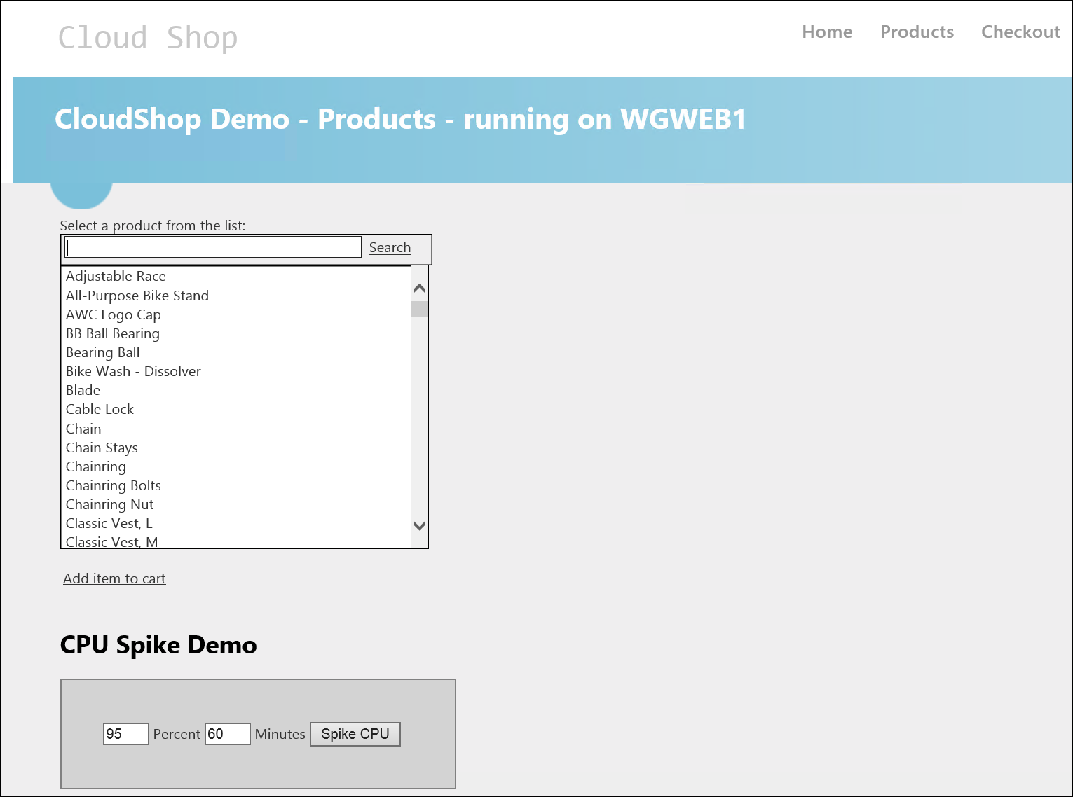

1. Now enter the IP address of the load balancer (10.7.1.10) and validate that you can access CloudShop. After validation, close the RDP session to WGMGMT1.
2. Open a browser on your client machine and enter **http://<firewall public IP>**, for example, [**http://13.65.88.31**](http://13.65.88.31).
3. Validate that you see the CloudShop website returned. If you refresh the page several times you should notice both WEB servers being accessed.

## Task 9 – Configuring site-to-site connectivity

In this task, we will simulate an on-premises connection to the internal web application. To do this we will first set up another virtual network in a separate Azure region. Then connect the 2 virtual networks via a site-to-site connection. Finally, we will set up a virtual machine in the new virtual network to simulate on-premises connectivity to the internal load-balancer.

### Create another virtual network

1. Using the Azure Management Portal, click **New**, **Networking**, and **Virtual network**.

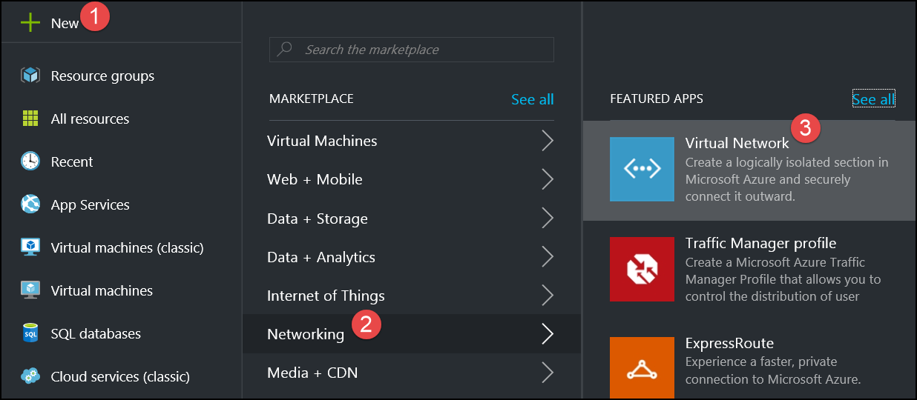

1. Accept the default value of **Resource Manager**, and click **Create**.

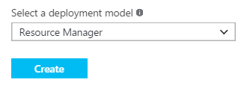

1. Specify the following configuration, see the following screenshot for more details:

|  |  |
| --- | --- |
| * Name: **OnPremSimVNet** * Address space: **192.168.0.0/16** * Subnet name: **default** * Subnet address range: **192.168.0.0/24** * Subscription: **Choose your Subscription** * Resource Group: Create new: **OnPremSimVNetRG** * Location: **East US**   Make sure this is **not** the same location you have specified in the previous labs. |  |

1. Check **Pin to dashboard,** and then click **Create** to create the new virtual network.

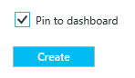

### Configure Gateway Subnets for both virtual networks

1. On the **OnPremSimVNet** virtual network configuration blade, click **Subnets** and then click **Gateway subnet +**.

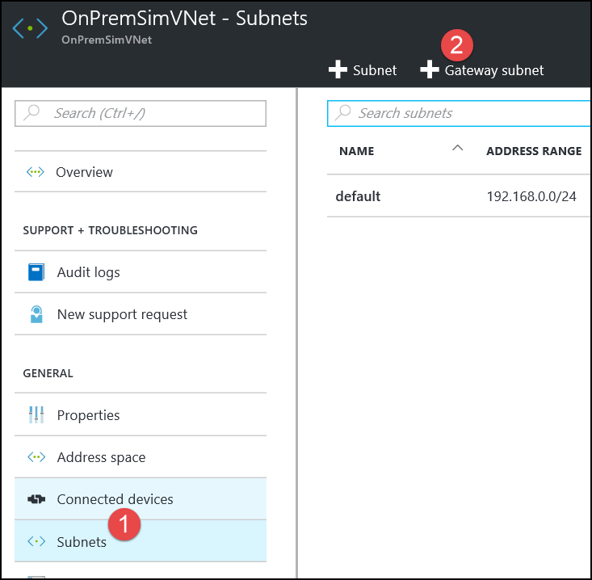

1. Specify the following configuration for the subnet and click **OK**.
   * Address range: **192.168.1.0/29**
   * Route table: **None** (we will add later)

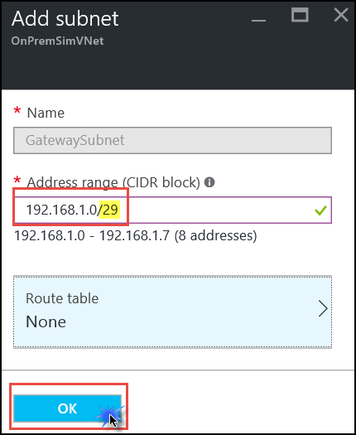

1. Next, we will add the gateway subnet to the WGVNet virtual network. Open the **WGVNet** configuration blade by clicking **More services**, typing **virtual networks** in the search window, then clicking on **Virtual Networks.**



1. This lists the 2 virtual networks configured in our subscription. Click on **WGVNet**.
2. On the **WGVNet** virtual network **Settings** blade, click **Subnets** and then click **Gateway subnet +**.

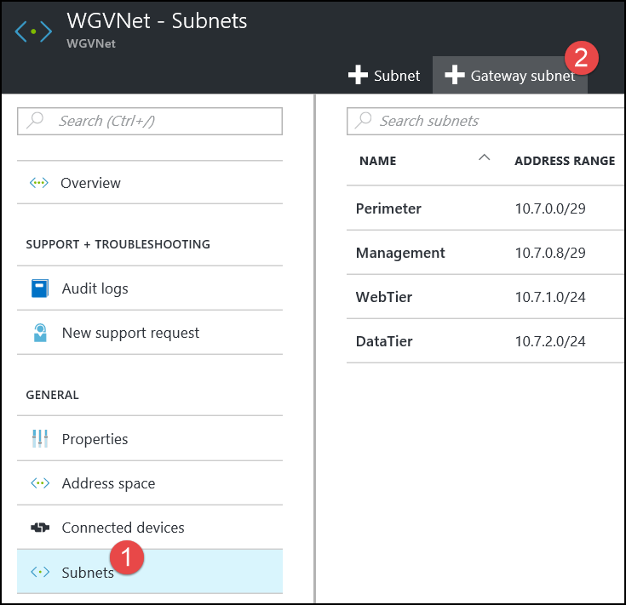

1. Specify the following configuration and click **OK.**
   * Address range: **10.7.0.16/29**
   * Route table: **None**

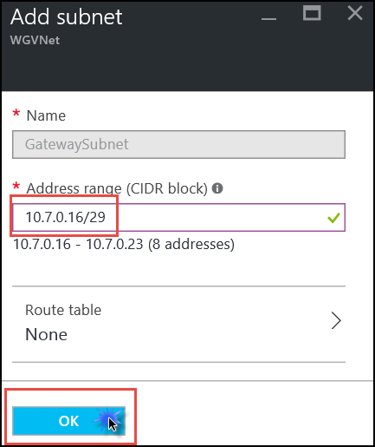

### Create the First Gateway

1. Using the Azure Management Portal, click **More services**, type **virtual network gateway** in the search window, and then click **Virtual Networks Gateways**.

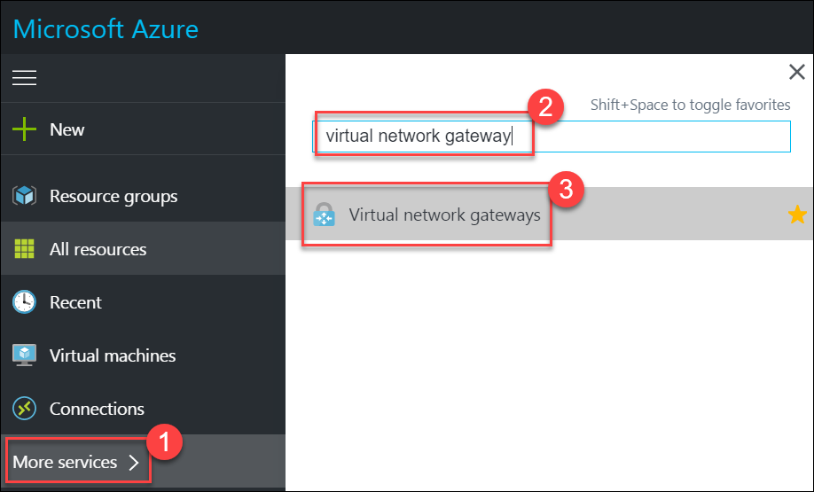

1. Click the **Add** button on the toolbar.

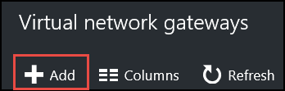

1. Name the gateway **AzureWGGW**.

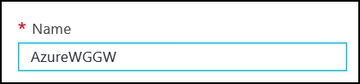

1. One of the last configurable options is the **Location**. Click to choose the Azure region where WGVNet exists (West US if following this guide).

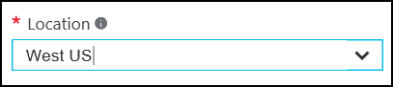

1. In the **Virtual network** section click **Choose a virtual network** and click **WGVNet**.

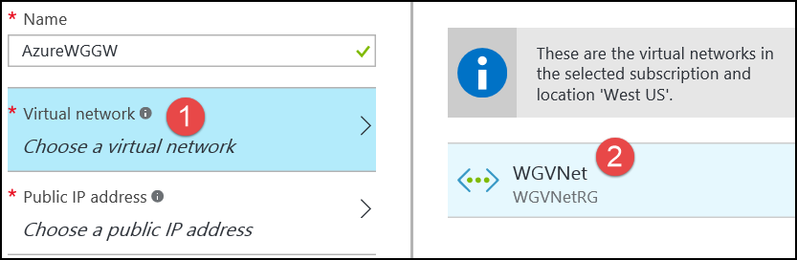

1. Click the **Public IP address** tile, and click **Create new**.

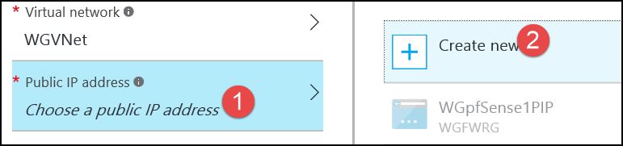

1. Name the IP **AzureWGGWPIP** and click **OK**.

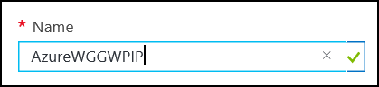

1. Validate that your settings look like the following screenshot, and then click **Create**.

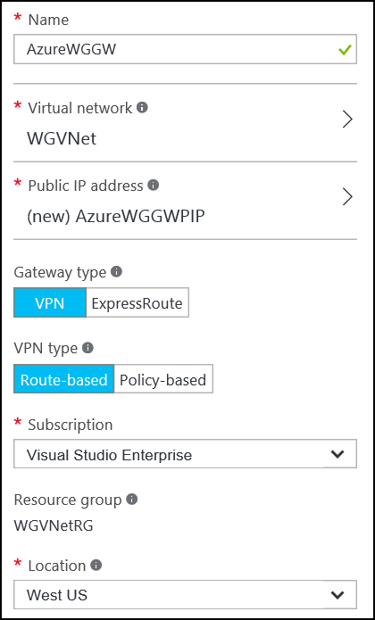

Note: The gateway will take 30-45 minutes to provision. Continue to the next section while waiting.

### Create the Second Gateway

1. Using the Azure Management Portal, click **More services**, type **virtual network gateway** in the search window, and then click **Virtual Networks Gateways**.



1. Click the **Add** button on the toolbar.



1. Name the gateway **OnPremWGGW**.

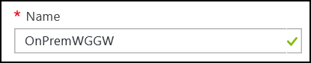

1. One of the last configurable options is the **Location**. Click to choose the Azure region where **OnPremSimVNet** exists (East US if following this guide).

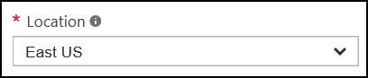

1. In the **Virtual network** section click **Choose a virtual network** and click **OnPremSimVNet**.

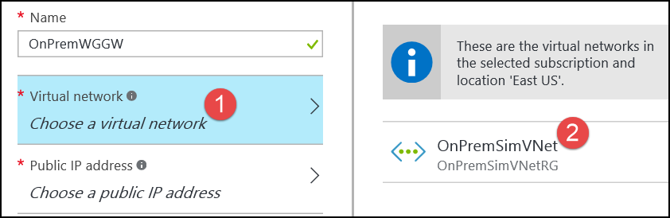

1. Click the **Public IP address** tile, and click **Create new**.



1. Name the IP **OnPremSimGWPIP** and click **OK**.

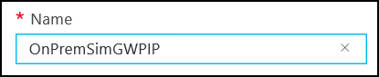

1. Validate that your settings look like the following screenshot, and then click **Create**.

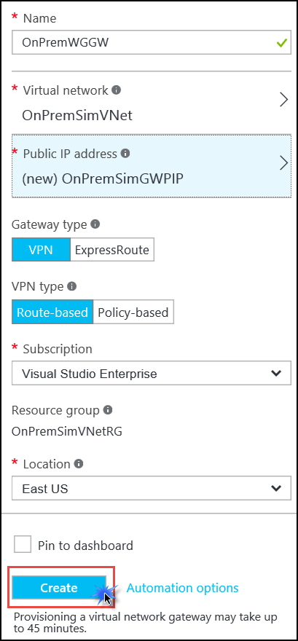

Note: The gateway will take 30-45 minutes to provision. **You will need to wait until both gateways are provisioned before moving to the next section**.

1. The Azure Portal will notify you when the deployments have completed.

### Connect the Gateways

1. Using the Azure Management Portal, click **New**, type in **Connection**, and press **Enter**.

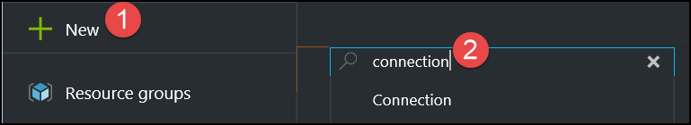

1. Click **Connection**, and then click **Create**.

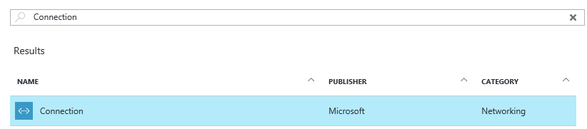

1. On the **Basics** blade, leave the **Connection type** set to **VNet-to-VNet**. Select the existing **WGVMRG** resource group. Then change the location of this connection to the Azure region the **WGVNet** virtual network is deployed to (West US). Click **OK**.

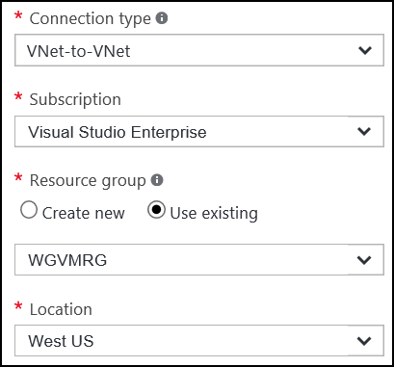

1. On the Settings tab, select **AzureWGGW** for the first virtual network gateway, and **OnPremSimGW** for the second virtual network gateway. Ensure **Establish bidirectional connectivity** is selected. Enter a Shared key, such as **A1B2C3D4** for example. After your settings reflect the below screenshot, click **OK**.

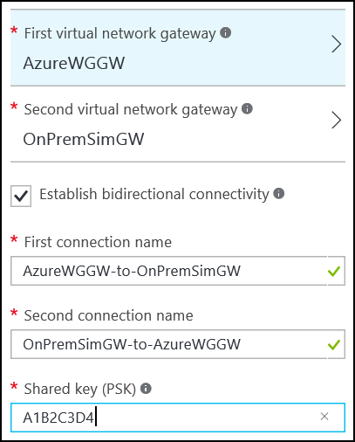

1. Click **OK** on the **Summary** page to create the connection.
2. Using the Azure Management Portal, click **More services**,thenenter **connections** in the search window and click **Connections**.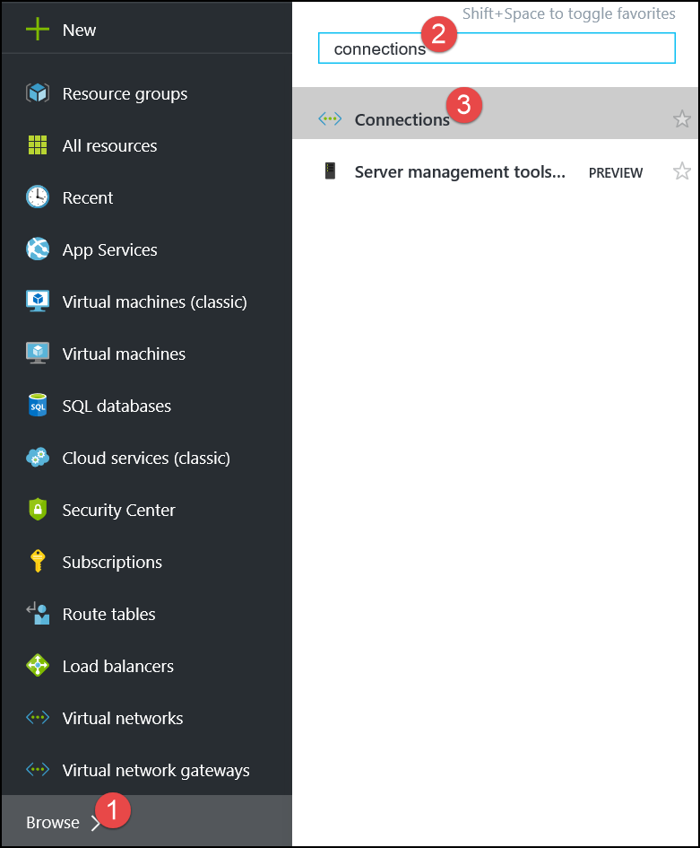
3. Watch the progress of the connection status and use the **Refresh** icon until the status changes for both connections from **Unknown** to **Connected**. This may take 5 minutes or more.

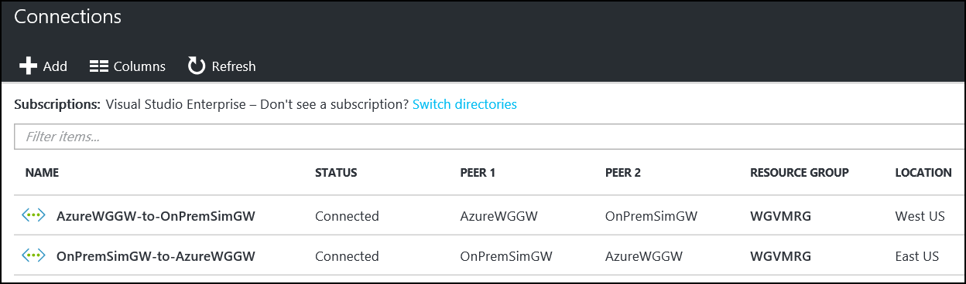

## Task 10 - Validate connectivity from ‘on-premises’ to Azure

### Create a virtual machine to validate connectivity

1. Create a new Virtual Machine in the second virtual network by clicking **New**, **Compute**, and **Windows Server 2012 R2 Datacenter**.

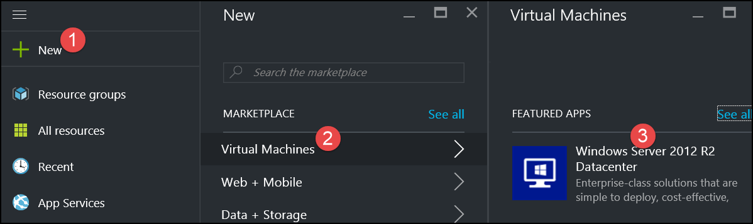

1. Accept the default setting of **Resource Manager** and then click **Create**.

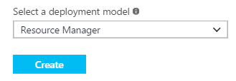

1. Specify the following configuration, and click **OK**. See the following screenshot for more details.

|  |  |
| --- | --- |
| * Name: **OnPremvm** * User name: **demouser** * Password: **demo@pass123** * Resource Group: Create new: **OnPremVMRG** * Location: **the region you created the OnPremSimVNet virtual network in (East US).** |  |

1. On the **Size** blade choose **F1 Standard** and click **Select**.

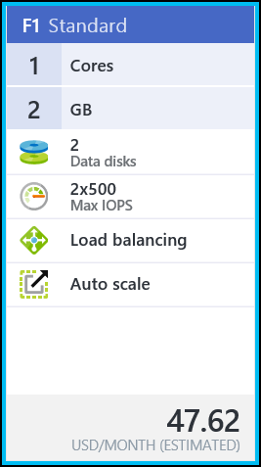

1. On the **Settings** blade, change the Virtual network to **OnPremSimVNet**, and set the subnet to the default subnet named: **default**.

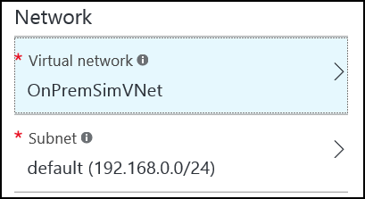

1. Click **OK**, and then click **OK** again to provision the virtual machine.

### Configure routing for simulated ‘on-premises’ to Azure traffic

When packets arrive from the simulated ‘on-premises’ virtual network (OnPremSimVNet) to the ‘Azure-side’ (WGVNET), they arrive at the gateway (WGAzureVNetGW). This gateway is in a gateway subnet (10.7.0.16/29). In order for packets to be directed to the pfSense firewall, we need another route table and route, this time associated with the gateway subnet on the ‘Azure’ side.

1. On the main portal menu to the left, click **More services** and the bottom. Enter **route** in the search box and click on **Route tables**.



1. On the **Route tables** blade click **Add**.



1. On the **Route table** blade enter the following information:
   1. Name: **WGAzureVNetGWRT**
   2. Subscription: **Choose your subscription**
   3. Resource group: Select **Use existing**, click the drop down menu, and select **WGVNetRG**
   4. Location: Same region where WGVnet exists
   5. Click **Create**.
2. Click on **WGAzureVNetGWRT**.

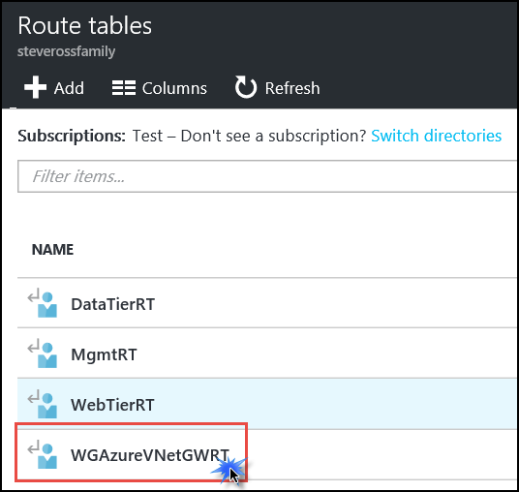

1. The **Essentials** and **Settings** blades open. On the settings blade click **Routes**.

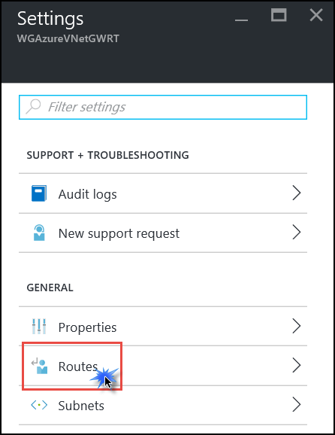

1. On the **Routes** blade, click the **Add** button. Enter the following information, and then click **OK**:
   1. Route name: **OnPremToWebTier**
   2. Address prefix: **10.7.1.0/24**
   3. Next hop type: **Virtual appliance**
   4. Next hop address: **10.7.0.4**

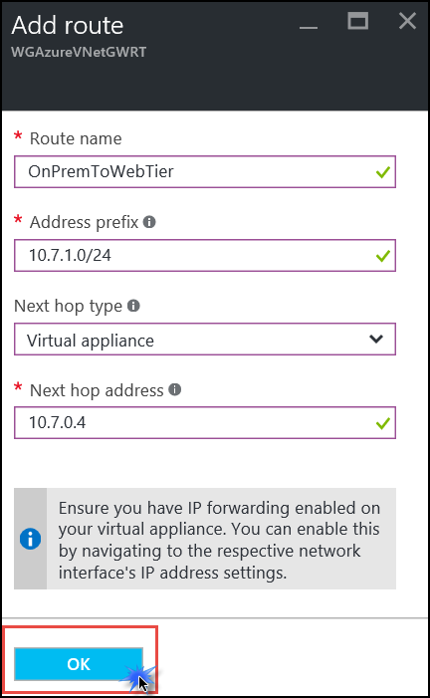

1. Using the breadcrumb menu at the top of the portal, navigate back to the WGAzureVNetGWRT route table settings.



1. On the **Settings** blade, click on **Subnets**.

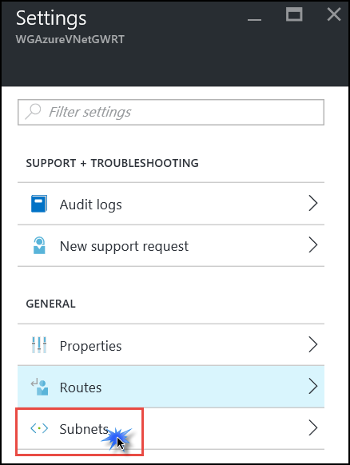

1. On the **Subnets** blade click on the **Associate** link.

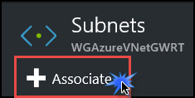

1. On the **Associate subnet** blade click on **Virtual Network**. Then click on **WGVNet**.

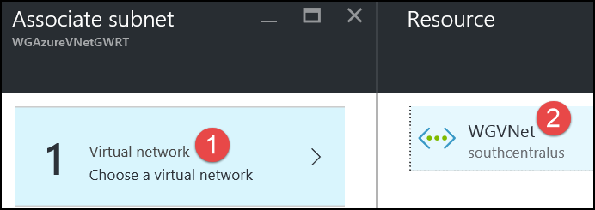

1. The **Choose subnet** blade opens. Click on **Gateway Subnet**. Then click **OK** at the bottom to complete the association.

### Add a firewall rule on pfSense

1. In a browser on your local machine, navigate to the public IP address of your pfSense firewall. If you followed the preceding instructions, it will be in this format: https://<publicIPofpfSense:8443
2. Log on using:
   1. User: **demouser**
   2. Password: **demo@pass123**
3. Hover over **Firewall** and click on **Rules**.



1. At the bottom of the list of rules, click the + icon to add a firewall rule



1. Make the following changes to the default settings, see the following screenshot for more details:
   1. Source:
      1. Type: **Network**
      2. Address: **192.168.0.0/24**
   2. Destination
      1. Type: **Network**
      2. Address: **10.7.1.0/24**
   3. Destination port range:
      1. From: Choose **HTTP (80)** from drop down
   4. Description: **From OnPrem to Web Tier**

Click **Save**.

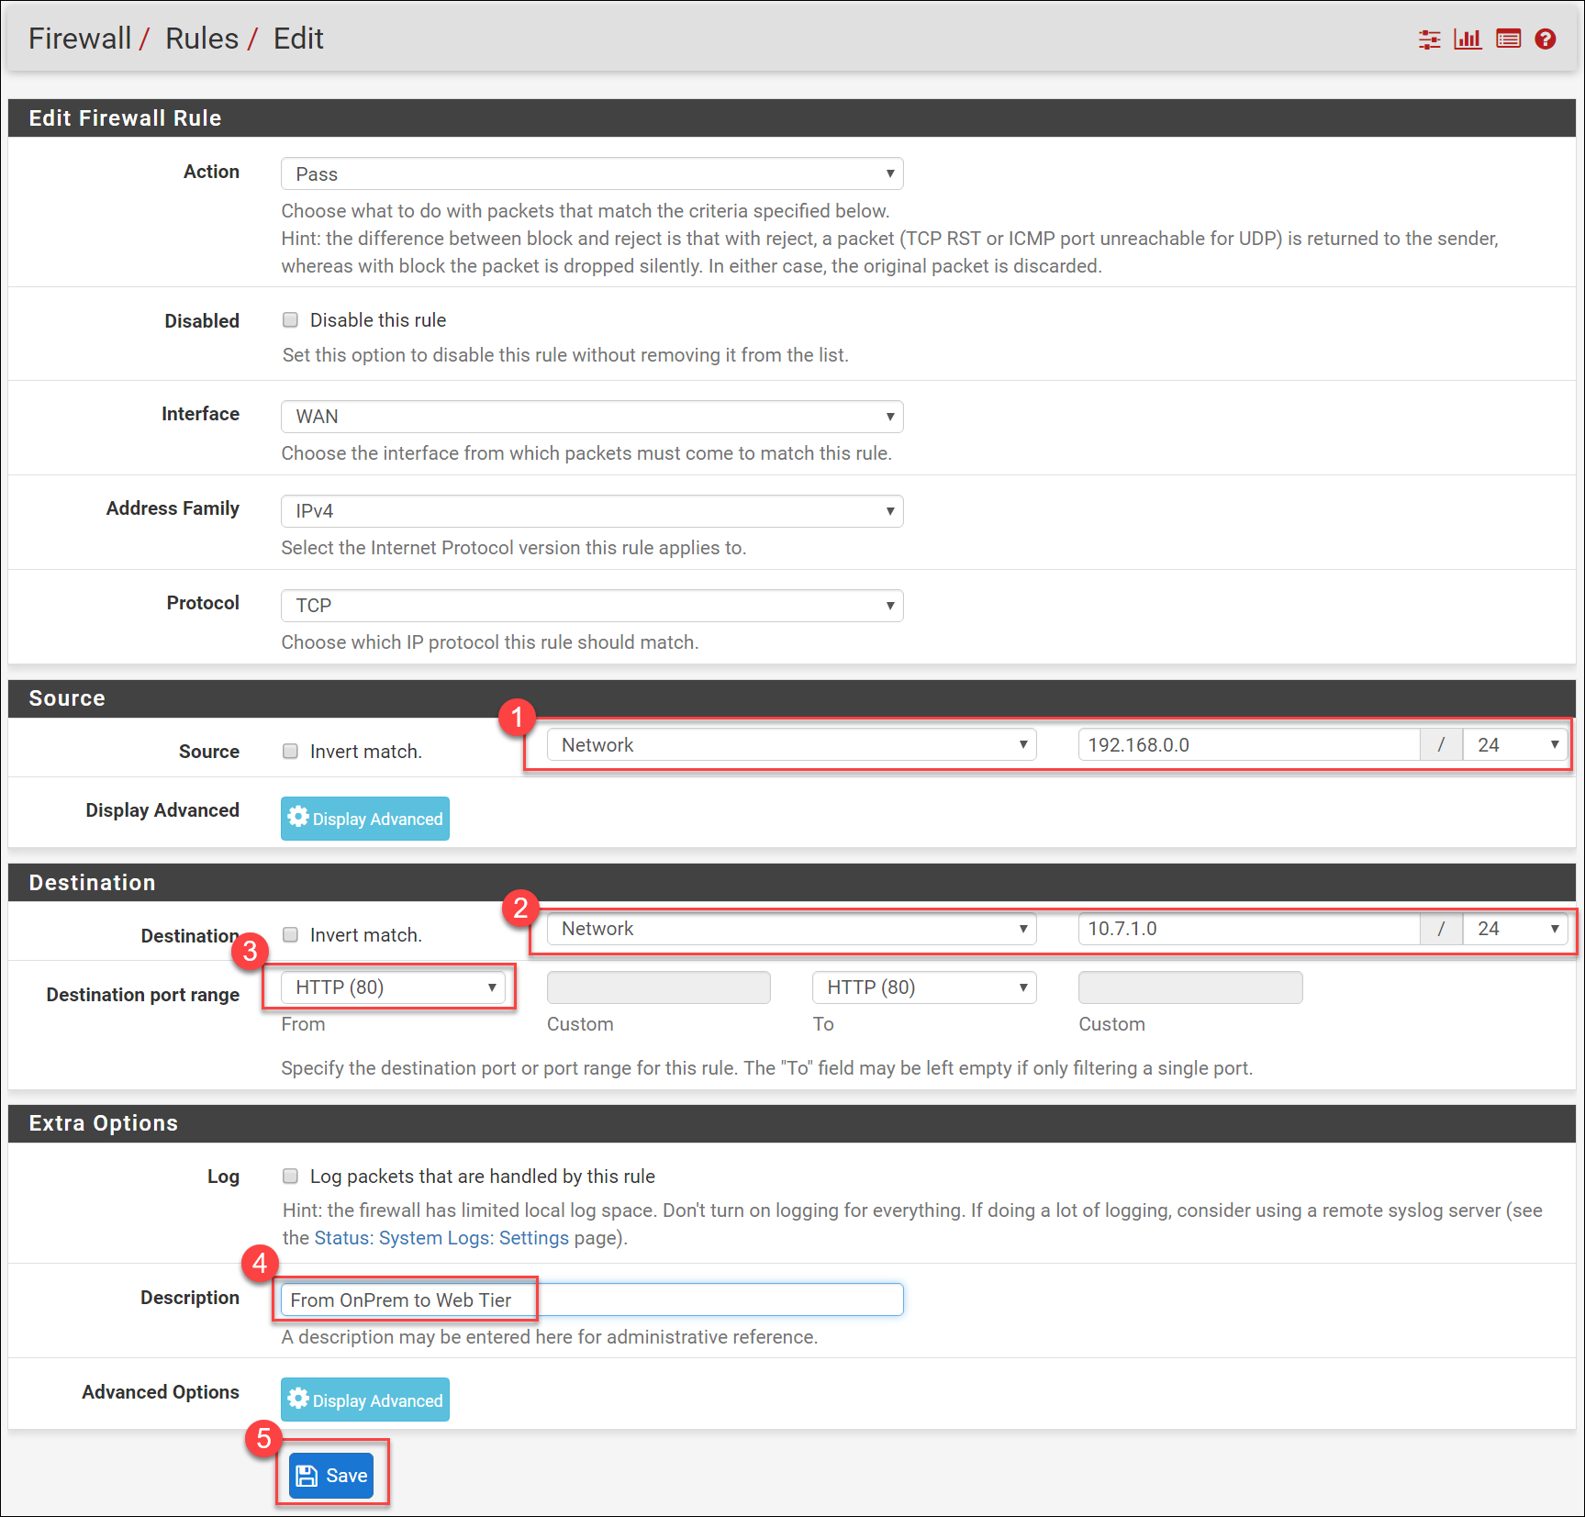

1. Click **Apply changes**.



### Validate connectivity from ‘on-prem’ to ‘Azure’ side

1. Click **Virtual machines** on the main Azure menu.

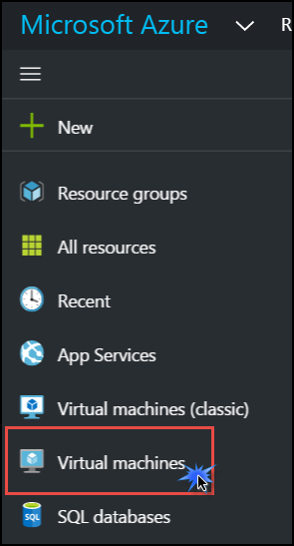

1. In the list of VMs, click **OnPremVM**.

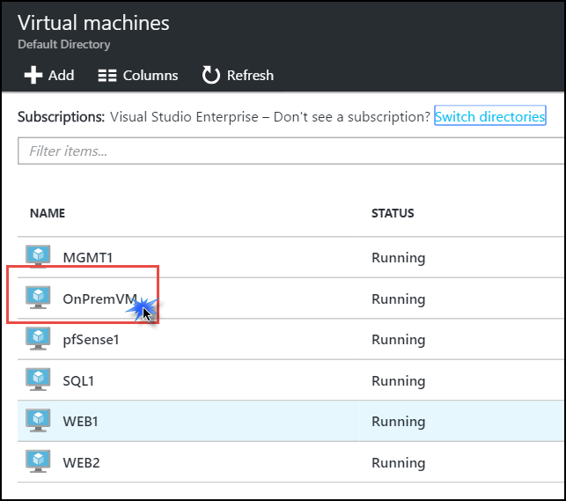

1. On the **Essentials** blade, click **Connect** to open an RDP session to **OnPremVM**.

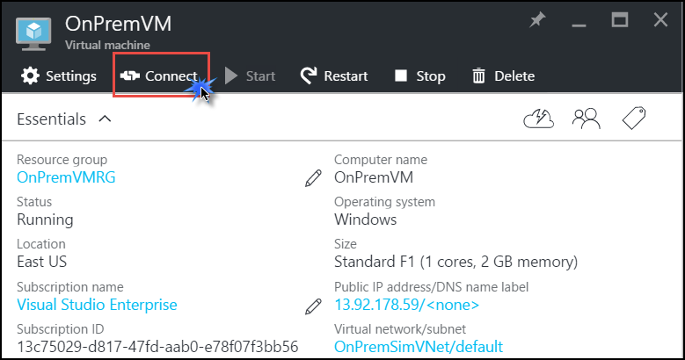

1. Log on with the following credentials:
   1. Username: **demouser**
   2. Password: **demo@pass123**
2. Once you have logged on, open **Server Manager** (if it is not already opened).



1. On the left, click **Local Server**.



1. On the right side of the pane, click **On** by **IE Enhanced Security Configuration**.



1. Change to **Off** for Administrators and click **OK**.



1. Open Internet Explorer and navigate to <http://10.7.1.10>. This should open the CloudShop app via the load balancer’s internal IP. If you refresh the browser several times you should see the server name changing:





# Conclusion

You have successfully completed the Enterprise-class Networking Hackathon.